Agricultural and Resource Economics and Agribusiness (AREA) Working Papers
2026, Paper 20
------------------------------------------------------------------------------------------------------------------------- Market and Policy Changes in World Dairy Product Markets

Matt Selvanª, Paul Deane^{b}, Alex Sinnett^{b}, Murray Jenkinsª, Bill Malcolm^{b} and Garry Griffith^{b}

ª Dairy Australia, Southbank.
^{b} School of Agriculture, Food and Ecosystem Sciences, University of Melbourne, Parkville.
--------------------------------------------------------------------------------------------------------------------------
Abstract
A project investigating the role played by international dairy product prices in determining Australian farm gate milk returns has been initiated. This project was developed to provide independent evidence to address industry concerns about the impact of discounted private label fluid milk sold by the major supermarkets. In this first paper, the focus is on setting the scene for subsequent empirical analyses by outlining current milk production and use in Australia, highlighting the role of trade in processed dairy products; describing world dairy product trade flows; and outlining the changes in market conditions and policies which have influenced these trade flows and associated prices. Subsequent papers are planned which will analyse available data and investigate the technical aspects of these price transmission relationships.

Key words: butter, cheese, skim milk powder, whole milk powder, export prices, Australia

Introduction

After many decades of national and state government intervention in both domestic fluid milk markets and processed dairy product markets (for descriptions of these policies, see for example, Lloyd, 1950; Griffith, 1989; Freebairn, 1992; Griffith et al., 1993; Griffith and Watson, 2016), these markets were finally deregulated in 2001 (Edwards, 2003). Australian dairy farmers have since operated essentially in an open market with minimal government intervention. Since deregulation, the number of dairy farms and number of cows milked have both fallen substantially, but total output has not fallen as dramatically in spite of ABARES estimating slightly negative productivity growth since 2001 (see for example, (https://www.agriculture.gov.au/abares/research-topics/productivity/agricultural-productivity-estimates). Marsden Jacobs (2025) confirmed a national annual growth rate in total factor productivity of -0.4 per cent over the period 2013/14 to 2022/23, although with some differences across States and milk production regions. Additionally, the processing sector has been rationalised and consolidated, and farm profitability, over most of the past two decades, has trended upwards (Dairy Australia, 2025, p.13).

When the major Australian supermarket chains introduced discounted private label fluid milk in 2011, many industry commentators claimed that this pricing strategy would drive dairy farmers out of business (see for example evidence presented to and reported in Senate Standing Committee on Economics, 2011). The argument was that lower retail prices for fluid milk would ultimately be passed through to farmers as lower farm gate milk prices.

However, this argument neglects the substantial role of export markets for dairy products in the Australian dairy industry. Across Australia at present, some 36 per cent of milk production is exported in various forms (Dairy Australia, 2025), more than is consumed as fluid milk within Australia. In many of the southern states, the export proportion is much higher. The key determinant of farm-gate milk prices therefore is not the retail price of private label milk, but the marginal value of raw milk to processors across all of its potential uses (Freebairn, 2016). That value is largely shaped by the returns processors expect to earn across the range of dairy products and markets in which they operate. It is also generally understood that, because Australia is a relatively small player in global dairy trade and largely takes international prices as a given (ABARES, 2026), since deregulation of the milk market, export market returns have exerted an even stronger influence on the value of raw milk to processors and, by extension, to farm gate milk prices.

The Australian Competition and Consumer Commission's (ACCC) Dairy Inquiry (2018) found that this was indeed the case - most private label milk contracts allow dairy processors to pass through farm gate milk prices to supermarkets, with processing costs forming the primary point of negotiation. This is shown in Figure 1, taken from the ACCC report.

Figure 1. Typical supermarket private label milk contract
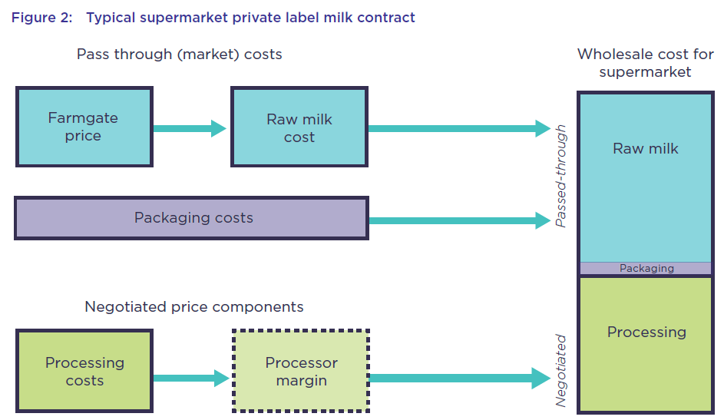
Source: ACCC (2018)

Other supporting evidence available is that in recent years, following deregulation in both the United States and the European Union about a decade ago (Vitaliano, 2016), international farm gate milk prices have been broadly similar (see Figure 2). As noted by Dairy Australia (2025, p.6): ‘As shown in Figure 2, the price received by farmers around the world has continued to converge. Farmgate prices now more closely reflect global dairy commodity price trends due to the removal of many market-distorting industry policies, progressive deregulation and increased global trade.’

In Figure 2, Canada is the obvious outlier, and Dairy Australia (2025, p.6) go on to say: ‘While broadly tracking other producers, Canada’s dairy farmers operate in a highly regulated environment, which determines prices, production, and imports according to a scheme known as Supply Management.’ Therefore, where domestic regulation is strong, as in Canada, farm gate prices are more independently

Figure 2. International farm gate milk prices, 2013-2024 (US$/100kg)
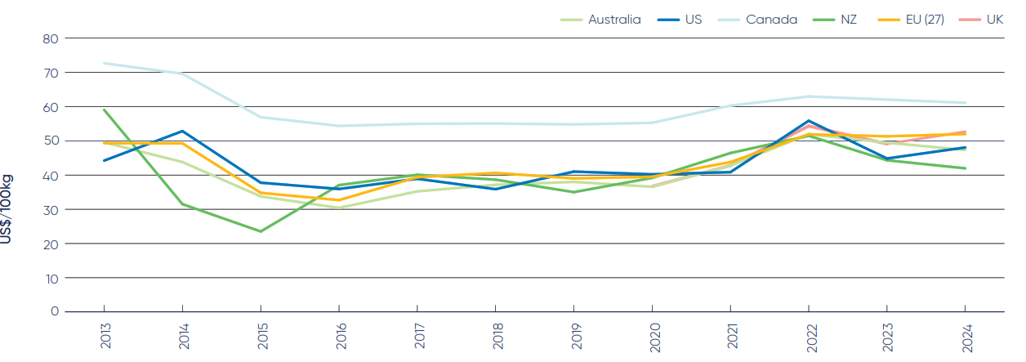
Source: Dairy Australia (2025)

determined, but where domestic regulation has been removed, as in Australia, farm gate prices for milk reflect the value of the products made from that milk in world markets.

However, in spite of this accumulation of evidence, industry concern about the role of international dairy product prices in influencing farm gate prices for fluid milk in Australia has recently resurfaced. This follows the recent sustained rises in international prices for butter and the Covid-related peaks in milk powder prices on the one hand, and on the other, unease about a second domestic retail milk price war during late 2024 (Wilson, 2024) and recent announcements about changes in retail pricing strategies by the supermarkets (Weekly Times, 2026).

To provide some independent evidence to address these concerns, an investigation of the role played by international dairy prices in determining Australian farm gate milk returns has been initiated with funding from Dairy Australia. In this first paper, the focus is on setting the scene for subsequent papers which will analyse the technical aspects of these price transmission relationships. Discussed in the following sections are an outline of current milk production and use in Australia, highlighting the role of trade in processed dairy products; world dairy product trade flows; and the major changes in market conditions and policies which have influenced these trends and patterns.

Australian Milk Production and Use and Dairy Product Trade

In this section, various ways of looking at Australian milk production, use and trade are examined. As shown in Figure 3, the number of dairy farms in Australia and the number of dairy cows milked have both declined substantially in the last two decades, while total milk production has also declined but at a much slower rate. In 2024/25, total milk production was about 8,300 million litres. How those 8,300 million litres were used is shown in Figure 4. Some 40 per cent was converted into cheeses of various types, about a third was consumed (predominately domestically) as fluid milk, and 21 per cent was processed into butter and skim milk powder. Only 2 per cent was processed into whole milk powder and only 5 per cent was used in other products such as yogurts.
Since milk production in its many processed forms exceeds the volumes required for domestic consumption, the surplus products are exported. With domestic demand for milk products increasing due to population growth and milk production declining, as shown in Figure 5, the share of total production destined for export has declined from around 50 per cent two decades ago, to approximately one-third in recent years. In 2024–25, Australia exported 36 per cent of milk produced in terms of milk equivalents.

Figure 3. Indices of the number of dairy farms and dairy cows, and Australian milk production, 1999/00-2024/25
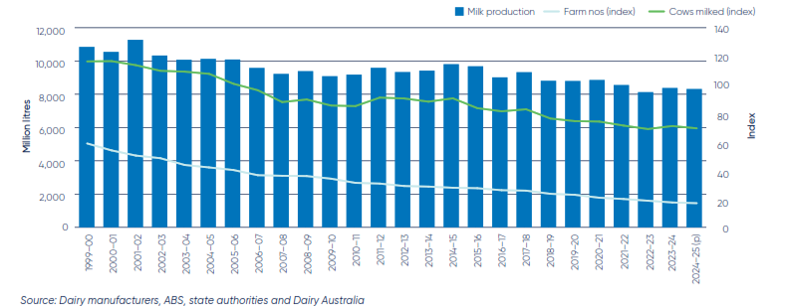
Source: Dairy Australia (2025)

Figure 4. Utilisation of Australian milk production, 2024/25
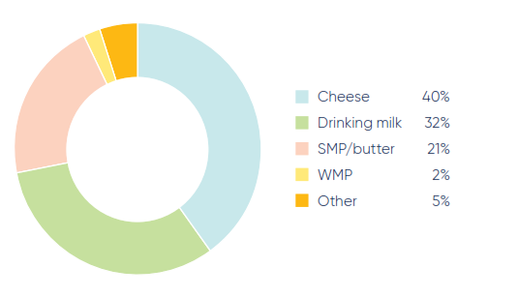
Source: Dairy Australia (2025)

Figure 5. Australian production and exports in milk equivalents, 2008/09-2024/25
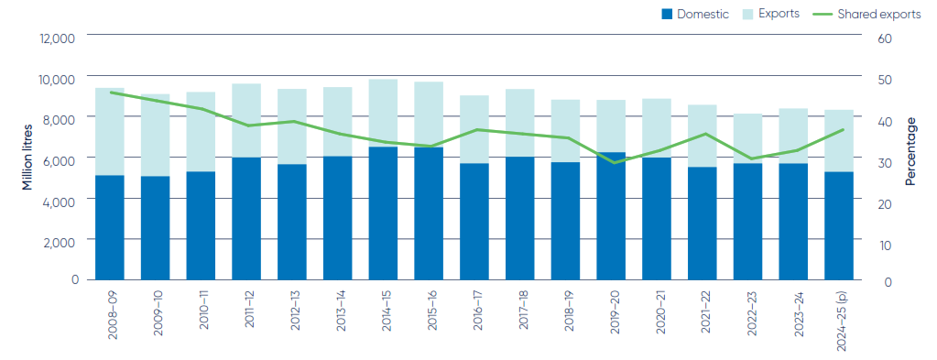
Source: Dairy Australia (2025)

Table 1. Imports, exports and domestic consumption of dairy products, Australia, 2000-2026 (m tonnes)
Commodity | Attribute | 2000 | 2001 | 2002 | 2003 | 2004 | 2005 | 2006 | 2007 | 2008 | 2009 | 2010 | 2011 | 2012
Dairy, Butter | Imports | 10 | 12 | 7 | 7 | 9 | 10 | 10 | 13 | 20 | 18 | 19 | 19 | 21
 | Exports | 139 | 123 | 125 | 110 | 75 | 70 | 82 | 80 | 58 | 87 | 58 | 42 | 54
 | Domestic Consumption | 58 | 57 | 50 | 60 | 60 | 65 | 62 | 55 | 64 | 60 | 73 | 78 | 82
Dairy, Cheese | Imports | 38 | 43 | 45 | 51 | 49 | 49 | 61 | 68 | 70 | 65 | 76 | 72 | 75
 | Exports | 223 | 219 | 218 | 207 | 212 | 227 | 202 | 202 | 202 | 162 | 160 | 168 | 163
 | Domestic Consumption | 200 | 205 | 225 | 230 | 230 | 223 | 225 | 215 | 214 | 220 | 230 | 235 | 245
Dairy, Dry Whole Milk Powder | Imports | 5 | 7 | 3 | 7 | 12 | 15 | 13 | 11 | 13 | 8 | 9 | 13 | 9
 | Exports | 169 | 183 | 213 | 142 | 173 | 161 | 153 | 130 | 111 | 133 | 115 | 116 | 109
 | Domestic Consumption | 20 | 25 | 24 | 25 | 23 | 22 | 27 | 27 | 27 | 28 | 32 | 30 | 33
Dairy, Milk, Fluid | Imports | 4 | 4 | 3 | 6 | 2 | 3 | 3 | 6 | 6 | 7 | 11 | 9 | 5
 | Exports | 86 | 81 | 87 | 88 | 86 | 84 | 86 | 82 | 69 | 71 | 74 | 90 | 98
 | Domestic Consumption | 11,090 | 10,787 | 11,524 | 10,554 | 10,293 | 10,348 | 10,312 | 9,424 | 9,437 | 9,262 | 9,276 | 9,470 | 9,701
Dairy, Milk, Nonfat Dry | Imports | 4 | 2 | 3 | 4 | 2 | 4 | 5 | 4 | 4 | 4 | 5 | 5 | 3
 | Exports | 253 | 218 | 231 | 193 | 187 | 141 | 189 | 175 | 126 | 167 | 132 | 140 | 168
 | Domestic Consumption | 32 | 33 | 35 | 35 | 20 | 35 | 38 | 42 | 43 | 50 | 56 | 68 | 76
Source: USDA

Commodity | Attribute | 2013 |  | 2014 | 2015 |  | 2016 |  | 2017 |  | 2018 |  | 2019 |  | 2020 |  | 2021 |  | 2022 |  | 2023 |  | 2024 |  | 2025 |  | 2026
Dairy, Butter | Imports | 21 |  | 23 | 22 |  | 30 |  | 35 |  | 42 |  | 40 |  | 43 |  | 37 |  | 41 |  | 50 |  | 44 |  | 48 |  | 50
 | Exports | 50 |  | 44 | 35 |  | 30 |  | 16 |  | 17 |  | 18 |  | 16 |  | 22 |  | 15 |  | 9 |  | 21 |  | 14 |  | 10
 | Domestic Consumption | 85 |  | 89 | 94 |  | 102 |  | 115 |  | 117 |  | 104 |  | 106 |  | 95 |  | 91 |  | 92 |  | 93 |  | 95 |  | 100
Dairy, Cheese | Imports | 69 |  | 80 | 89 |  | 99 |  | 116 |  | 98 |  | 97 |  | 98 |  | 97 |  | 96 |  | 108 |  | 101 |  | 115 |  | 120
 | Exports | 163 |  | 151 | 171 |  | 167 |  | 171 |  | 172 |  | 160 |  | 153 |  | 157 |  | 145 |  | 129 |  | 167 |  | 172 |  | 175
 | Domestic Consumption | 252 |  | 265 | 270 |  | 275 |  | 291 |  | 293 |  | 297 |  | 305 |  | 330 |  | 330 |  | 340 |  | 345 |  | 350 |  | 365
Dairy, Dry Whole Milk Powder | Imports | 8 |  | 9 | 11 |  | 16 |  | 28 |  | 28 |  | 37 |  | 43 |  | 37 |  | 40 |  | 47 |  | 37 |  | 38 |  | 40
 | Exports | 96 |  | 81 | 65 |  | 70 |  | 55 |  | 55 |  | 42 |  | 37 |  | 51 |  | 58 |  | 38 |  | 55 |  | 50 |  | 40
 | Domestic Consumption | 35 |  | 32 | 30 |  | 30 |  | 32 |  | 35 |  | 33 |  | 40 |  | 40 |  | 35 |  | 30 |  | 20 |  | 20 |  | 20
Dairy, Milk, Fluid | Imports | 7 |  | 6 | 5 |  | 5 |  | 5 |  | 6 |  | 6 |  | 5 |  | 5 |  | 7 |  | 7 |  | 9 |  | 8 |  | 8
 | Exports | 111 |  | 154 | 166 |  | 192 |  | 214 |  | 227 |  | 254 |  | 270 |  | 402 |  | 335 |  | 207 |  | 169 |  | 182 |  | 190
 | Domestic Consumption | 9,205 |  | 9,650 | 9,930 |  | 9,299 |  | 9,253 |  | 9,230 |  | 8,584 |  | 8,834 |  | 8,670 |  | 8,122 |  | 8,269 |  | 8,508 |  | 8,326 |  | 8,518
Dairy, Milk, Nonfat Dry | Imports | 5 |  | 6 | 10 |  | 6 |  | 8 |  | 13 |  | 15 |  | 16 |  | 14 |  | 15 |  | 14 |  | 11 |  | 10 |  | 10
 | Exports | 119 |  | 164 | 201 |  | 163 |  | 157 |  | 155 |  | 128 |  | 129 |  | 156 |  | 154 |  | 133 |  | 170 |  | 157 |  | 150
 | Domestic Consumption | 80 |  | 81 | 85 |  | 75 |  | 46 |  | 48 |  | 45 |  | 43 |  | 40 |  | 28 |  | 28 |  | 24 |  | 25 |  | 25
 |  |  |  | Source: USDA

Another way of looking at the data is to tabulate imports, exports and domestic consumption of milk and the major dairy products over time, as shown in Table 1. It is evident that Australia is both an exporter and an importer of each of these classes of dairy products, even if some of the volumes are very small such as imports of fluid milk. This is evidence of an integrated world dairy products trade.

The trends and patterns in the individual products are also of interest. Domestic milk consumption has fallen from more than 11,000 m L in the early 2000s to less than 8,500 m L in the most recent years. With a steady growth in population over that time, the decline in per capita consumption of milk would be even more pronounced.

As shown in Table 1, domestic consumption of butter has almost doubled over the last 25 years, from around 60 m tonnes in the early 2000s to around 100 m tonnes in recent years, although off the highs of 2017 and 2018. However, the composition of that consumption has changed significantly, with substantial declines in domestic production and exports and an expanded role for butter imports. Imported butter now makes up about half of domestic consumption. Butter which once dominated Australian dairy product exports has declined sharply and now represents less than 6 per cent of the total value of exports (Table 2).

The same general picture is evident for cheese – substantial rises in domestic consumption, a steady decline in domestic production and exports, and an increasing role for imports of cheese. Total consumption of cheese sits at around 350 m tonnes, with imports making up about one-third of that volume (Table 1). Cheese is the major product group exported by Australia at around 33 per cent of the sector’s export value in 2024/25 (Table 2).

The patterns with the milk powders are slightly different. Domestic consumption of both has been relatively flat over the whole period, rising slowly to about 2012/2013 then falling away to recent years. The rise and fall were more pronounced for skim milk powder than for whole milk powder (Table 1). The decline in exports and the rise in imports follows the other product groups. The whole milk powder data is interesting – imports are approximately double domestic consumption, so there must be a substantial re-export trade in this product category. Skim milk powder makes up 20 per cent of Australia’s dairy product exports by value, and whole milk powder 17 per cent in 2024/25 (Table 2).

Overall, while accounting for just over 1 per cent of the world’s estimated milk production (Dairy Australia, 2025), Australia remains a significant exporter of dairy products, with some $A3.8 billion shipped in 2024/25 (Table 2).

Table 2. Australian dairy exports by product and region, 2024/25 ($A million)

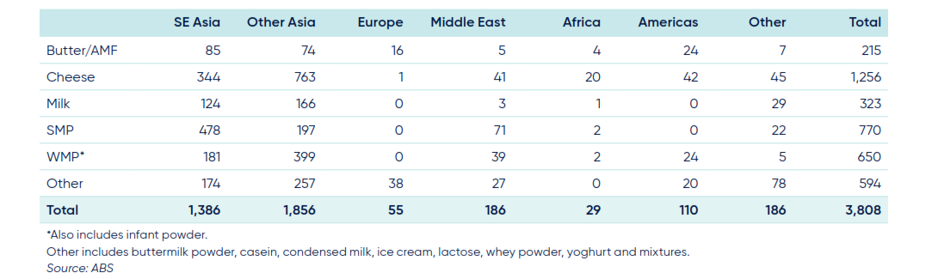
Source: Dairy Australia (2025)

The major markets for Australian dairy products exports are in Southeast Asia (36 per cent) and Other Asia (mainly China and Japan, together 41 per cent) (Table 2). Asia in total imports some 85 per cent of Australia’s dairy product exports as measured by value. More detailed information on the export markets for the major processed dairy products is available in the Appendices to Dairy Australia (2025).

Table 3. Australian imports of dairy products, 2019/20-2024/25 (tonnes)

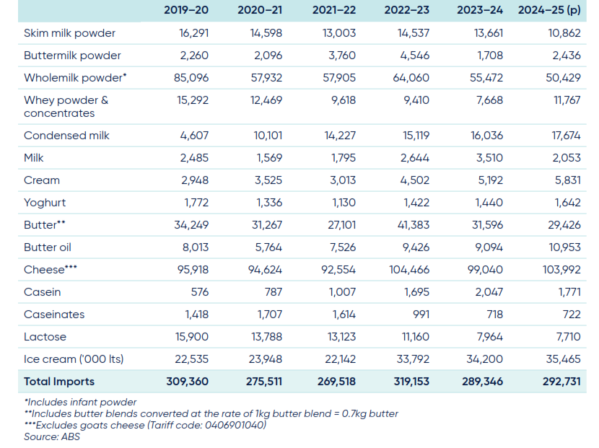
Source: Dairy Australia (2025)

Australia also imports significant quantities of dairy products, as shown in Table 1 and Table 3. This trade is dominated by cheese imports (about 36 per cent of the total), but there are also large volumes imported of whole milk powder, butter and ice cream. More than half of these imports come from New Zealand, with Europe and the United States being the other major suppliers (Table 4).

Table 4. Australian imports of dairy products by region, 2019/20-2024/25 (tonnes)

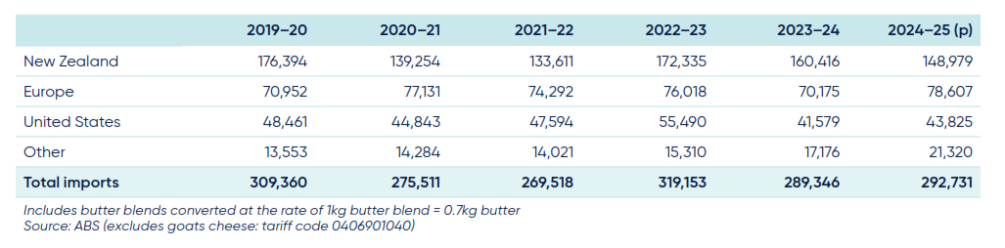
Source: Dairy Australia (2025)
These three suppliers account for 93 per cent of Australia’s dairy product imports on a volume basis. Detailed information on the sources of imports is also available in the Appendices to Dairy Australia (2025).

World Dairy Product Trade Flows and Prices

World dairy product trade flows and associated prices are examined in this section. Although Australia exports some $3.8 billion worth of dairy products (Table 2), it is a relatively minor player in world trade of dairy products, holding just a 4 per cent share of world dairy trade as measured by value. Australia is currently ranked fifth behind New Zealand, the European Union, the United States and the United Kingdom (post Brexit) in world dairy product trade value (Dairy Australia, 2025). These five countries make up on average about three-quarters of world dairy product exports.

World dairy products trade has been recently reviewed by OECD (2026) and USDA (2026). A decade ago, Vitaliano (2016) also provided a comprehensive review.

The OECD report notes (p.103): ‘Around 50% of world production of WMP and SMP is traded since these products are often produced only to store and trade milk over longer time periods or distances. Fresh dairy products such as fermented milk products are traded in small amounts between neighbouring countries – between Canada and the United States or between the European Union and Switzerland, for example. One exception is imports of liquid milk by China from the European Union and New Zealand, made possible by ultra-high temperature milk and cream products capable of being shipped long distances, and in some cases, favourable Chinese freight rates’.

The OECD report also includes projections out to 2035. Their summary (OECD, 2026, p.104) is that: ‘World dairy trade is projected to expand over the next decade to reach 13.7 Mt in 2035, 11% higher than during the base period. Most of this growth will originate in the European Union, the United States, and New Zealand. These three exporters are projected to jointly account for around 67% of cheese, 64% of WMP, 69% of butter and 73% of SMP exports in 2035 (Figure 6). In addition, the United States is expected to increase market share more than the European Union and New Zealand. While Australia has lost market shares, it remains a notable exporter of cheese and SMP. Argentina is also an important exporter of WMP and is projected to account for 6% of world exports by 2035. In recent years, Belarus has become an important exporter, orienting its exports primarily to the Russian market due to the Russian embargo as of 2015 on several major dairy-exporting countries’.

‘The European Union will continue to be the main world cheese exporter, followed by the United States and New Zealand. The United Kingdom, Russian Federation (hereafter “Russia”), Japan, Mexico and Saudi Arabia are projected to be the top five cheese importers in 2035. Since consumers value variety, these countries are often also exporters of cheese and international trade is expected to offer more choices of cheeses in the domestic markets’.

‘New Zealand remains the primary source for butter and WMP on the international market, and its market shares are projected to be around 41% and 56%, respectively, by 2035. China is the principal importer of WMP from New Zealand. The expected growth in domestic milk production in China will limit the growth in WMP imports’.

‘The United States is expected to be the most dynamic large exporter over the next decade and to expand SMP exports especially. This would require growth in drying capacity beyond current investments. SMP imports are dispersed globally as it is often the easiest dairy product to trade for use in food processing’.

Figure 6. Exports of dairy products by region, 2023/25 and 2035 (Mt)
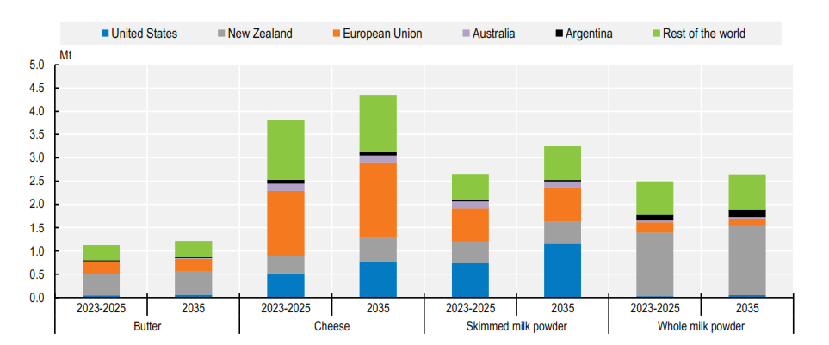
Source: OECD (2026)

The OECD (2025) report also discusses and forecasts world dairy product prices. They note (p.105) that: ‘International dairy prices are prices of processed products from the main exporters in Oceania and Europe. The two main reference prices are butter and SMP, where butter is the reference for milk fat and SMP for other milk solids’.

These prices are shown in Figure 7. Several issues are evident from these graphs.

First, the ‘Oceania’ region is regarded by the OECD and FAO as the price setter for each of the dairy products included in Figure 7.

Second, there is an obvious change in behaviour in each of the series around the 2015 period when both the United States and the European Union partially deregulated their domestic dairy policies. Before 2015, all of the product group prices were relatively similar in value and moved together in a closely related manner. After 2015, there has been a divergence in values and in the nature of the relationships between them. Underlying changes in demand for milk fat and non-fat milk solids are now reflected in the prices of the products with different levels of these two characteristics.

Third, since 2015, ‘increased demand for milk fat has resulted in the price of butter increasing considerably more than SMP, with a price gap emerging between the two products. The price of butter is expected to continue to be supported by stronger demand for milk fat compared to other milk solids on the international market. This reflects underlying differences in demand patterns, with non-fat solids often associated with more price-sensitive import demand while demand for milk fats – particularly in high-income markets – tending to show relatively more stable consumption patterns. Thus, while all products have been increasing in nominal terms over the data period shown in Figure 7, the real price of butter has increased while the real price of the milk powders has decreased.’ (p.106). The real price of the indicator cheese category has remained relatively stable.

Finally, Figure 7 indicates strong historical volatility of international dairy product prices and the possibility of regular 3-4 year cyclical patterns, especially in butter prices. ‘This volatility stems from its small trade share, the dominance of a few exporters and a widely restrictive trade policy environment in many import markets. Most domestic markets [outside of Australia, New Zealand, the European Union and the United States] are only loosely connected to those international dairy prices as fresh dairy products dominate consumption, and only a small share of milk is processed compared to that which is fermented or pasteurised’. (p.107).
Figure 7. World dairy product indicator prices, 2005-2025, and projects to 2035 ($US/t)
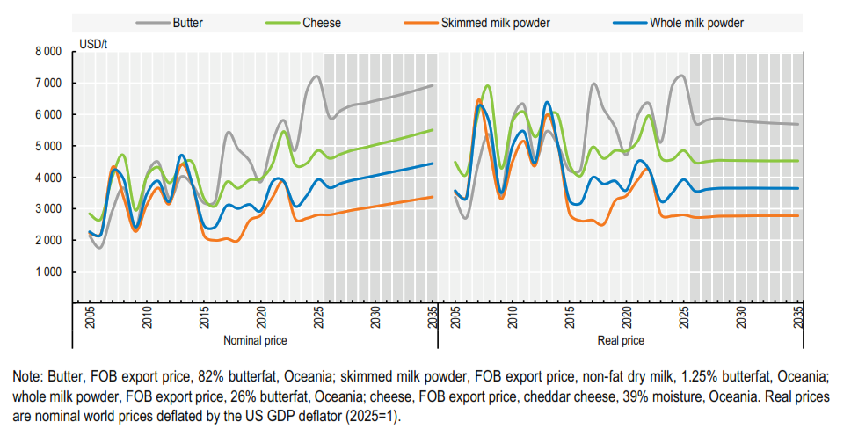
Source: OECD (2026)

Recent Changes in the World Dairy Products Market

To provide some context for the descriptions of dairy product trade flows and prices reported above, it is useful to describe some of the major changes in markets and policies in the major exporting regions over the period 2005-2025 that have contributed to these price trends, patterns and relationships. Market developments are examined first.

The GFC

Early in the period under study, the global financial crisis (GFC) occurred. The RBA (2026, p.1) summarises the crisis as follows: ‘The global financial crisis (GFC) refers to the period of extreme stress in global financial markets and banking systems between mid-2007 and early-2009. During the GFC, a downturn in the United States housing market was a catalyst for a financial crisis that spread from the United States to the rest of the world through linkages in the global financial system. Many banks around the world incurred large losses and relied on government support to avoid bankruptcy. Millions of people lost their jobs as the major advanced economies experienced their deepest recessions since the Great Depression in the 1930s. Recovery from the crisis was also much slower than past recessions that were not associated with a financial crisis.’

One consequence was that commodity prices around the world rose sharply over this period, including in the markets for dairy products. All the product groups peaked during this period, with butter seemingly the least effected and the milk powders the most. European Union prices showing the larger rises and United States prices the least (Figure 7).

Variations in Chinese dairy product imports

Another significant change was brought about some years earlier by the melamine milk scandal in China in 2008. Watered down milk and infant formula from a major dairy processor was adulterated with the chemical melamine to induce higher protein readings in quality control tests. Some 300,000 affected infants were identified as having kidney stones or other kidney damage. Of these, 54,000 were hospitalised, and the deaths of six babies were concluded to be related to the contaminated milk.

Following the scandal, China engaged in a large-scale effort to replace its fragmented, small farm-based milk production sector, with its weak quality controls, with a more centralised system of large farms and greater control over its supply chain (Vitaliano, 2016). However, the transition took much longer than expected and in 2013 and 2014 China experienced a significant shortfall in its domestic supply of milk and embarked on a program of massive purchases of dairy products, primarily whole milk powder, from export suppliers. The resulting supply-demand situation pushed dairy product prices to historic highs around the world. China severely scaled back its dairy purchasing in early 2014, particularly from New Zealand, its major supplier (Figure 17), after having acquired very substantial stocks. World dairy product prices almost immediately began a long slide to much lower levels. These price changes are clearly shown in Figures 7.

Vitaliano (2026, p.32) notes: ‘The depressed world dairy product price and trade situation of 2014–2016 represents something of a break or reset point in the evolution of world dairy trade. It represents the end of the “latent demand gap” period of demand-led export growth and the commencement of a period of heightened competition among export suppliers.’

It is noteworthy that following on from this price slide in dairy product prices, in 2016 both Murray-Goulburn and Fonterra Australia had to ‘step down’ their farm-gate milk prices to farmers which had quite a devasting financial impact on their suppliers.

Further significant cutbacks in Chinese dairy product imports occurred in 2021, associated with the Covid pandemic, and the subsequent tensions with major trading partners. Again, New Zealand, and the European Union, were the suppliers most affected (Figure 8).

Figure 8. China imports of dairy products by supplier, 2005-2025, tonnes

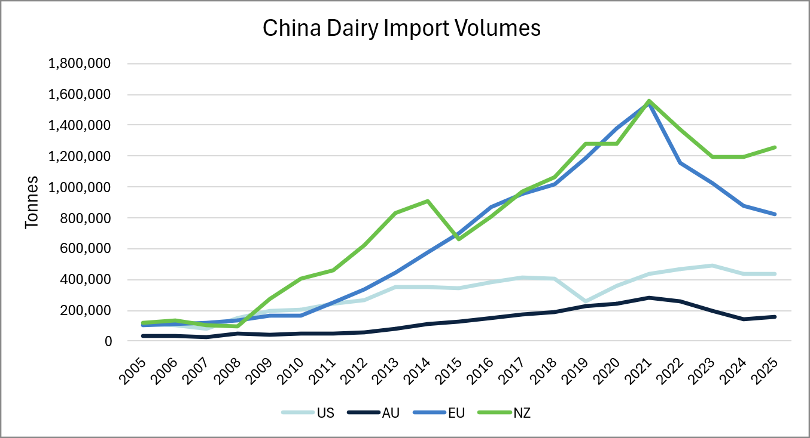
Source: Trade Data Monitor

Recent Changes in Policies Related to World Dairy Products

Australia

Domestic policies

The dairy industry was the most highly regulated and assisted major industry in Australia for 75 years until deregulation in 2000 (Griffith and Watson, 2016). The ﬂuid milk markets were previously controlled by state marketing authorities (SMAs), while processed product markets were regulated by the Australian Dairy Corporation (ADC) and its predecessors. Edwards (2003) and Griffith and Watson (2016) describe the range of policy instruments used: for fluid milk, state SMAs licensed farmers to produce milk, regulated quality, took over ownership of milk at the farm gate, set farm prices for milk, imposed production quotas or price pooling, regulated wholesale and retail margins, regulated milk transport and restricted interstate trade in milk; while until 2000, the ADC regulated dairy product exports through licensing, administered the statutory marketing arrangements and promoted dairy products domestically and internationally. From 1986 a levy was paid by dairy farmers on milk production, which was redistributed as an export subsidy on manufactured products. The plan provided for progressive reduction in support towards import parity, and eventual phasing out.

National policy settings for manufactured dairy products were removed in 2000, as were monopoly arrangements for ﬂuid milk operated by the state SMAs. However, a contentious ‘structural adjustment’ package was brought into eﬀect, with a price tag of over $1.5 billion. This package, funded by a levy of 11 cents/litre on all retail milk sales for 8 years, was said to facilitate adjustment and improve industry performance. Edwards (2003) provides a detailed analysis of the package and its impacts.

Trade policies

ChAFTA: The absence of a bilateral free trade agreement (FTA) with China during the first half of the period under review meant Australian producers and exporters faced significant tariffs on agricultural products and were at a competitive disadvantage to New Zealand which already had an FTA with China. The China-Australia Free Trade Agreement (ChAFTA), implemented in late 2015, addressed this issue, with tariffs to be progressively eliminated across all Australian dairy products. For the product groups of interest in this paper, this agreement means elimination of the 10 to 15 per cent tariff on cheese, butter and yogurt by 1 January 2024, and elimination of the 10 per cent tariff on milk powders by 1 January 2026.

DFAT (2026a) note that ChAFTA ‘gives Australia a significant advantage over other larger players’, such as New Zealand. ‘The New Zealand's FTA with China contains restrictive safeguard measures on a wide range of dairy products, including liquid milk, cheese, butter and all milk powders (where China raises the tariff back to the higher normal rate when New Zealand exports exceed a certain volume). By contrast, under ChAFTA, Australia only faces a discretionary safeguard on whole milk powders, with the safeguard trigger volume set well above current trade levels and indexed to grow annually. For all other dairy products, Australia will receive unlimited preferential access.’ China is now Australia's largest market for dairy product exports.

Other FTAs: DFAT (2026b) outline current FTAs that Australia has with trading partners. During the period under review, Australia has implemented some 16 FTAs, other than ChAFTA, covering many of Australia’s major dairy product markets (such as ASEAN and many member countries individually, Japan, Korea, and the United Arab Emirates, as well as several higher-level regional groupings) and competing suppliers to those markets (the United States and the United Kingdom).

The Closer Economic Relations agreement with New Zealand has been in force since 1983, and a FTA with the European Union (A-EUFTA) has been agreed and is awaiting final approval by the respective governments. Within the A-EUFTA, the European Union will eliminate tariffs on 87.3 per cent of dairy products exported from Australia (DFAT, 2026c). Australian producers will have duty-free access into the European Union for cheese, whole milk powder, dairy spreads and fats and oils, ice cream, yoghurt, milk and cream. For a small number of products, the agreement delivers guaranteed access per year for 5,000 tonnes of natural butter; 8,000 tonnes of skimmed milk powder; and 2,000 tonnes of high protein whey. Dairy farmers have expressed some disquiet over this agreement however (Australian Dairy Farmers, 2026).

Once the A-EUFTA is ratified, all the major dairy product suppliers will be moving toward a free trade environment and the expectation would be that global dairy product prices would continue to converge towards a ‘world price’.

United States

Domestic policies

The aim of United States dairy product policy was to maintain and stabilise financial returns to dairy producers. The primary mechanism of this stabilisation, or safety net, policy, was market intervention through the Dairy Price Support Program to remove surplus products from United States commercial markets and inventory them domestically until recovering prices permitted them to be sold back into commercial markets or diverted to non-commercial uses. That is, a buffer stock program.

The United States made major changes in dairy policies at about the time of the large price falls for dairy products in 2015. The United States discontinued its long-standing Dairy Price Support Program and replaced it with the milk price-feed cost margin insurance program, the Margin Protection Program, in the 2014 farm bill. The events of 2009 had demonstrated to the industry how fundamentally incompatible a purchase and inventory-based dairy policy is with an export growth-led marketing strategy.

Recent changes to United States dairy policy are detailed in USCRS (2025). These provisions are summarised in the following quotations (no page number given):

‘The U.S. Department of Agriculture (USDA) administers a suite of programs authorized by the Agriculture Improvement Act of 2018 (2018 farm bill; P.L. 115-334) and subsequent extensions to help dairy producers recover from the financial effects of natural disasters and adverse market conditions (e.g., low milk prices and/or increasing feed costs). The farm bill is an omnibus, multiyear law that governs an array of agricultural and food programs. The 2018 farm bill included dairy provisions in Title I and Title XII. Title I, Commodity, established the Dairy Margin Coverage (DMC) program and the Milk Donation Program, and reauthorized the Dairy Forward Pricing Program (DFPP), the Dairy Indemnity Payment Program, and a provision in the Dairy Promotion and Research Program. Title XII, Miscellaneous, included a provision creating the Dairy Business Innovation Initiative. Dairy producers may also participate in other programs authorized or amended in the farm bill, including the Federal Crop Insurance Program; Livestock Indemnity Program; Livestock Forage Disaster Assistance Program; and Emergency Assistance for Livestock, Honey Bees, and Farm-Raised Fish Program.

USDA also administers programs authorised by legislation other than the farm bill. These include agricultural commodity promotion and research programs (i.e., checkoff programs) and the Federal Milk Marketing Orders (FMMOs). USDA’s Agricultural Marketing Service (AMS) oversees two agricultural commodity programs that promote the dairy industry: the Dairy Promotion and Research Program (i.e., dairy checkoff program) and the National Fluid Milk Processor Promotion Board (i.e., fluid milk checkoff program). In general, these programs are to strengthen the U.S. dairy industry’s position in the marketplace. The FMMO system is a permanently authorized mechanism for stabilizing the supply and price of fluid milk. Under FMMO law and regulations, USDA establishes a minimum milk price, and milk handlers (processors) are required to pay milk producers at least the minimum price and adhere to other specified rules. The collection of formulas used to calculate the minimum price are referred to as the uniform pricing formula.

Since 2018, USDA has created additional ad hoc dairy support programs using funds appropriated by Congress as well as funds from the Commodity Credit Corporation (CCC). These programs provided various types of supplemental support for disaster assistance, response to the COVID-19 pandemic, and increased costs associated with organic dairy production. For some stakeholders and policymakers, this increase in supplemental dairy support raises questions regarding the federal government’s role in responding to natural disaster-related losses or other economic events impacting the U.S. dairy industry and the effectiveness of the permanently authorized dairy programs.’

Trade policy

The United States Congress enacted the Dairy Export Incentive Program (DEIP) in the mid-1980s, allowing export subsidies, primarily in response to the European Union’s use of the same instrument.
During the late 1980s and early 1990s, the Department of Agriculture did make extensive below cost export sales of the large stocks of dairy products it acquired under the Dairy Price Support Program in the late 1970s and early 1980s, but its use was always relatively small compared with the size of the United States dairy industry (Vitaliano, 2016).

The last time the United States exported dairy products with direct government assistance was in 2009, when the European Union also ceased using export subsidies.

United States FTAs are listed in USCBP (2026). Since 2005 agreements with special relevance to dairy product trade have been signed with Australia, Korea and Japan. The United States does not have a FTA with the European Union or New Zealand, or with China as a major importer.

Also worth mentioning are the unilateral tariffs imposed by the United States on many of its trading partners in 2025, and again during 2026, which are outside the scope of negotiated trade agreements, and the consequent retaliation by those partners. Many dairy products are caught up in these recent disputes.

European Union

Domestic policies

Dairy policy in the European Union is managed under the Common Agricultural Policy (CAP), first implemented in 1962 (European Commission, 2026b,c). The CAP was conceived as a common policy across all member states, with the objectives of increasing productivity and stabilising markets, providing affordable food for European Union citizens and a fair standard of living for farmers. However, with its policy of support prices, which were very high compared with world market prices, and an unlimited buying guarantee, the CAP started to produce more and more food surpluses (European Parliament, 2026). In order to close the widening gap between supply and demand and bring agricultural expenditure under control, the Council introduced a series of changes to the CAP by gradually replacing the system of protection through prices with a system of compensatory income support.

This began in 2003 and was slightly revised in 2009 – ‘decoupling’ of payments to farmers provided from volumes produced, to make farms more market-oriented and to reduce distortions in agricultural production and trade. Decoupled aid became a ‘single farm payment’. This fixed annual payment to farmers was not linked to production volumes and was aimed at guaranteeing income stability. Another change was to ensure ‘Compatibility with World Trade Organization rules, insofar as the ultimate objective of aid decoupling was to ensure that it was included in the ‘green box’, the category for agricultural subsidies that do not distort trade.’ (European Parliament, 2026).

The major change of relevance to this study occurred in 2013. The abolition of all supply control measures, such as limits on how much farmers could produce (e.g. milk quotas for dairy production), was confirmed. The new milk scheme, without quotas, in force since 2015, was preceded by the adoption of a ‘milk’ mini-package.

The post-2020 reform, which determines the CAP for the 2023-2027 period, concluded with the final adoption of the agreed texts in December 2021. ‘The new CAP aims to build a sustainable food system and, in so doing, will contribute to the objectives of the ‘Green Deal’, the ‘farm to fork’ strategy and the ‘biodiversity’ strategy, by protecting and enhancing the variety of plants and animals in rural ecosystems. In order to meet the Green Deal targets, it introduces enhanced conditionality (linking direct income support to environmentally friendly farming practices), eco-schemes (payments beyond basic support for voluntary environmental and climate-friendly farming practices) and national strategic plans.’ (European Parliament, 2026).

Trade policy

The European Union had long faced the same domestic-world price difference as the United States, but, by contrast, chose to rely more heavily on export subsidies to manage its surplus milk production, with a smaller role assigned to domestic intervention and domestic storage of surplus products (Vitaliano, 2016). When the Uruguay Round Agreement on Agriculture was fully implemented in 2000, use of export subsidies by all World Trade Organisation members was limited to percentages of both product volumes and monetary outlays during a designated period, 1986–1988. Under the agreement, the European Union was permitted to use by far the largest product volumes and expenditures to subsidise the export of dairy products, which it subsequently used to maintain its large dairy export sales volumes. However, as the decade of the 2000s progressed, European Union governments reassessed the budgetary cost of financing those export volumes and began to curtail their expenditures for doing so. The last time the European Union exported dairy products with direct government assistance was in 2009.

Following its slow decline as an export supplier of dairy products, and facing declining world prices, and the overnight embargo of its exports to its major market, Russia, in early 2015 the European Union dairy industry ended the milk production quota policy and announced a refocussing on world markets (Vitaliano, 2016). European Union dairy companies, particularly those in northern Europe, have made major investments in processing capacity to convert surplus milk into processed products.

The European Union has a very long list of FTAs with trading partners, including most of the countries that Australia and New Zealand have FTAs with, except the United States and China, and as well many countries in Africa, South and Central America, the Caribbean and west Asia (European Commission, 2026a).

New Zealand

New Zealand has had a deregulated agricultural sector since 1986, and since the great majority of New Zealand dairy production is exported, much of the policy focus is on trade.

In New Zealand, Fonterra Co-Operative Group Ltd., formed by the merger of the previous state export monopoly New Zealand Dairy Board and the two largest domestic dairy cooperatives, continues to handle the overwhelming majority of the country’s dairy exports and thereby avail itself of the price pooling power and flexibility that such a commanding share of national exports confers.

New Zealand currently has 17 FTAs with virtually the same list of partners as Australia (NZMFAT, 2026). One important difference is that New Zealand already has a FTA with the European Union, signed in May 2024. This is important for New Zealand as the European Union is New Zealand's third largest source of imports and is their fourth largest export market. Another difference is that New Zealand does not have a FTA with the United States.

Conclusion and Implications
The major product groups making up global dairy product trade are butter, cheese, skim milk powder and whole milk powder, and the major exporters of these products are New Zealand, the United States, the European Union and Australia. The ‘Oceania’ region (an amalgam of New Zealand and Australia) is regarded by the OECD and FAO as the price setter for each of the major dairy product groups.

In this paper, current milk production and use in Australia was outlined, highlighting the role of trade in processed dairy products, and then world dairy product trade flows were described. Finally, changes in market conditions and changes in domestic and trade policies of the major exporters and importers were examined. This information reveals a number of valid reasons why behaviour in world dairy product prices may have changed after 2015. These include the transformation of the Chinese dairy industry following the melamine scandal, including the massive purchases of dairy products by China in 2013 and 2014 to fill domestic shortfalls; changes in both United States and European Union domestic dairy sector policies in 2015; and the implementation of the China-Australia Free Trade Agreement (ChAFTA) in late 2015, with tariffs to be progressively eliminated across all Australian dairy products.

This discussion of market and policy changes over the whole period, suggest that any further quantitative analyses should consider the possibility that market behaviour did change around 2015 (see related studies by Rezitis and Rokopanos, 2019; and Fousekis et al., 2017).

References

ABARES (2026). Agricultural Commodities Report, Volume 16, Issue 3 (September), Canberra.

Australian Competition and Consumer Commission (2018). Dairy inquiry: final report. ACCC, Canberra.

Australian Dairy Farmers (2026). Will EU-FTA bring fair future for dairy? – Australian Dairy Farmers

Dairy Australia (2025). The Australian dairy industry: in focus 2025. Dairy Australia, Southbank.

DFAT (2026a). ChAFTA fact sheet: Agriculture and processed food | Australian Government Department of Foreign Affairs and Trade.

DFAT (2026b). Australia's free trade agreements (FTAs) | Australian Government Department of Foreign Affairs and Trade.

DFAT (2026c). A-EAFTA Outcomes and Benefits. https://www.dfat.gov.au/trade/agreements/not-yet-in-force/aeufta/key-outcomes-and-benefits

Edwards, G. (2003). The story of deregulation in the dairy industry. Australian Journal of Agricultural and Resource Economics, 47 (1), 75–98.

European Commission (2026a). EU Trade agreements

European Commission (2026b). Common Agricultural Policy. https://agriculture.ec.europa.eu/common-agricultural-policy_en

European Commission (2026c). Feeding Europe. 60 years of common agricultural policy. https://agriculture.ec.europa.eu/document/download/f783ebe8-8405-4e86-8646-354c758e274a_en?filename=60-years-cap_en.pdf

European Parliament (2026). The Common Agricultural Policy – Instruments and Reforms. Fact Sheets on the European Union. Policy Department for Regional Development, Agriculture and Fisheries, Brussells. The common agricultural policy – instruments and reforms

Fousekis, P., Emmanouilides, C., and Grigoriadis, V. (2017). Price linkages in the international skim milk powder market: empirical evidence from nonparametric and time-varying copulas. Australian Journal of Agricultural and Resource Economics, 61 (1), 135–153.

Freebairn, J.W. (1992). Dairy industry policy. Review of Marketing and Agricultural Economics, 60 (1), 23–41.

Freebairn, J.W. (2016). Higher supermarket prices for milk won't necessarily help farmers. The Conversation, 6 June. Available at https://theconversation.com/higher-supermarket-prices-for-milk-wont-necessarily-help-farmers-60184.

Griffith, G.R. (1989). Policies and Trends in the Australian Dairy Products Market: 1964-65 to 1988-89, NSW Agriculture & Fisheries, Division of Rural and Resource Economics: Rural and Resource Economics Report No. 7, Armidale.

Griffith, G.R., Lattimore, R.G. and J.C. Robertson (1993). Domestic dairy policies and international market adjustment in a simplified model of world dairy products trade, Journal of Policy Modeling, 15(2), 141-156.

Griffith, G. and Watson, A. (2016). Agricultural markets and marketing policies. Australian Journal of Agricultural and Resource Economics. Available at: DOI: 10.1111/1467-8489.12161

Lloyd, A. G. (1950). The marketing of dairy produce in Australia. Review of Marketing and Agricultural Economics, 18 (1), 6–92.

Marsden Jacobs Associates Pty Ltd (2025), International Dairy Productivity Report, prepared for Dairy Australia, Melbourne, March.
NZMFAT (2026). Free trade agreements in force | New Zealand Ministry of Foreign Affairs and Trade

OECD/FAO (2026). OECD-FAO Agricultural Outlook 2026-2035, OECD Publishing, Paris/FAO, Rome, https://doi.org/10.1787/47874669-en.
Reserve Bank of Australia (2026), The global financial crisis.
https://www.rba.gov.au/education/resources/explainers/the-global-financial-crisis.html

Rezitis, A. N., and Rokopanos, A. (2019). Impact of trade liberalisation on dairy market price co-movements between the EU, Oceania, and the United States. Australian Journal of Agricultural and Resource Economics, 63, 472–498.

Senate Standing Committee on Economics (2011). The impacts of supermarket price decisions on the dairy industry, 3 November. AGPS, Canberra.
https://www.aph.gov.au/Parliamentary_Business/Committees/Senate/Economics/Completed_inquiries/2010-13/dairyindustrysupermarket2011/report/c05

USCBP (2026). Implementation and Expiration Dates, Selected FTAs and Preferential Trade Legislation | U.S. Customs and Border Protection

USCRS (2025). U.S. Dairy Policy

USDA (2026). Dairy: World Markets and Trade. USDA, Foreign Agricultural Service, Global Market Analysis. Washington, DC. July.

Vitaliano, P. (2016). Global dairy trade: where are we, how did we get here and where are we going? International Food and Agribusiness Management Review, 19 (B), 27–36.

Weekly Times (2026), Coles, Woolworths, Aldi milk price cuts hit dairy farmers | The Weekly Times

Wilson, A. (2024), Alarm over second milk price war abated. Dairy News Australia, October 20. https://www.dairynewsaustralia.com.au/news/alarm-over-second-milk-price-war-abated-2/

The AREA Working Paper series reports work in progress prior to formal external review and includes draft research articles, reports to funding agencies, literature reviews, data collections and the like. Each paper is reviewed within the AREA group. Not for quotation without the consent of the authors.
The authors gratefully acknowledge the assistance and support of Dairy Australia in funding this project. The authors also thank Karl Ellis of Dairy Australia for comments on an earlier draft.
Following a review of milk production data, during which new data became available, Dairy Australia subsequently revised the estimated milk production figure to 8,525 million litres.
It is noted that more recent data suggests significant growth in imports from the United States.
While true at the time, these safeguard measures have since been eliminated through further negotiation.

