Agricultural and Resource Economics and Agribusiness (AREA) Working Papers
2026, Paper 4
-------------------------------------------------------------------------------------------------------------------------------------- What Incentive is There for Wet-season Lowland Rice Producers in Lao PDR to Adopt Alternative Rice Production Practices?
Alexandria Sinnettª, Bill Malcolmª, Chinthani Rathnayakeª, John Mullen^{ac}, Margaret Ayreª, Chitpasong Kousonsavath^{b}, Fue Yang^{b}, Lytoua Chialue^{b} and Garry Griffithª
ª School of Agriculture, Food and Ecosystem Sciences, The University of Melbourne, Parkville.
^{b} Department of Rural Economics and Food Technology, Faculty of Agriculture, National University of Laos, Vientiane.
^{c} Private Consultant, Orange.
--------------------------------------------------------------------------------------------------------------------------------------
Abstract

Agriculture plays a vital role in the Lao People's Democratic Republic's economy. Sixty per cent of the national labour force works in agriculture. The main cereal crop and staple food of the Lao population is rice. Changing climate and policies increasingly focused on agricultural practices that policy-makers deem to be ‘sustainable’ are harbingers of change on the Lao rice industry. Farmers, scientists, advisors, policy-makers, and participants in the rice value chain in the Lao rice industry will need information about the possible social and economic impacts of alternative rice production technologies and systems if the nation’s rice-growers are to adapt to their changing environment. ACIAR has funded a two-year preliminary project to assess the welfare impacts throughout the economy of the adoption of alternative rice-growing technologies in the Lao PDR. In this paper, the findings from research into the rice-producing farm-households current rice growing technologies and systems and implications of them using alternative rice-growing technologies and systems, are presented. The results, reflecting current low-input practice, show that for the representative rice growing farm -household, the current farm system is best given risk considerations. Some 70 per cent of wet-season lowland semi-subsistence rice producers in Lao PDR use relatively low levels of crop inputs. This suggests, as long identified in the literature, that smallholder farmers who are semi-subsistent have considerable degrees of aversion to risk and are responding rationally to the imperative of meeting their annual needs for rice consumption under variable rice harvest yields, while acting under financial constraints such as lack of credit and costly credit. The results also show that a typical rice farm household in the lowland areas of Laos, which produced only wet-season rice, would face significant challenges if inorganic fertilisers were not able to be used. If inorganic fertiliser could not be used to grow rice and no other changes were made to the farm system, rice production in Laos would decline, leading to reduced security of supply of rice for household consumption, less profits, and less cash flow. Investigating ‘sustainable’ rice production systems, the researchers found that limited data was available on the costs, benefits and risks of such systems. This finding suggests that if the goal of the Lao government is for rice production systems to change towards systems envisaged as being more ‘sustainable’, then information and evidence are needed on how these systems will perform over time. At the moment, these ‘sustainable’ farm systems have an added risk for farmers considering them, because it is not known how they will perform compared to what the farmers are currently doing. The researchers defined two such hypothetical alternative systems, specifically how they might look like in terms of benefits, costs, and risks. Exploratory hypothetical findings of such an analysis are no basis for changing practice: real on-farm data over time is required. Thus, if the Lao PDR government's sustainability aims are to reduce reliance on inorganic fertilisers and promote agroecological practices, further research, development, and extension involving long-term field and farm trials and demonstrations that identify the costs, benefits, and risks of these systems is essential. Finally, this ACIAR research project has demonstrated that assessing the performance of a farm system and the implications for farm households requires looking at the question from the perspectives of economic efficiency, finance (liquidity), growth in wealth, supply of food for household consumption and sale, and risk. Each measure provides unique insights to decision-makers about how well or poorly farm-households are performing.

Keywords: farm management economics, small-holder rice production, risk

Introduction
The Lao PDR is a lower-middle-income, landlocked country bordering Cambodia, Vietnam, Thailand, Myanmar, and China. The agricultural sector contributed 13 per cent to Lao PDR's total GDP in 2023 (FAO, 2025). The sector employs more than 60 per cent of the workforce (FAO, 2025). Rice is the staple food, accounting for almost 80 per cent of the daily calorie and protein intake of the rural population in Lao PDR. Therefore, food security in Laos essentially means ‘rice security’. According to the FAO, 94 per cent of small-scale farmers grew rice in 2023. The wet season (May to November) makes up about 85 per cent of the annual paddy production (FAO, 2025).

There are significant challenges to producing rice in Laos. The soils are generally infertile (Manivong, 2014), droughts and floods are common (Shiller et al., 2006), there is a lack of available labour (Newby et al., 2020; Ayre et al., 2026), and due to climate change, the growing season is expected to become warmer and rainfall increasingly volatile (Sinnett et al., 2024).

The yield of a rice crop depends on rice variety, crop establishment method, soil conditions, soil fertility management, topography, weeds, pests and diseases, and environmental factors such as rainfall, temperature, day length, and solar radiation. The average yield of lowland wet-season rice has increased over the years due to improved varieties, greater use of inorganic fertilisers, and increased mechanisation. Inorganic fertilisers are the main input contributing to paddy rice yields. (FAO, 2025; Ayre et al., 2026). All synthetic fertilisers are imported and overseen by the Department of Agriculture within the Ministry of Agriculture and Forestry (MAF DOA). The MAF DOA issues import permits for specified quantities of fertiliser to be sold in selected provinces (FAO, 2025).

A countrywide general fertiliser recommendation of 60 kg Nitrogen (N), 30 kg Phosphorus (P), and 30 kg Potassium (K) per hectare for traditional and improved rice varieties was devised by Linquist and Sengxua (2001). However, the response of yield to added fertiliser depends on the previous crop and weed burdens, intervening crops, the crop position in the rotation sequence of crops, water availability, soil texture, inherent nutrient supply and variety of rice (Fukai and Ouk, 2012). Research by Linquist and Sengxua (2001) showed that yield responses of all types of rice to added fertiliser could be observed up to 60 kg N/ha in most regions, and the yield of improved rice varieties in the southern region of Lao PDR showed a response beyond the recommended 60 kg N/ha. This result implied a potential to achieve higher yields in the southern region with higher fertiliser rates when weather conditions are favourable. Haefele et al. (2010) also studied rice yield responses to a range of fertiliser applications and found similar results to those of Linquist and Sengxua (2001).

Although inorganic fertiliser is used for crop nutrition and chemicals are used for weed control, farmers, their advisers, and researchers reported low use of chemicals (see Ayre et al., 2026; Kousonsavath et al., 2026; Rathnayake et al., 2025).

The policy directives, strategies, and plans of the Lao PDR government reflect the government aim to change rice production practices. Specifically, the government aims to increase rice output while also prioritising and increasing the use of so-called ‘Green’ and ‘Sustainable’ farming methods (Mullis, 2020). Agroecology, albeit ill-defined, is an approach endorsed in several policies, strategies, and plans developed by the Lao PDR (Vongthilath, 2023). Ambiguity surrounds these methods and as Vongthilath (2023) notes, these policy priorities have not yet been fully implemented at the local level.

Given this context, what options do rice producers in Lao have to increase rice production and/or reduce their reliance on nutrients for their rice crops that are imported into the farm system? Would the benefits of changing the current rice-growing farm system outweigh the costs? The ACIAR funded a Small Research Activity to examine the economy-wide welfare impacts of various rice-growing technologies in Lao PDR. This research aims to provide information to the government of Lao PDR and other agencies local and international, specifically offering insights into the implications for farm-households, the wider value chain and the economy, and social impacts, of changes from the traditional input use in growing rice. Implications include effects on rice production systems, farm-household welfare, and effects through the broader rice industry value chain and economy. Such information supports policies to deliver on goals that are based on evidence.

In this paper the results of the farm economics component of this research is presented. The research question guiding the farm economic component of the ACIAR project was: How do alternative rice production practices affect farming households in Lao PDR, considering economics, finance, risk, and food security?

The research results presented in this paper are a start to answering this question, but, importantly, as is usual, raise further questions and indicate that additional research would be helpful.

Method
To answer the research question (i) a representative lowland wet-season farm business/household was defined; (ii) alternative ways this farm could be run were outlined; and (iii) each of these farm systems was analysed using standard farm management economic methods based on farm and household budgets.

Representative case study farm
Using a structured, iterative approach, a lowland wet-season rice farm household system, representative of current rice production systems in Savannakhet Province, was defined (see Rathnayake et al. (2026) for details on the method used to define this representative farm).

Growing rice is the main activity for most farm families, although they often also keep a few cattle or goats and some chickens, and grow fruit and vegetables. These sideline activities are minor (and relatively costless) compared to rice cultivation, and the researchers focused solely on the rice enterprise. Most rice-growing families lead a semi-subsistence lifestyle, focussed, first, on growing enough rice to meet their family needs and secondly, a surplus as well to sell for cash.

This representative case-study farm is 1.5 ha in size, with 1 ha used for rice cultivation during the wet season only. Both inorganic fertilisers and herbicides are applied. This case study farm applies approximately 31:10:10 kg/ha of inorganic fertiliser (N-P₂O₅-K₂O) to the wet season rice crop. Some organic fertiliser (animal manure) is applied opportunistically. It was assumed that the rice crop is established using the broadcast method, and family labour is the sole source of labour on the farm. It is also assumed that 6 people live in the household, and they rely on the farm to provide enough rice for each member. Lastly, it is assumed there is some off-farm work done by some of the members of the farm-household, as and when the opportunity arises and which provides a small annual benefit to the farm household. In Figure 1 is summarised the characteristics of this farm household (see Rathnayake et al 2025 for further detail about the representative rice farm system and farm household).

Figure 1. Characteristics of the representative farm, current system (variables and their values)
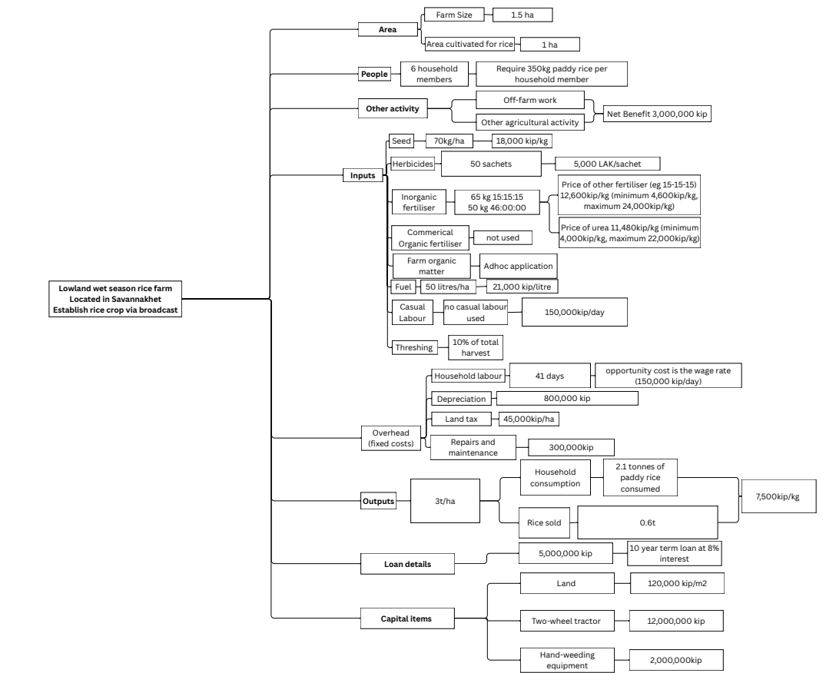
Alternative ways the representative farm system could be operated in the future

The representative farm could continue to operate as it currently does, applying low levels of inorganic fertiliser and using herbicide to control weeds. Alternatively, it could be modified to better align with the government's goals of increasing production and adopting more sustainable farming practices.

To define alternative production practices, the researchers considered options that could: increase production only; reduce reliance on inorganic fertiliser only; or increase production and incorporate ‘sustainable’ farm activities into the system. (Table 1 summarises the key characteristics of each of these farm systems).

To define these systems, the researchers started with the current farm system (referred to as ‘Current Farm System’). This is a low-input farm system characterised by a robust data-collection process (the method for defining this system is explained in Rathnayake et al. 2026, and the variables and values of this farm system are outlined in Rathnayake et al. 2025).

The two farm systems that only increased production—‘Medium Input farm system’ and ‘High Input farm system’—were essentially the current farm system, with more fertiliser applied. The project reference group agreed on the most likely yields of these systems. The underlying assumption of these two systems is that the farmer has savings or access to credit and can afford to buy more fertiliser during the production season.

To examine how the farm system would perform without inorganic fertiliser and herbicide, it was assumed that the farm did not use inorganic fertiliser (and did not use another product to replace crop nutrition), and labour replaced herbicides to control weeds. This farm system, ‘No Input’, was modelled to explore what farmers would do today if restrictions were placed on the use of agrochemicals. The reference group agreed on the likely yields that would be achieved and additional labour days that would be needed.

The researchers also attempted to model the current farm system as an ‘organic’ or ‘agroecological’ system that would be less reliant on inorganic fertiliser, and would increase production above the levels achieved by the current low-input rice growing systems. However, to specify the details of such systems, it was found that very little data was available. The researchers interviewed farmers who had attempted to farm under the guidelines defined as ‘Good Agricultural Practice’, but the farmers provided few details about how their systems changed from their traditional methods. Researchers from CIRAD also had little data on how to operationalise systems defined as ‘agroecology’ on a farm. This revealed a gap in technical information on these alternative farm systems. To explore these alternative systems of growing rice, the research team devised and modelled two hypothetical systems representing a commercial organic farm system and a Good Agricultural Practice system. The results of these analyses are intended for research purposes only. They can help inform whether further research into these systems is worthwhile and what is needed to make them better than the current system. Additionally, these models show future researchers what technical information farm economists need to analyse farm systems.

Table 1. Key characteristics of each farm system evaluated

 | Key characteristics
Current farm  31-10-10 kg/ha  N-P₂O₂-K₂O | Continue to run the representative farm as a low-input farm system, as presented in Figure 1, which uses some inorganic fertiliser and some herbicide to control the weeds
Medium input farm  60-30-30 kg/ha  N-P₂O₂-K₂O | - Higher rice yield (as defined by the reference group)  - Increased amount of inorganic fertiliser  - All other inputs and outputs of the current farm and household system remain
High input farm  90-60-60 kg/ha  N-P₂O₂-K₂O | - Higher rice yield (as defined by the reference group)  - Increased amount of inorganic fertiliser  - All other inputs and outputs of the current farm and household system remain
No input | - No agrochemicals used (no inorganic fertilisers or herbicides).  - Labour was used to replace the use of herbicide to control weeds (as explained by the focus group participants)  - Lower yield  - All other inputs and outputs of the current farm and household system remain
Hypothetical organic | - This is a hypothetical farm system. Researchers have defined this system and, where possible, used data collected from field interviews and focus groups.  - Assumed that the amount of commercial organic fertiliser applied equated to 60:30:30 N:P:K  - to estimate the yield of this farm system, the optimal economic amount of nitrogen was calculated using the production function by Linquist and Sengxua (2001), assuming rice prices 30% higher and the cost of the hypothetical organic fertiliser 10% above the cost of urea. From informal discussions with farmers in Sangthong, we learnt there is approximately a 30% price premium, and farms need to keep detailed records to achieve organic certification  - Labour was used to replace the use of herbicide to control weeds  - Assumed extra days for labour related to this change  - Assumed a price premium for the product sold (also analysed this farm system without a price premium)  - All other inputs and outputs of the current farm and household system remain
Hypothetical GAP | - This is a hypothetical farm system. Researchers have defined this system and, where possible, used data collected from field interviews and focus groups.  - It was assumed that the current level of inorganic fertilizer was applied, being 31-10-10 kg/ha N-P2O2-K2O (Falconnier et al. 2023 argued that it is unlikely that green manure crops alone would meet the nutritional needs of the rice crop).  - Implement cover crops (green manure) DALaM (2024) found that integrating paddy rice cultivation, duck raising, and cover cropping significantly increased rice yields  - Yield of 4t/ha, achieving the government target.  - Labour was used to replace the use of herbicide to control weeds (as explained by the focus group participants), ducks could also help to control weeds (but cost of ducks has been excluded)  - Assumed extra days for labour related to this change  - Assumed a small price premium for the GAP/Sustainable Agricultural Framework product sold (based on our finding that GAP rice had a small price premium and assuming the product is differentiated and segregated in markets) (also analysed this farm system without a price premium)  - All other inputs and outputs of the current farm and household system remain the same as in the other systems.

Farm management economics

Farm management economic theory was the analytical framework used to evaluate the representative farm's performance. A key aspect of this form of analysis is recognising that a distinctive feature of smallholder agriculture is the interdependence between the household and the farm system and the business. Dillon and Hardaker (1980, p. 41) highlight the linkages between the farm business and the household and also emphasise the cash and non-cash components of this system.

‘The small farm household provides the labour for farm production. In return the household receives income in the forms of cash and items for direct consumption. As well as family labour, the farm uses goods and services from the rest of the economy which are paid for, usually in cash but sometimes in kind. Farm output is divided between production used for family subsistence, output sold to the rest of the economy and payments in kind. The household also uses goods and services from the rest of the economy which are normally paid for in cash. In some households there may be some off-farm employment for which remuneration in cash or in-kind will be received. For farms employing credit, cash loans may be received from time to time, or inputs may be supplied on credit. Interest must be repaid, either directly or by automatic deductions from receipts for produce sold.’

To answer the research question about the performance of the farm-household, a farm business and household budget model was developed. The work of Abbott and Makeham (1990), Makeham and Malcolm (1985), McConnell and Dillon (1997), and Dillon and Hardaker (1980) was used to create this farm and household budget model. This model was used to assess levels of, and changes in, profit, cash flow, wealth, food security, and risk for each alternative farm system. Each of these measures—profit, cash flow, wealth, food security, and risk—provides a decision-maker with different insights into a farm and household system. The following summarises each of these measures (for a more detailed description, see Malcolm et al., 2005).

- Profit measures efficiency, indicating how well farm resources—both capital and management—are utilised, as these could be employed elsewhere in the economy. Sometimes, a measure such as return to family labour is calculated, but, as McConnell and Dillon (1997) explain, this conflicts with the system view of the farm. ‘From a systems perspective, the essence of farm production is that management is applied to a complex set of factors (i.e., land, labour, and capital resources) which interrelate and interact with one another and with management to produce outputs. From such a perspective, evaluation of the farm system implies that the resources used should be assessed as a totality or unified whole, not as a set which can be broken down into separate categories of land, labour, capital, and management.”
- Cash is a measure of liquidity (for the business to survive over time, it requires making sufficient cash to pay the bills and service debts).
- Change in net worth measures a change in wealth (Increasing wealth gives a household choices and the ability to achieve their goals).
- Food supply indicates the likely balance between the supply of rice (and other farm-grown food consumed) and the demand for rice from households. This measure indicates whether the rice produced by the farm is sufficient to meet household needs.
- Risk – the volatility of profit, cash, wealth and food supply.

The budgetary approach involved integrating Makeham's 1970s concept 'annual household cash and food flow' with Dillon and McConnell's 1990s concept 'return to capital', along with Barry, Hopkin and Baker's 1980s finance ideas linking assets, debt, and growth in wealth with annual profit and net cash flow. This is not usually done in the developing-country farm systems literature, partly due to the challenges posed by the semi-subsistence, semi-opportunistic commercial nature of farm household activities.

The approach is summarised in Figure 2.

Figure 2. Budget approach

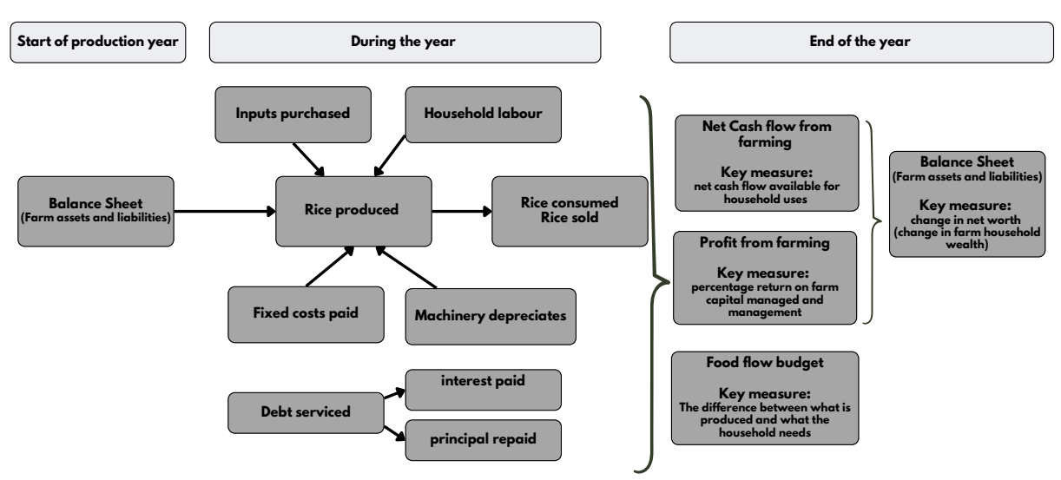

Risk was assessed using discrete scenarios of possible events and outcomes, defined in consultation with the project’s reference group. A simulation model was developed using @RISK, an Excel add-in. The parameters of the discrete scenarios are summarised in Table 2. The simulation model parameters are summarised in Table 3.

Parameters of each alternative way the representative farm system could be run

The variables that changed for each way the representative current farm could be operated, along with their values, are summarised in Table 2 (all other inputs and outputs of the representative farm remain unchanged). Furthermore, to examine what might happen if these values are too high or too low, two discrete scenarios have been defined.

Table 2. Deterministic scenarios

 | Most likely yields, prices and costs | Lower yields  most likely price and higher costs | Better yields slightly lower price of rice; slightly higher costs; hypothetical scenarios higher number of days of labour than most likely
Yield  * current: low input  * medium input  * high input  * No input  * Hypothetical organic  * Hypothetical GAP | 2.9 t/ha  3.5 t/ha  3.7 t/ha  1.4 t/ha  3.5 t/ha  4 t/ha | 2.5 t/ha  3 t/ha  3.2 t/ha  1 t/ha  3 t/ha  3 t/ha | 3.2 t/ha  3.7 t/ha  4 t/ha  2 t/ha  3.7 t/ha  4.2 t/ha
Price of paddy rice | 7,500 kip/kg | 7,500 kip/kg | 6,000 kip/kg
Price premium organic paddy rice | 27% | 10% | 27%
Price premium GAP rice | 5% | 5% | 5%
Fertiliser  * current: low input  * medium input  * high input  * No input  * Hypothetical organic  * Hypothetical GAP | Approximately 2 50kg bags of inorganic fertiliser  5 50kg bags of inorganic fertiliser  8.5 50kg bags of inorganic fertiliser  No inorganic fertiliser  5 50kg bags of commercial organic fertiliser  Approximately 2 50kg bags inorganic fertiliser
Days of household labour  * current: low input  * medium input  * high input  * No input  * Hypothetical organic  * Hypothetical GAP | 41  41  41  55  67  73 | 47  47  47  71  83  87 | 41  41  41  55  75  79
Wage rate (kip/day) | 150,000 kip/day | 160,000 kip/day | 160,000 kip/day
Inorganic fertiliser  * 15-15-15  * 46-00-00 | 12,600 kip/kg  11,480 kip/kg | 25,200 kip/kg  23,000 kip/kg | 16,000 kip/kg  15,100 kip/kg
Price premium commercial organic fertiliser | 10% | 10% | 10%
New hypothetical technology | 1,500,000 kip | 2,000,000 kip | 3,000,000 kip
Herbicide used on current farm system; medium input; and high input farm system | 250,000 kip/ha | 500,000 kip/ha | 500,000 kip/ha

Notes: for each of these scenarios, a no price premium scenario was explored for the hypothetical organic and hypothetical GAP scenarios; all scenarios are using the same amount of ad hoc organic farm material; a bag is 50kg in weight; the reference group supported the assumptions about most likely yields; prices and costs were defined based on data collected at interviews with key stakeholders (DAFO, PAFO, farmers, and researchers)

For the ‘No-input’, ‘Hypothetical Organic’, and ‘Hypothetical GAP’, labour was increased by 16 days for weeding (as assumed by Laing et al, 2015). In addition, the hypothetical organic, and the hypothetical GAP crop systems involved an extra 12 days to allow for costs that are not accounted for and for record keeping and other activities (it was found from the interviews and focus group discussions that there is a large amount of record keeping for organic and GAP rice farming, and for some farmers they stopped this practice because of the onerous requirements. To account for this, we have allowed extra days for labour and presumed that labour had an opportunity cost).

Also, during the farm interviews, it was noted that, as part of a Climate Smart Agriculture project, no synthetic fertiliser was used, and a mung bean crop was grown between rice crops to improve soil fertility. The recommended rate of sowing mung beans to improve soil fertility is 30-50 kg/ha, and the price of mung beans is 30,000kip/kg. For this hypothetical scenario, it was assumed that 50 kg/ha was used at a cost of 30,000 kip/kg.

To further explore risk, a simulation model of the operation of the alternative farm systems was built using the @RISK add-in in Excel. Triangular probability distributions for the paddy rice yield, price of paddy rice, fertiliser costs, and the costs of the cover crop in the ‘hypothetical GAP’ scenario (see Table 3 for details). The simulation model was also run both with and without a price premium applied to the two hypothetical scenarios—20 per cent for the commercial organic fertiliser farm system and 5 per cent for the GAP/agroecology farm system.

Table 3. Assumptions for the stochastic model

Variable | Type of probability distribution | Parameters
Variable | Type of probability distribution | Minimum | Most Likely | Maximum
Yield | Triangular | 0.2 t/ha for all scenarios | Current farm system: 2.9 t/ha  Medium Input: 3.5 t/ha  High input: 3.7 t/ha  No input: 1.4 t/ha  Hypothetical commercial organic: 3.5 t/ha  Hypothetical GAP: 4 t/ha | Current farm system: 4 t/ha  Medium input: 4.5 t/ha  High input: 4.6 t/ha  No input: 2 t/ha  Hypothetical commercial organic: 4.5 t/ha  Hypothetical GAP: 4.8 t/ha
Price | Triangular | 4,500 kip/kg | 7,500 kip/kg | 12,000 kip/kg
Fertiliser  15-15-15 * | Triangular | 4,600 kip/kg | 12,600 kip/kg | 25,200 kip/kg
Fertiliser  46-00-00* | Triangular | 4,000 kip/kg | 11,480 kip/kg | 23,000 kip/kg
Cost of cover crop | Uniform | Expect to cost between 1,500,000 and 3,000,000 (all values equally likely)
* Hypothetical commercial organic fertiliser is assumed to cost 10% more than inorganic fertiliser for all scenarios

Results of Deterministic Scenarios

Current farm system

The representative farm operating the current farm system is likely to perform well and meet the goals of the farm family of supplying enough rice for home consumption, and some profit, cash, and addition to wealth.

Under the most likely scenario, the representative farm operating the current system is expected to be profitable, earning a return on capital and management of around 6 per cent per annum. It will have cash available for household use, build wealth, and produce enough rice to meet household needs, with a surplus of about 500kg of rice likely to be sold. If the yield is lower than expected, more labour is required, and the cost of inorganic fertiliser is higher, then the profit would drop to a 3 per cent per annum return on capital and management. In this case, the farm household would need to support the rice farm business, with the annual net cash flow turning negative, indicating the household must provide the cash needed to cover farming costs. Conversely, if the yield exceeds expectations but rice prices are lower, and labour, inorganic fertiliser, and herbicide costs are higher, the farm is projected to earn a 4.3 per cent return on capital and management. Along with cash from off-farm work, this would generate sufficient cash for household use, improve the security of rice supply for household consumption, and allow around 780kg of rice to be sold (Table 4).

Current farm system with more fertiliser – ‘Medium input’ farm system and ‘High input’ farm system

In the modelled analysis, if the representative farm had the finances to use more inorganic fertiliser than it currently does, more rice would be grown. Under the most likely prices and costs, the representative farm is likely to be more profitable, generate greater cash flow, and increase the representative farmer's wealth if they used more fertiliser than the current two bags (Table 4). However, this assumes the farmer can buy more fertiliser throughout the year, which is unlikely.

Furthermore, if prices, costs, and yields turned out worse than expected, the representative farmer would be likely to be just as well off or better off using the current low-input farm system (only two bags of fertiliser) than applying higher levels of fertiliser (Table 4). This emphasises the increased risk of using more fertiliser; smallholder farmers need access to cash to buy the fertiliser, which, if obtained on credit, incurs higher costs (not explored in this study), and in some years, they could end up worse off economically compared to using lower amounts of fertiliser. This is especially true under the high-input farm system scenario.

Current farm system run with no fertiliser and no herbicides – ‘No input’ farm system

Across all the scenarios explored, the ‘No input’ (no fertiliser and no herbicide) farm system would be unlikely to produce enough rice for household consumption, unlikely to be profitable, unlikely to generate sufficient cash for the household’s needs or to add to wealth (Table 4).

These results show that using some inorganic fertiliser is better than not using any. This result confirms the findings from the focus group discussions, in which farmers explained that inorganic fertiliser is needed to produce sufficient rice for the farm household.

Hypothetical alternative rice production systems to the current rice production system

The two hypothetical alternative farm systems, designed to explore how a commercial organic farm system or GAP (or Agroecological) farm system might look, showed that if these systems could be afforded and achieved higher yields than the current farm system and if a price premium applied to the rice produced, then these hypothetical alternative systems could outperform the current farm system, under most likely prices and costs. This evidence supports further research being done into these alternative systems and the constraints to their adoption. Probably, future research ought to focus on designing such systems without relying on a price premium, as price premiums get competed away with time.

Importantly, these results highlight what these systems need to achieve to surpass the performance and safety of the current low-input farm system. Researchers exploring these systems need to demonstrate that they can consistently deliver high yields, that labour for farm activities and certification is not overly burdensome, that the new technology is low-cost, and that the financial constraints on using more inputs that currently prevail will not limit their adoption and implementation.

The results also suggest that understanding the volatility of these rice-growing systems is important. The researchers explored what would happen if yields were lower and costs higher, or if yields were higher but prices were lower, and costs were higher. The results of this analysis showed that these alternative hypothetical farm systems could be worse in several ways than the current farm system. Future research into such systems should examine their performance over several years to provide rice producers with information about how they perform and may perform in the future under different weather conditions, prices, and costs. Farmers know how their current system performs, and changing to one of these alternative ‘sustainable’ systems brings added uncertainty to a way of life that is at times already precarious.

Stochastic Results

The simulation modelling results displayed a pattern similar to that seen in the deterministic scenarios.

The ‘Current’ low-input farm system is likely to be profitable, is likely to require some cash from the household to support the rice farm business, and is likely, in more years than not, to produce sufficient rice for the household with surplus to sell.

If the representative farmer had the ability to buy more fertiliser, and thus could operate the ‘Medium Input’ or ‘High Input’ farm systems, then they could be rewarded for taking on more risk. The ‘Medium Input’ and ‘High input’ farm systems had higher returns but also higher volatility than the ‘Current’ low input farm system (Figure 4). The medium- and high-input farm systems were likely to produce the most rice and, consequently, the highest amount for sale (Figure 5).

If the representative farm did not use agrochemicals and did not change its farming system (the ‘no input’ farm system), it is unlikely to be profitable (Figure 3). Furthermore, under this farm system, the household would likely need to provide cash to support the rice farming business and rice would need to be purchased for home consumption (Figures 4 and 5).

Table 4. Profit, cash, wealth and rice, of the three discrete scenarios for each alternative farm system
Farm system | Scenarios | Profit (Return on capital and management) | Cash available for household uses | Wealth (kip) | Rice
Low input  (2 bags fertiliser) | Most likely yields and prices | 5.8% | 1,589,500 | 1,289,500 | Household rice requirement met and  510 kg sold
Low input  (2 bags fertiliser) | lower yields, most likely prices, very high costs | 3.0% | - 2,555,500 | - 2,855,500 | Household rice requirement met and  150 kg sold
Low input  (2 bags fertiliser) | higher yields, lower prices and higher costs | 4.3% | 1,792,500 | 1,492,500 | Household rice requirement met and  780 kg sold
Medium Input  (5 bags fertiliser) | Most likely yields and prices | 7.0% | 3,938,500 | 3,638,500 | Household rice requirement met and  1,400 kg sold
Medium Input  (5 bags fertiliser) | lower yields, most likely prices, very high costs | 3.0% | - 2,582,500 | - 2,882,500 | Household rice requirement met and  900 kg sold
Medium Input  (5 bags fertiliser) | higher yields, lower prices and higher costs | 4.6% | 2,332,500 | 2,032,500 | Household rice requirement met and  780 kg sold
High input  (8.5 bags fertiliser) | Most likely yields and prices | 6.3% | 2,538,900 | 2,238,900 | Household rice requirement met and  1,600 kg sold
High input  (8.5 bags fertiliser) | lower yields, most likely prices, very high costs | 0.8% | - 6,732,500 | - 7,032,500 | Household rice requirement met and  1,100 kg sold
High input  (8.5 bags fertiliser) | higher yields, lower prices and higher costs | 3.6% | 450,500 | 150,500 | Household rice requirement met and  1,900 kg sold
No input  (No fertiliser & no herbicide) | Most likely yields and prices | 0.4% | - 6,892,500.00 | - 7,192,500 | Insufficient rice produced to meet household needs; buy 700 kg rice
No input  (No fertiliser & no herbicide) | lower yields, most likely prices, very high costs | -2.5% | - 9,392,500.00 | - 9,692,500 | Insufficient rice produced to meet household needs; buy 1,100kg rice
No input  (No fertiliser & no herbicide) | higher yields, lower prices and higher costs | 1.1% | - 2,392,500.00 | - 2,692,500 | Insufficient rice produced to meet household needs; buy 100kg rice
Farm system | Scenarios | Profit (Return on capital and management) | Cash available for household uses | Wealth (kip) | Rice
Hypothetical Organic  5 bags commercial organic fertiliser  (no price premium) | Most likely yields and prices | 8.1%  (5.0%) | 5,753,350  (3,936,500) | 5,453,350  (3,636,500) | Household rice requirement met and  1,400 kg rice sold
 | lower yields, most likely prices, very high costs | 0.8%  (0.1%) | - 2,503,500  (- 2,334,500) | - 2,803,500  (- 2,634,500) | Household rice requirement met and  900 kg rice sold
 | higher yields, lower prices and higher costs | 5.1%  (2.5%) | 5,087,300  (3,407,500) | 4,787,300  (3,107,500) | Household rice requirement met and  1,600 kg rice sold
Hypothetical GAP  low amount of fertilizer & no herbicide  (no price premium) | Most likely yields and prices | 7.1%  (6.4%) | 8,075,000  (7,512,500) | 7,775,000  (7,212,500) | Household rice requirement met and  1,900 kg rice sold
 | lower yields, most likely prices, very high costs | 1.0%  (0.5%) | - 707,500  (- 932,500) | - 1,007,500  (-1,232,500) | Household rice requirement met and  900 kg rice sold
 | higher yields, lower prices and higher costs | 4.2%  (2.7%) | 6,739,500  (4,440,500) | 6,439,500 | Household rice requirement met and  2,100
  (4,140,500)

Stochastic results for the hypothetical alternative rice production systems

The modelled two alternative hypothetical farm systems were not as profitable as the low-input farm system, unless there was premium for the rice that was grown in this way. These hypothetical alternative systems were higher risk, reflecting in part how little is known about how these systems may actually perform over time. Such alternative systems, depending on the cost and benefits of the technology, could generate more cash, and if they achieve higher, more consistent yields, they could also increase rice food security (Figures 3 to 5). This shows that future research needs to identify and demonstrate the reliability of yields for such systems, the likely costs, and the associated risks.

Figure 3. Annual profit – with and without a price premium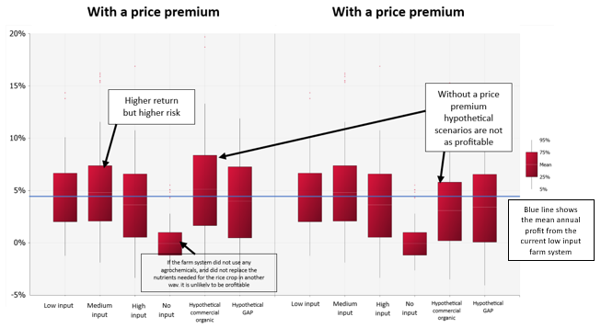
Figure 4. Annual cash flow available for household uses
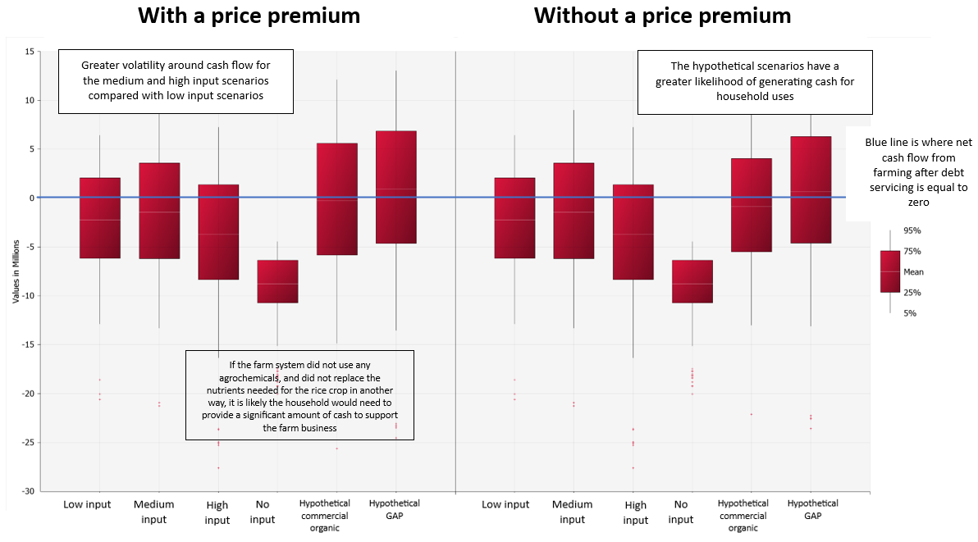
Figure 5. Annual food surplus/deficit
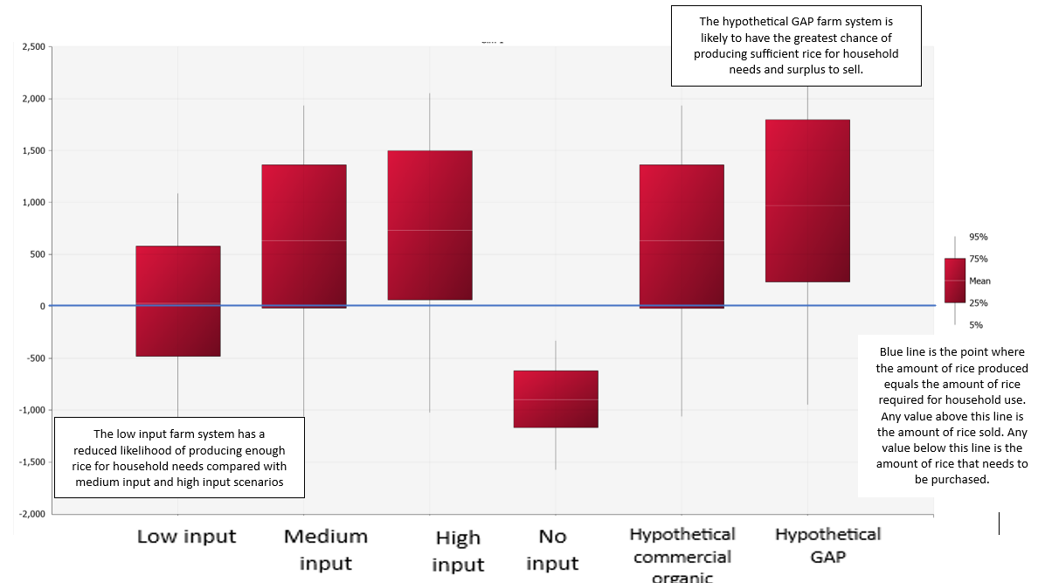

Rice yield is the most important factor affecting the results shown in Figures 3-5 (Table 5). It is also the variable that researchers have found most difficult to define. At the time of writing, there were no estimates of current production functions for rice response to different nutrient treatments. Long-term studies are required to understand how various farm systems respond in terms of yield. The yield estimates used here were based on stakeholder opinions.

Table 5. Contribution to variance in profit (ranking does not change if looking at cash or wealth)

 | Current | Medium input | High input | No input | Hypothetical Organic | Hypothetical GAP
Rice Yield | 72% | 73% | 72% | 71% | 74% | 74%
Price | 25% | 23% | 22% | 27% | 23% | 23%
Cost of fertiliser | less than 1% | 1% | 4% | - | Less than 1% | Less than 1%

Discussion

This research explored the question: ‘How do alternative rice production practices affect farming households in Lao PDR across economic, financial, risk, and food security aspects?’

The results indicate that the current, low-input farm system is likely the best choice for the representative farm business and household, given risk considerations and financial constraints. Unsurprisingly, this aligns with what lowland wet-season rice producers currently do (the majority of lowland wet-season rice is grown with 2 bags of fertiliser). This finding supports what is reported in the literature: actual use of inorganic fertiliser by rice farmers is well below the recommended rate (FAO, 2023; Sacklokham et al., 2020; Newby et al., 2020; Newby et al., 2013; Manivong, 2014; Hefele et al., 2010; and Linquist and Sengxua, 2001).
Haelefe et al. (2010) argued that the unfavourable input/output cost ratio and the limited response of rice yield to applied fertiliser are reasons why farmers find fertiliser use less profitable and apply it at rates below the recommended levels. Sacklokham et al. (2020), Newby et al. (2013, 2020), and Manivong (2014) also explained that farmers’ risk-averse behaviour, perceptions of fertile soils, inadequate knowledge of fertiliser application, and financial difficulties in purchasing fertiliser contribute to lower levels of fertiliser use.

The finding that the modelled representative rice production business is likely to perform best when run as the current farm system is important because it serves as the baseline scenario (the counterfactual against which other alternative farm systems are compared). Any alternative rice production system needs to surpass this status quo in meeting farmer’s goals and risk criteria if rice producers are to be motivated to change their current practices. An alternative system must be reliable, meaning it can reliably produce enough food for the household, with appealing prospects of surpluses to sell too. It must also be profitable; otherwise, farmers would prefer to use their resources and land for other activities. Additionally, it needs to generate sufficient cash to cover rice production costs rather than relying on accumulated household funds. Most importantly, the risk of such a change needs to be acceptable.

This research has shown that risk is a significant factor determining smallholder farmers interest in changing their systems. The representative case study farm could be more profitable, generate more cash, build greater wealth, and produce more food if the farmer had access to the finance needed to use five bags of inorganic fertiliser (roughly the recommended rate), and if they could accept the risk that when harvests fail they could be worse off than with the less productive less risky systems. Lowland wet-season rice producers are likely to know that applying more fertiliser could lead to higher yields, but financial constraints and the risk of poorer outcomes impact the decisions they make.

McConnell and Dillon (1997) observed that risk, especially for smallholder farmers, can make them cautious in their decision-making. They also argue that because farm-household survival depends on these decisions, they tend to weigh downside risks more heavily than upside risks. Binswanger and Sillers (1983) also found that risk aversion causes farmers to reject techniques that might be profitable. Schultz (1964) cautioned that small-holder farmers should not be viewed as irrational or foolish because of such behaviour; rather, they should be viewed as ‘fine-tuning entrepreneurs’ who are responding rationally to economic constraints and risks they are facing. Anderson (2002) noted that smallholder farmers become less risk-averse as their wealth increases.

If the representative rice-producing household stopped using agrochemicals, rice output would likely decline, along with profits, cash, wealth, and security of supply of rice for household consumption. The farm business would no longer be profitable, nor would it generate enough cash to cover costs and meet debt servicing obligations. This was also true at yields of 2 t/ha. The household would then need to financially support the farm, and rice would have to be purchased from outside the farm to meet household needs. This is a significant finding. It provides evidence that a ban on inorganic fertilisers, like the ban Sri Lanka imposed in 2021 (Nordhas and Shah, 2022), would have a major impact on farm businesses and household welfare.

Another way the rice farm business could be operated, aligning with the Lao PDR government's goals, is to adopt ‘sustainable’ rice production practices, albeit ill-defined practices and systems at this stage. Organic farming, agroecology, and good agricultural practices are promoted as ways for rice farmers to reduce their reliance on agrochemicals. The researchers found limited information available on the practical application of alternative farm methods that reduce rice producers' dependence on agrochemicals. To encourage practice change towards these ‘sustainable’ farm systems, evidence of ‘revealed advantage’ is crucial. In this work, the researchers, using hypothetical models, have shown that a hypothetical commercial organic and GAP farm system potentially could perform better than the current low-input farm system if higher yields were achieved and low-cost technology were used. Importantly, the farmers made it abundantly clear that their choice of rice-growing methods is affected by the opportunity cost of farm family labour and, relatedly, by the supply of family and non-family labour. Many farmers are attracted to higher off-farm wages, creating an incentive to minimise labour through direct seeding and herbicide-based weed control (Ayre et al., 2026). Alternative rice cultivation techniques that require more labour are unlikely to be viewed positively.

Areas of further research

This research has begun to provide insights into how alternative rice production practices affect farming households in Lao PDR across economic, financial, risk, and food security dimensions. However, further investigation is needed to strengthen the evidence base for the Lao PDR Government to make informed decisions about policies to transform the current rice production system while also balancing economic growth, environmental sustainability, and social equity goals. Such research ought to be undertaken within the framework of Schultz’s (1964) understanding about why smallholder farmers often appear resistant to change. This framework states that risk is a rational constraint (a failed attempt at new technology could result in starvation); farmers are rational economic agents who consider potential returns against risks; and that farmers are already efficient with what they have (reiterated in this research), so governments should focus on providing new, less risky technologies and investing in human capital through education.

The World Bank (2023), in their report Resilient and Low Carbon Agriculture in Lao PDR: The Priorities for a Green Transition, recommended that GAP should be expanded and regarded it as ‘a great foundation for resilient, low-carbon, environmentally friendly commercial production’. However, this research has found that farmers tried and abandoned this practice, preferring their current low input farm system. These findings suggest that the hoped-for increase in GAP adoption, as advocated by the World Bank, is unlikely to occur without (i) information and evidence of how this farm system is better (from an economic, financial, food security and risk perspective) than what they do today, and (ii) functioning credit systems for smallholder rice producers.

Future research is also needed to build on the work started in this project. The researchers know that a unique characteristic of smallholder farm businesses is their interdependence with households. Real farm case studies are required to identify and better understand the linkages between all the farming activities and the household.

Finally, future research could use the budget framework developed in this work to explore how a rice farm business/household could adapt its farm and household systems to manage with less labour in a hotter, more volatile climate, whilst reducing its reliance on agrochemicals. The questions that need answering include: how can a farm business/household be set up to manage with less labour, a more volatile climate, and reduced reliance on agrochemicals? How does the adoption of these alternative technologies change the farm business and household? What are the extra costs, extra benefits and risks associated with these changes?

Conclusion

There are two main messages from this work: (i) risk and access to finance are always significant factors in smallholder farmer decision-making; and (ii) more research, development, and extension are needed on alternative production systems for rice-growing small farmer households. The risk that an alternative rice production system with higher variable costs could lead to greater losses in some years influences financially constrained smallholder farmers' decision-making more if this outweighs the potential for higher rewards during good years. Change will be constrained. Smallholder farmers are likely to be more risk-averse than commercial-scale farmers because the consequences for them and their families are much more severe. Researchers exploring alternative technologies for farmers need to understand this risk aversion and limited access to finance and recognise that smallholder farmers are responding rationally to the risks and economic constraints they face. To promote changes in practice, more information and evidence are needed on the costs, benefits, and risks of alternative farm systems. Without such data, uncertainty about alternative farm systems will impede their adoption. The findings of this research suggest that, at present, there is little incentive for Lao rice farmers to adopt alternative rice production practices.

References

Anderson, J.R. (2002), Risk Management in Rural Development. Rural Strategy Background Paper #7, The World Bank, Washington, DC.

Abbott, J.C. & Makeham, J.P. (1990), Agricultural economics and marketing in the tropics. Intermediate Tropical Agriculture Series, Longman Scientific & Technical, Harlow, United Kingdom.

Ayre, Margaret, Height, Kaitlyn, Kousonsavath, Chitpasong, Fue Yang, Chialue, Lytoua, Mullen, John, Griffith, Garry, Rathnayake, Chinthani and Sinnett, Alexandria (2026), ‘Exploring the social implications of changing to low-input and organic rice production in Lao PDR’, Agricultural and Resource Economics and Agribusiness (AREA) Working Papers, 2026, Paper 1 (in press).

Binswanger, H.P. & Sillers, D.A. (1983), ‘Risk aversion and credit constraints in farmers decision-making: A reinterpretation’. The Journal of Development Studies, 5-21.

DALaM (2024), Increase Productivity in Paddy Rice Field: Integrating Cover Crop, Dry-Season Cropping, and Duck Raising. Practice Brief. Available at https://www.asset-project.org/news/increase-productivity-in-paddy-rice-field-integrating-cover-crop-dry-season-cropping-and-duck-raising

Dillon, J.L. & Hardaker, J.B. (1980), Farm management research for small farmer development. Issue 41 of Agricultural Services Bulletin, FAO, Rome.

Falconnier, G.N., Cardinael, R., Corbeels, M., Baudron, F., Chivenge, P., Couëdel, A., Ripoche, A., Affholder, F., Naudin, K., Benaillon, E., Rusinamhodzi, L., Leroux, L., Vanlauwe, B. & Giller, K. E. (2023), ‘The input reduction principle of agroecology is wrong when it comes to mineral fertilizer use in sub-Saharan Africa’. Outlook on Agriculture, 52(3), 311-326. https://doi.org/10.1177/00307270231199795 (Original work published 2023)

FAO (2023), Special report − 2022 FAO/WFP Crop and Food Security Assessment Mission (CFSAM) to the Lao People’s Democratic Republic. 7 March 2023.

FAO (2025), Special report − 2024 FAO/WFP Crop and Food Security Assessment Mission (CFSAM) to
the Lao People’s Democratic Republic April 2025. FAO, Rome.
Fukai, S., & Ouk, M. (2012), Increased productivity of rainfed lowland rice cropping systems of the Mekong region. Crop and Pasture Science, 63(10), 944-973.

Haefele, S.M., Sipaseuth, N., Phengsouvanna, V., Dounphady, K. and Vongsouthi, S. (2010), ‘Agro-economic evaluation of fertiliser recommendations for rainfed lowland rice’. Field Crops Research 119, 10.

Linquist, B. and Sengxua, P. (2001), Nutrient Management in Rainfed Lowland Rice in the Lao PDR. Los Banos, the Philippines: International Rice Research Institute. 88pp.

Linquist, B. and Sengxua, P. (2003), ‘Efficient and flexible management of nitrogen for rainfed lowland rice’. Nutrient Cycling in Agroecosystems 67, 9.

Kousonsavath, Chitpasong, Yang, Fue, Chialue, Lytoua, Mullen, John, Griffith, Garry, Rathnayake, Chinthani, Ayre, Margaret, Sinnett, Alexandria (2026), ‘Exploring domestic consumers rice buying behaviour and perceptions toward organic rice in Lao PDR.’ Agricultural and Resource Economics and Agribusiness (AREA) Working Papers, 2026, Paper 9 (in press).

Makeham, J.P. and Malcolm, L.R. (1985), The Economics of Tropical Farm Management. Cambridge University Press.

Malcolm, B., Makeham, J. and Wright, V. (2005), The Farming Game: Agricultural Management and Marketing. 2nd ed. Cambridge University Press.

Manivong, V. (2014), Agrarian transition in lowland southern Laos: implications for rural livelihoods. Unpublished PhD dissertation, The University of Queensland. Brisbane.

McConnell, D.J. & Dillon, J.L. (1997), Farm management for Asia: A systems approach (Vol. 13). FAO, Rome.

Mullis, E. (2020), Laos Rice Report Annual.
Available at https://apps.fas.usda.gov/newgainapi/api/Report/DownloadReportByFileName?fileName=Laos%20Rice%20Report%20Annual_Bangkok_Laos_06-08-2020.

Newby, J.C., Manivong, V. and Cramb, R.A. (2013), Intensification of lowland rice-based farming systems in Laos in the context of diversified rural livelihoods. Paper presented at the Australian Agricultural and Resource Economics Society Conference, Sydney.

Newby, J., Manivong, V. & Cramb, R. (2020), ‘Economic constraints to the intensification of rainfed lowland rice in Laos’. In R. Cramb (Ed.), White gold: The commercialisation of rice farming in the lower Mekong Basin (pp. 201-223). Springer Nature.

Norhaus, T., Shah, S. (2022), In Sri Lanka, organic farming went catastrophically wrong, Foreign Policy.

Rathnayake, Chinthani, Sinnett, Alexandria, Kousonsavath, Chitpasong, Fue Yang, Chialue, Lytoua, Ayer, Margaret, Mullen, John, Malcolm, Bill and Griffith, Garry (2025), ‘Characteristics of a representative wet-season lowland rice farm in Lao PDR’, Agricultural and Resource Economics and Agribusiness (AREA) Working Papers, 2025, Paper 19, 4 September.
Rathnayake, Chinthani, Sinnett, Alexandria, Malcolm, Bill, Ayer, Margaret, Kousonsavath, Chitpasong, Fue Yang, Chialue, Lytoua, Mullen, John and Griffith, Garry (2026), ‘An Approach to Defining the Characteristics of a Representative Farm’, Agricultural and Resource Economics and Agribusiness (AREA) Working Papers, 2026, Paper 2 (in press).

Schultz, T.W. (1964), Transforming Traditional Agriculture, Yale University Press, United Kingdom.

Schiller, J., Chanphengxay, M.B., Linquist, B. & Appa Rao, S. (2006), Rice in Laos. International Rice Research Institute, Los Banos.

Sacklokham, S., Chialue, L. and Yang, F. (2020), ‘Rainfed and Irrigated Rice Farming on the Savannakhet Plain’, In R. Cramb (ed) White Gold: The Commercialisation of Rice Farming in the Lower Mekong Basin, Palgrave Macmillan, Singapore, pp.151-168

Sinnett, A., Rathnayake, C., Kousonsavath, C., Yang, F., Chialue, L., Ayre, M., Griffith, G., Malcolm, B. & Mullen, J. (2024), ‘Current Issues in Rice Production in the Lao People’s Democratic Republic’. Australasian Agribusiness Perspectives, 27, 19.

Vongthilath, S. (2023), Policies Stocktaking to Support Agroecological Transition in Lao PDR.
Available at: https://ali-sea.org/wp-content/uploads/Topic-3_Policy_stocktaking_to_support_AE_SFS_in_Lao_SSWG_24_November_2023-SG_update.pptx.pdf

World Bank Group (2023), Resilient and Low Carbon Agriculture in Lao PDR: Priorities for a Green Transition. Agriculture and Food Global Practice, World Bank, Washington, DC.

The AREA Working Paper series reports work in progress prior to formal external review and includes draft research articles, reports to funding agencies, literature reviews, data collections and the like. Each paper is reviewed within the AREA group. Not for quotation without the consent of the authors.
The support of the Australian Centre for International Agricultural Research (ACIAR) in funding this investigation is gratefully acknowledged.
Note the measure of efficiency is return to capital and management. The researchers, following Makeham and Malcolm (1985) excluded operators allowance from the calculation of profit. Makeham and Malcolm (1985) argued that operator’s allowance is often an irrelevant concept for semi-subsistence farming and thus is excluded and rather the opportunity cost of the household members working on the farm is included.

