Agricultural and Resource Economics and Agribusiness (AREA) Working Papers
2026, Paper 17
------------------------------------------------------------------------------------------------------------------------- Issues in Lao PDR Rice Industry Value Chains

Chinthani Rathnayakeª, Alexandria Sinnettª, Garry Griffithª, John Mullen^{c}, Chitpasong Kousonsavath^{b}, Fue Yang^{b}, Lytoua Chialue^{b}, Bill Malcolmª and Margaret Ayersª

ª School of Agriculture, Food and Ecosystem Sciences, The University of Melbourne, Parkville.
^{b} Department of Rural Economics and Food Technology, Faculty of Agriculture, National University of Laos, Vientiane.
^{c} Private Consultant, Orange.
--------------------------------------------------------------------------------------------------------------------------
Abstract

A recently completed small ACIAR-funded project in Lao PDR examined the social and economic implications of alternative rice-growing technologies that might reduce environmental impacts while maintaining productivity. Two key findings from this project were first, that there is a disconnect between the Lao government’s aspirations for a shift towards sustainable rice production systems, and market realities, and second, that in any follow-up research, there should be a focus on describing and understanding the various types of rice value chains in Lao PDR and whether there are any critical issues that constrain or impede the effective operation of these value chains. The purpose of this paper is to outline some of the issues which need to be considered in such a study. The conclusion reached is that there is a need for first, a detailed mapping of rice value chain channels in Lao PDR, to reflect current economic conditions, second, a detailed performance assessment of these channels, using comprehensive assessment frameworks which cover not only economic efficiency criteria but also risk, responsiveness, and social, cultural and environmental considerations, and third, a careful consideration of potential improvement mechanisms which may help minimise the costs incurred by the constraints identified in the performance assessment, to identify those which are both feasible and valuable, given current economic conditions, market structures and the elements of the broader enabling environment.

Keywords: value chain, performance assessment, mapping, upgrading, rice industry, Lao PDR

Introduction

The rice industry in Lao PDR is under significant pressure to change (Cramb, 2020; Mullis, 2020; FAO, 2020, 2023). Farm businesses face a difficult economic environment, rising competition for labour, and common weather challenges, now worsened by climate change. The milling and marketing sector requires significant investment (ASEAN Briefing, 2025). As well, the Lao PDR government have proposed that the industry should increase rice production and exports while minimising environmental impacts (Secretariat for Formulation of National Green Growth Strategy of the Lao PDR, 2018; Ministry of Agriculture and Forestry, 2021; Sinnett et al., 2024).

The Australian Centre of International Agricultural Research (ACIAR) has a long-standing presence in Lao PDR. In 2024/25, ACIAR had 16 active projects with a total budget of some $6.4 million. In relation to the Lao PDR rice industry, the ACIAR country priority (ACIAR, 2026) is stated as:

- Improving cost-effective and sustainable rice-based farming systems with higher crop quality, through mechanisation, diversification and intensification in quarantine standards and value-adding for domestic and export markets.

ACIAR funded a Small Research Activity (SRA) over 2024-2025 to explore some of the issues mentioned above in the context of the country priority. In particular, the research team sought to provide evidence-based insights into the social and economic implications of alternative rice-growing technologies that might reduce environmental impacts while maintaining productivity.

The SRA has now been completed. In the final report back to ACIAR (Sinnett et al., 2026), the research team outlined the different types of social science, farm economics, market economics, and consumer research undertaken, and the results achieved. In summarising the implications arising from the SRA, the research team noted (p.7): ‘The overall conclusion of this work is that there is a disconnect between the Lao government’s aspirations and market realities. Future work is needed to address this disconnect. To promote practice change towards a farming system designed to navigate future challenges and achieve government aspirations, knowledge gaps need to be addressed within the farm system and across the entire value chain. Specifically, more work is needed to understand the knowledge broker system, how farm businesses and households can adapt to future challenges, whether such changes are worthwhile for a farm business to adopt, and the issues in the value chain that constrain or impede the effective operation of markets. This would provide evidence on how a transition to a more ‘sustainable’ farming system could be implemented across all actors in the value chain, whether it is likely to increase economic welfare, and whether government or market incentives are required to achieve adoption.’

Thus, in any follow-up research, it has been proposed that a key focus should be on describing and understanding the various types of rice value chains in Lao PDR and whether there are any critical issues that constrain or impede the effective operation of these value chains. The purpose of this paper is to outline the scope of such a study and some of the issues which need to be considered.

Background on the Lao PDR Rice Industry

To understand the issues arising in Lao PDR rice value chains, it is necessary to appreciate the broader context in which these value chains form and operate. Some of this information has already been included in previous documentation related to the SRA (for example, Sinnett et al., 2024). Other sources for this general information on the rice industry in Lao PDR are the books by Schiller et al. (2006), Cramb (2020) and Sakata (2022), the PhD thesis by Manivong (2014), Cosslett and Cosslett (2018) and various reports from international institutions such as the Asian Development Bank (ADB) (Bestari et al., 2006), the Food and Agriculture Organisation (FAO) (FAO, 2020,2023), the International Food Policy Research Institute (IFPRI) (Chen et al., 2013), the International Rice Research Institute (IRRI) and the World Bank (2012, 2018, 2023, 2026). Many of these reports are listed in the references cited at the end of this paper.

Geographically, Lao PDR is a landlocked country located in Southeast Asia. It borders five neighbouring countries: China to the north, Myanmar to the northwest, Thailand to the west, Cambodia to the south, and Vietnam to the east. The Mekong River flows along most of Laos's western border.

Based on World Bank and Organisation for Economic Cooperation and Development (OECD) measures, Lao PDR is regarded as a ‘developing economy in transition’, currently slated for official graduation from Least Developed Country (LDC) status. However, in recent years, the Lao PDR economy has faced significant challenges. Before 2020, annual GDP growth exceeded 5 per cent, but by 2022, it had slowed to 2.7 per cent. The Lao currency (the kip) has depreciated considerably over recent years (by 43 per cent against the US dollar up to April 2023) and has contributed to inflation of around 40 per cent per annum, partly caused by increasing prices of imported fuel and fertiliser. Real household incomes have declined, and public debt reached 110 per cent of GDP in 2022 (World Bank, 2023). Thus, there are significant macroeconomic pressures affecting the entire Lao PDR economy, which flow into the rice sector.

Lao PDR has a relatively large land area but is sparsely populated. In December 2023, the population of Laos was 7.682 million, almost two-thirds of whom lived in rural areas (FAO, 2023). The population of the capital city Vientiane is less than 700,000, and there are a large number of smaller cities scattered through the country in the range of 25,000-75,000 people. Agriculture is key to the rural economy in Lao. Agriculture contributes 16 per cent of the country’s GDP, with 70 per cent of the employed population working in agriculture (World Bank, 2026). The agricultural sector is characterised by small family farms (1-2 ha), often fragmented into even smaller plots.

Rice is the main crop grown in Lao PDR, covering about 60 per cent of total arable land. In 2024, rice production reached approximately 3.5 million tonnes (ASEAN Briefing, 2025). It is also the staple food for almost 80 per cent of the rural population in Lao PDR, whose daily calorie and protein intake mainly comes from rice. According to the World Bank (2012), Lao PDR’s per capita rice consumption is among the highest in the world at around 206 kg (milled) per year. Since most Lao prefer to eat glutinous (sticky) rice, this type of rice accounts for around 90 per cent of production.

Most rice in Lao is cultivated during the wet season (May to November) in the lowland regions. Farmers utilise both organic farm materials and inorganic fertiliser in their rice cultivation because soil fertility remains a major constraint to rice production in Lao (Manivong, 2014). Over the past 30 years, rice production, harvested area, and yields have all increased (Figure 1).

Figure 1. Lao People’s Democratic Republic – total rice production, area and yield, 1982–2023

Source: FAO, 2023

Yield improvements have been driven by the increased use of improved seed varieties, mechanisation, and inorganic fertilisers (FAO, 2023), and more recently chemical weedicides, often as a response to the declining availability and rapidly increasing cost of rural labour.

Newby et al. (2020) found that rainfed production systems mostly remain subsistence-focused, using low-input, labour-efficient, and more sustainable methods rather than commercial, high-input, high-yield systems. Growing sufficient rice for household consumption is the primary objective for these producers. See also Newby et al. (2013).

The more commercial production systems, especially those in the central and south geographic regions, produce to supply to local urban and export markets as well as their own households. The neighbouring, more developed countries of Thailand and Vietnam are major rice producers and leading exporters of non-glutinous rice, so Lao PDR cannot compete in these markets, but because Lao produces mostly glutinous rice, some of that (less than 10 per cent of production) makes its way to export markets, through either formal channels or informal border trading.

To summarise, as with the country at large, the rice industry in Lao PDR faces substantial pressures to change. This stems from sharply rising costs of key inputs, such as fertiliser and labour, and the effects of climate change (Sinnett et al., 2024). As well, additional pressures arise from government policies on environmental sustainability and food security (Sinnett et al., 2024).

The policy goals for the Lao rice industry are a mix of social, economic and environmental goals. The government of Lao PDR seeks to: improve smallholder farmers’ incomes, reduce poverty, and encourage young farmers to continue farming; increase rice productivity, increase the quantity of rice exported; but also to increase agricultural production ‘sustainably’ through programs such as agroecology, Good Agricultural Practice and organic agriculture. The aims of the latest sustainable growth policy are (i) to limit pollution, (ii) to reduce waste and greenhouse gas emissions, and (iii) to ensure agriculture is conducted in ways that are ‘sustainable’. One pillar of the Lao PDR Government’s ‘Green and Sustainable Agriculture Framework’ (Ministry of Agriculture and Forestry, 2021, p.15) is expressed as: ‘natural and sustainable nutrient inputs – minimising dependence on external sources for crop nutrients and promoting the production of biofertilizers via nitrogen-rich crops or on-farm recycling of crop residues and livestock waste.’ (p.15).

To achieve these government goals, rice production systems need to change. Such changes to rice production systems will bring both benefits and costs, with effects that extend beyond the farm (Sinnett et al., 2026).

However, the combination of natural constraints (being landlocked, mainly mountainous terrain), technological limitations, a lack of farm labour and systemic inefficiencies in processing and marketing, all reduce the incentives for change, and this is exacerbated by a policy environment that is still evolving to meet the demands of a more commercialised market. This is the context in which any further research project has to be designed.

Rice Value Chains in Lao PDR

There have been a number of previous studies of rice value chains in Lao PDR. Some of these include Wong et al. (2013), The Ahn et al. (2020), IFPRI (2013), World Food Programme (2023) and World Bank (2023). Most of these have been primarily descriptive, with few attempts at formally evaluating the performance of these chains using modern value chain principles and methods.

One of the more detailed descriptions of the Lao PDR rice value chain is from Wong (2013) which is a section in the larger Chen et al. (2013) study. This is shown in Figure 2 (their Figure 2.9).

Figure 2. Rice value chain in Lao PDR, 2011

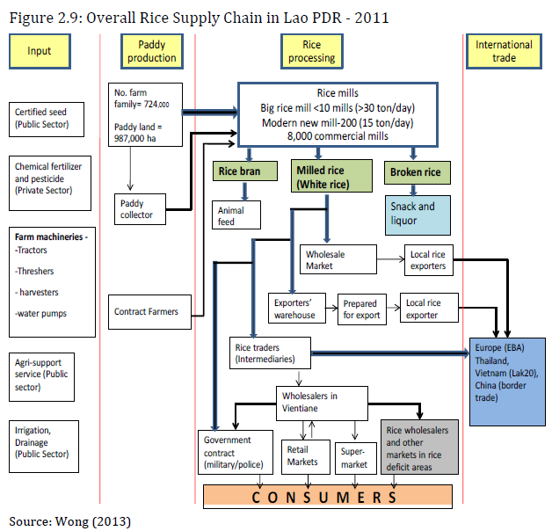

Figure 3. Private millers’ and government rice value chains in Lao PDR

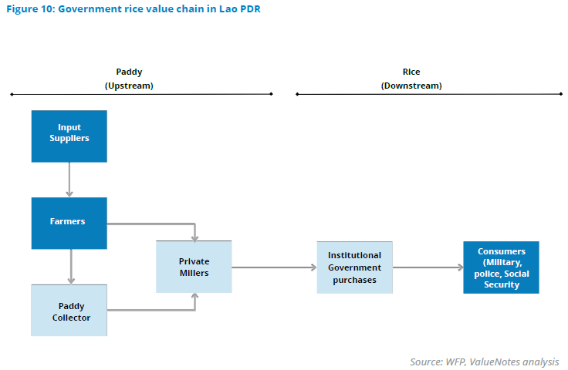
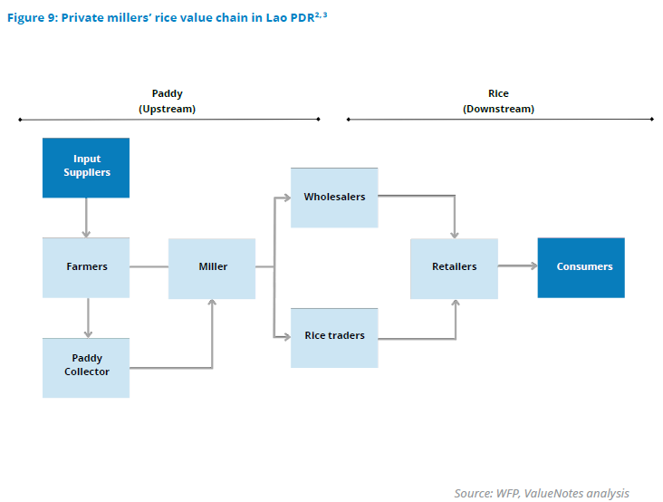

An alternate way of representing the Lao PDR rice value chain comes from the World Bank (2023), which presents a stylised mapping of the two broad types of value chains, namely the private millers’ value chain and the government value chain of rice, to cater to different consumer groups, general rice consumers and consumers of food programs. This is shown in Figure 3 (their Figures 9 and 10).

The Anh et al. (2020) provide an updated value chain map of their earlier 2013 study of the rice value chain in the Vietnamese Mekong Delta (their Figure 18.2). This is shown in Figure 4.

Figure 4. Rice value chain in the Mekong Delta

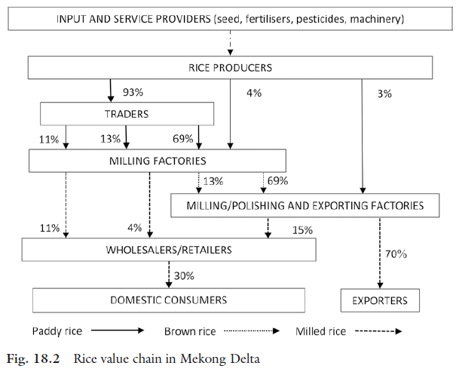

Finally, Phouyyavong (2016) provides a detailed description of a regional rice value chain, specifically that for Khammouane Province (Figure 5). An earlier study of the same province was done by Raumsit et al. (2013).
Other regional value chain studies have been completed. For example, Bruckert et al. (2025) report research on the value chain of the Khao Kai Noi variety of rice in Xieng Khouang province, just to the north of Vientiane province. This variety is ‘highly prized for its aromatic character and excellent quality’ and is increasing grown using ‘agroecological’ principles. It has had geographical indication (GI) certification since 2018 and around 15 per cent of output is either exported or sold to the major wet markets in Vientiane. This work reports an attempt to capture consumer willingness to pay for some of these niche varieties of rice produced in Lao PDR. Onphanhdala (2022) reports a value chain study of the northern geographic region of Lao PDR.

The different examples shown above provide only partial information on the components of the rice value chain in Lao PDR or in the broader regional market. The various actors in the value chain and how they are linked together are often well described, and the rice product flows are usually well defined. However, actual quantities moving through the various channels are rarely provided, information and value flows are absent, none of the examples show prices at the different market levels, none provide detailed information which reflects current market structures and economic conditions, and none of the studies take the next step and analyse the performance of the chains.

A new, comprehensive investigation of Lao PDR rice value chains is required if credible evidence-based advice is to be provided to government about the feasibility and the costs and benefits of transitioning to a more sustainable rice industry. That requires in the first instance knowledge of the general set of issues to be considered and examined.

Figure 5. Rice value chain structure in Khammouane Province
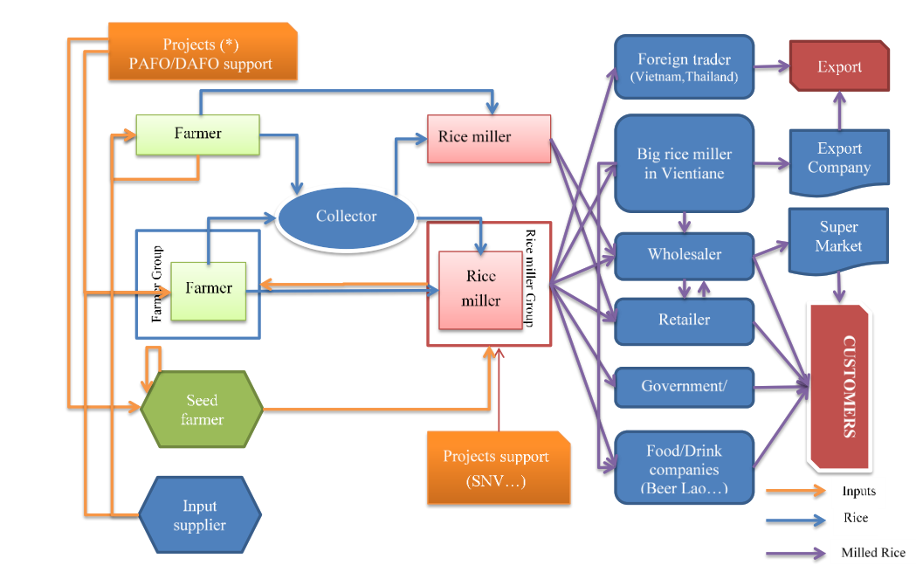Source: Phouyyavong (2016)

Issues in Lao PDR Rice Value Chains

Rice production at the farm level

Sinnett et al. (2024) summarised current issues in rice production in Lao PDR and highlighted challenges of changing government policies, the broad economic situation, rice prices, extreme weather events, climate change, labour issues, input costs and soil infertility, etc, affecting the farm level.

Reliance on agrochemicals: A major portion of rice is produced using conventional methods, which involve the use of agrochemicals to supplement plant nutrients and manage pests and diseases. Other types of rice, such as organic rice and GAP rice, are also produced in smaller quantities to cater to specific consumer markets, facilitated by private rice trading companies. However, the current focus of the Lao government is on promoting the production of rice using natural and sustainable inputs and farming systems to reach global markets through exports. It is questionable whether the value chain is organised enough to accommodate these government policy directives.

Organic rice exports from Lao are restricted to a small quantity produced under contract farming (Manivong and Cramb, 2020). This was observed during informal visits to rice farmers, that the quantity of organic rice to produce is decided based on a quota provided by traders.

GAP rice was produced in some parts of rice-producing regions under a contract farming arrangement with a private company; however, findings from our field data collection revealed that the GAP rice program no longer exists. Additionally, farmers find it less profitable to produce GAP rice, given the price premium for GAP rice is not sufficient compared to the extra labour used for recordkeeping that demand extra labour.

Reliance on rainfed agriculture: A significant majority of rice cultivation in Laos is rainfed, making it highly vulnerable to climate variability. This leads to large fluctuations in annual production due to frequent droughts and floods, which directly impact farmer income and national food security.

Low productivity and yields: Compared to neighbouring countries like Vietnam and Thailand, Laos has lower rice yields. This is attributed to several factors, including poor soil fertility, limited access to and inefficient use of modern inputs like quality seeds and fertilisers, and a reliance on labour-intensive conventional farming practices.

Unsustainable farming practices: The use of nitrogen-based fertilisers and traditional ‘slash-and-burn’ cultivation in the uplands contributes to environmental degradation, including soil acidification, erosion, and water pollution. This creates a long-term sustainability issue for the sector.

Limited access to technology and credit: Farmers often lack the capital to invest in modern farming equipment, improved seed varieties, and irrigation systems. This hinders their ability to increase productivity and transition to more commercialised farming. Farmers often have to accept loans from traders to purchase fertiliser and weedicide and are then locked in to selling to those traders to repay the debt.

Input supply/ production supplies

Fertiliser and other chemicals: Inorganic fertiliser is widely used in rice production in Lao PDR but producers often do not have access to the fertiliser mix that is best for their farm soil fertility. Especially in the more remote areas, farmers have to take what the traders have available, which may be of low nutrient quality. Actual fertiliser use bears little resemblance to government recommended rates.

New rice varieties are being developed by government institutions that meet certain issues in production, but such seeds are expensive and not widely available. Farmers often use rice from last year’s harvest as the seed for this year’s sowing.

Some farmers have a preference to produce rice with organic inputs, such as commercial organic fertilisers, other organic nutrient supplements, organic pesticide and fungicide products, but there are no regulatory mechanisms on either the supply channels and or the quality of these products. Key informants pointed out during interviews that organic fertiliser factories are being built in Savannakhet to commercially produce organic fertiliser; however, farmers complained about not having access to locally produced commercial organic fertiliser and they were also unsure of the nutrient quality.

In addition, there are only small and irregular market premiums for rice products made organically, using good agricultural practices or agroecological concepts, without a trader involved to facilitate the market. Furthermore, even if non-conventional rice production is facilitated by a trader, farmers would not get better farmgate prices for their produce, as pointed out by farmers.

Machinery services – land preparation/harvesting/threshing: Satisfactory use of machinery at the farm level in rice production. However, machinery use in small plots of land is challenging.

Production and market infrastructure: A major challenge faced by the farm sector is the lack of proper infrastructure for irrigation, transport and storage facilities. Irrigation is crucial during the dry season and periods of irregular rainfall, which are becoming more common, and inadequate or neglected irrigation structures worsen the problem of providing sufficient water on time for crops. While, investments in irrigation had significantly supported the expansion of irrigated rice production in the past, investments have not been made in new schemes, and the already existing infrastructure has not been properly maintained, worsening their condition.

The country's mountainous terrain and lack of adequate road networks, especially in rural areas, make it difficult and costly to transport paddy from farms to mills and then to markets. Poorly maintained road networks cause delays in farm operations and lead to significant post-harvest losses during the transport of produce from farms to storage or processing facilities. Farmers lack on farm drying and storage facilities which also contribute to post-harvest losses and hence higher consumer prices and reduced farmer profits.

Agricultural extension and training: Lao PDR has a well-organised administrative structure nationwide at the provincial and district levels to work closely with the agricultural sector, including the rice sector. Government institutions such as the Ministry of Agriculture and Forestry, Provincial Agriculture and Forestry Office, District Agriculture and Forestry Office, DALAM, etc, operate closely with rice farmers and stakeholders to provide extension and training services.

Additionally, there are numerous international organisations such as IRRI, IFPRI, FAO, etc and research institutions and funding agencies such as CGIAR, ACIAR, etc, that operate in Lao PDR to conduct projects and programs in collaboration with local institutions and universities. Hence, farmers also receive extension and training services through such arrangements on new knowledge, technologies, and practices in rice production.

However, there are questions about whether farmers will continue with these practices or adopt new applications in rice production, even after the project period, with the lack of monitoring by local institutions. Farmers also complained that they do not receive satisfactory service from extension officers and therefore rely on traders of fertiliser, agrochemicals, etc, for knowledge on the application of such products, and new technologies in rice production.

Rice processing

Fragmented and outdated milling sector: The rice milling sector in Laos is highly fragmented, dominated by a large number of small-scale, district-based mills that use old technology. These mills often have low efficiency and produce lower-quality rice with low head-rice recovery rates (the percentage of whole kernels after milling). The World Bank (2023) pointed out that the milling process of rice is mostly done manually. This might increase the cost of production. Large mills are few in number and located across a few major cities (FAO, 2012).

Lack of quality control: The overall market system lacks incentives for maintaining product quality. Issues like mixing different rice varieties and poor post-harvest handling by farmers result in a low-quality final product. This makes it difficult for Lao rice to compete with higher-quality imports in domestic urban markets and with exports from other countries.

Rice trading (domestic and export)

The World Bank (2023) notes that there is a limitation on the commercialisation of rice because rice is mostly purchased by urban domestic consumers, while the production takes place mostly in rural regions, mainly for the own consumption of households. Also, the World Bank (2023) highlighted that the majority of the population prefers small grocery stores or markets where they can bargain because of low disposable incomes. Packaged rice is mostly sold in urban areas of the country, but it is estimated that only 20-30 per cent of the urban population buys packaged rice from supermarkets (although this seems to be changing quite rapidly – see Kousonsavath et al., 2026b,c). Retailers are hesitant to stock new products without existing demand in the market.

One major issue is the lack of properly regulated product description schemes, especially for credence goods such as organic certification. Characteristics of rice which are easily distinguished, such as colour and proportion of broken rice (grade) are valued appropriately by traders and consumers (Kousonsavath et al., 2026a), but characteristics of rice which are not easily distinguished and rely on certification, are not valued as expected. For example, Kousonsavath et al. (2026b,c) have shown that there was no market premium for organic rice on average over the period December 2024 to December 2025, and this was put down largely to consumer slack of trust in the branding of organic rice. Much is sold with an organic claim, but without an organic certification logo. Other recent studies into Lao consumer valuations of rice characteristics include Bouphakaly (2017) and Chialue et al. (2018).

These factors, in addition to the value chain issues raised earlier, result in a lack of value chain integration. There is often poor coordination between different actors in the value chain—farmers, millers, and traders. This lack of communication and trust can lead to inefficient practices and a failure to meet market demands. For example, farmers may be cheated by unscrupulous traders using inaccurate scales.

The combined effect is suppressed farm-gate prices. Despite high retail prices for consumers in urban areas, farmers often receive low prices for their paddy. This is due to the inefficiencies and high costs along the value chain, and the lack of value chain coordination mechanisms, rather than low demand. The increasingly high cost of production due to the macroeconomic conditions in Lao PDR mean that many rice farmers are growing rice just for household consumption rather than generating a surplus for sale, and they are actively examining other enterprises on their small blocks. These outcomes are shown in Figure 1 – in recent years area planted has fallen, yields have stabilised and total recorded output has fallen.

In relation to export markets for rice, while the government has made efforts to improve trade, cumbersome regulations, internal roadblocks, and the high cost of transportation limit the export potential of Lao rice. One factor is that glutinous rice is produced in the largest quantities for consumption, but it limits the export potential to international markets as the larger export markets prefer non-glutinous rice varieties. The factors which limit the formal export of rice also lead to an undocumented but anecdotally large informal cross border trade with neighbouring countries.

Chen et al. (2013) summarised their review of Lao PDR rice value chains as follows (p.44):

“Overall, we found that in the case of Lao PDR, the mills and processing plants are increasingly acting as the fulcrum linking/driving upstream and downstream development/transformation of the supply chain. Upstream through contract farming, the provision of good/certified seeds, fertilizers and mechanization services and downstream to modern retailers like supermarkets and minimarkets with branded packaged rice. Some are also involved in exports both formal and informal (more so) of mainly glutinous rice and in some cases also paddy. There are also imports of mainly non-glutinous and aromatic rice for major cities as well as industrial use and snacks and also some hybrid rice from China to Northern Lao.

Unresolved Issues

There are a number of issues arising from within the enabling environment of these value chains that will constrain future development potential.

First, to restate information presented earlier, the stated policy goals for the Lao rice industry are a mix of social, economic and environmental themes. To paraphrase, the government of Lao PDR seeks to: improve smallholder farmers’ incomes, reduce poverty, and encourage young farmers to continue farming; increase rice productivity and increase the quantity of rice exported; but also to increase agricultural production ‘sustainably’ through programs such as agroecology, Good Agricultural Practice and organic agriculture.

Many of these policy goals are in direct conflict. For example, while the government's focus on rice self-sufficiency has been successful (see Table 1), the policy mix is not always optimal for fostering a competitive and profitable commercial sector. There is a need for policies that facilitate trade, encourage private investment in modern milling, and improve the efficiency of public services like agricultural extension. The acceptance of a framework like that proposed in Mullen et al. (2023) would at least allow the trade-offs to be recognised and minimised.

In particular, recent policy announcements discouraging the use of inorganic fertilisers and agrochemicals and encouraging the use of sustainable inputs and agroecological concepts (Secretariat for Formulation of National Green Growth Strategy of the Lao PDR, 2018; Ministry of Agriculture and Forestry, 2021; Sinnett et al., 2024), have been made without any research-based evidence that rice productivity can be maintained and without the provision of substitute, organic inputs with certified nutrient content. There is insufficient information available to farmers on the inclusion of agroecology in rice production and the benefits and costs associated with rice production under such farming systems.

Second, Lao PDR rice prices have not been routinely and consistently reported in recent years in global databases such as FAOSTATS, so there remains much uncertainty about price trends for Lao paddy rice (Sinnett et al., 2024). Discussions with Lao rice producers and scientists suggest that in 2024 the price of paddy rice at the farm gate was about 7,500 kip/ kg (ranging from 5,000 to 10,000 kip/kg), a marked increase in recent years. For example, Mullen et al. (2019) used a price of 2,500 kip/kg. There was a significant depreciation of the Lao kip in 2023 which lowered the price of Lao rice on the world market making exports more attractive and hence, even though the volume of exports from Lao PDR is small, this may be one factor driving the increase in the price of paddy rice.

Third, in terms of background information that helps explain market reactions, there are no recent published estimates of the elasticities of demand and supply for Lao rice at the farm gate. Furuya et al. (2020, p.30) report an aggregate elasticity of demand of -0.419, based on the real retail price of non-glutinous rice, as well as a large number of yield and area supply functions for rice. However, these estimates were based on a data set commencing in 1980 which covers many years of highly restrictive regulation of the rice market in Lao PDR. Mullen et al. (2019) assumed that the elasticity of demand is -0.5 and the elasticity of supply is 1.5. These values would need confirming during any detailed value chain investigation to reflect recent market conditions.

Conclusions

A large number of issues were identified above as constraining the development of rice value chains in Lao PDR. These range from on-farm issues related to rice drying, storage and quality through infrastructure issues such as inadequate transport networks and options, through to small scale and outdated communal rice milling facilities. There are also issues in the enabling environment which constrain the full expression of consumer preferences such as poor information flows and poor regulation of product certification schemes. For example, consumers are not willing to pay more for organic and other credence attributes if they do not trust the brands to correctly specify the qualities they value (Kousonsavath et al., 2026a,b,c). Such issues are common in many developing country agricultural industries.

Considering the context and the issues outlined above, to be able to generate credible information and recommendations as a basis for industry and government decisions which meet the requirements of Lao PDR society, the conclusions that can be drawn from this review are as follows:

- First, there is a need for a detailed mapping of rice value chain channels in Lao PDR, to reflect current economic conditions and economic structures. These channels should include different types of rice, different production regions and different market options. Information provided should include actual quantities of product flowing through the various channels and the values obtained at the different transaction points, as well as the key elements of the enabling environment which either constrain or promote value chain development.
- Next, there is a need for a detailed performance assessment of these channels, using comprehensive assessment frameworks such as Aramyan et al. (2007) which cover not only economic efficiency criteria but also risk, responsiveness, and social, cultural and environmental considerations. Sustainability issues should be foremost, using perhaps the FAO (2014) general framework plus specific methods such as used in the Bonney et al. (2012) approach to thinking about the trade-off between effectiveness and value (see also Fleming et al. 2020 for a review of this literature).
- Finally, there is a need for careful consideration of those potential value chain improvement mechanisms (often called ‘upgrading options’) which may help minimise the costs incurred by the constraints identified in the performance assessment. Options should include individual business actions, whole-of-chain actions and whole-of-government actions. Such consideration should identify those which are feasible and valuable, given current economic conditions, market structures and the elements of the broader enabling environment, as well as who should fund them (Mounter et al., 2019). Such considerations could be done using processes described in the various value chain toolkits such as Valuelinks (Springer-Heinze, 2007) and M4P (Department for International Development, 2008) and ranked or evaluated using methods such as social benefit cost analysis (Malcolm et al., 2026).

Any follow-up project should be designed along these lines so as to generate credible information and recommendations as a basis for industry and government decisions which meet the requirements of Lao PDR society.

References

ASEAN Briefing (2025), ‘Investment opportunities in the Lao agricultural sector’, April 16. https://www.aseanbriefing.com/news/investment-opportunities-in-the-lao-agriculture-sector/

ACIAR (2026), Laos. https://www.aciar.gov.au/east-and-south-east-asia/lao-pdr

Aramyan, L.H. et al. (2007), ‘Performance measurement in agri‐food supply chains: a case study, Supply Chain Management: An International Journal, 12(4), 304-315. doi:10.1108/13598540710759826

Bestari, Njoman George, Shrestha, Samjhana and Mongcopa, Caren Joy (2006), Lao PDR: An Evaluation Synthesis on Rice - A Case Study from the 2005 Sector Assistance Program Evaluation for the Agriculture and Natural Resources Sector in the Lao People’s Democratic Republic, September, Operations Evaluation Department, Asian Development Bank.

Bonney, L., Clark, R., Collins, R., Dent, B. and Fearne, A. (2012), Sustainable Value Chain Analysis: An Agri-Food Chain Diagnostic. Available at:
http://www.pir.sa.gov.au/__data/assets/pdf_file/0017/120455/Final_version__SVCA_Methodology_guidePIMC_IDC_approved.pdf

Bouphakaly, Oula (2017), ‘The consumer’s evaluation of rice attributes in Laos: an application of the hedonic approach’, Journal of Agriculture Science, Technology and Development 2(2), 284-292.

Bruckert, Michaël, Chialue, Lythoua, Yang, Fue, Kousonsavath, Chitpasong and Guéneau, Stéphane (2025), ‘The transformations of rice production and market: the case of Khao Kai Noi rice in Xieng Khouang Province’, invited paper presented at the 10th National and International Agricultural Science, Technology and Development Conference, ASTDC2025, Vientiane, Lao PDR, 10 December.

Chialue, Lytoua, Moustier, Paule and Manivong, Phengkhouane (2018), ‘Laotian consumer perceptions of rice quality. Insights from a conjoint analysis’, Systèmes alimentaires / Food Systems, 3, 61-87.

Chen, Kevin Z., Reardon, Thomas, Wang, Jianying, Wong, Larry and Dao, Anh T. (2013), The Final Report, Component 2: Delivering Agri-food Value Chain, Rice Value Chains in China, India, Lao PDR, and Viet Nam: 2012 Survey Results, Interpretations, and Implications for Policy and Investment, Submitted by The International Food Policy Research Institute, September 15, 2013.

Cosslett, T.L. and Cosslett, P.D. (2018), ‘Rice cultivation, production, and consumption in mainland Southeast Asian countries: Cambodia, Laos, Thailand, and Vietnam’, In: Sustainable Development of Rice and Water Resources in Mainland Southeast Asia and Mekong River Basin. Springer, Singapore. https://doi.org/10.1007/978-981-10-5613-0_3

Cramb, R. (2020), White Gold: The Commercialisation of Rice Farming in the Lower Mekong Basin, Palgrave Macmillan, Singapore.

Department for International Development (2008), Making Value Chains Work Better for the Poor: A Toolbook for Practitioners of Value Chain Analysis, Agricultural Development International, Phnom Penh, Cambodia.

FAO (2012), ‘Millers drive productivity and capacity in smallholder rice farming in Lao PDR.’ FAO Knowledge Repository, Rome. https://openknowledge.fao.org/items/aa421a60-2c27-491c-a3b8-5dc9507ba5f1.

FAO (2014), Developing Sustainable Food Value Chains – guiding principles, FAO, Rome.

FAO (2020), Special Report - 2019 FAO/WFP Crop and Food Security Assessment Mission to the Lao People's Democratic Republic, available at https://reliefweb.int/report/lao-peoples-democratic-republic/special-report-2019-faowfp-crop-and-food-security-assessment.

FAO (2023), Special report - 2022 FAO/WFP Crop and Food Security Assessment Mission (CFSAM) to the Lao People's Democratic Republic, available at https://www.fao.org/documents/card/en/c/cc4748en.

Fleming, E., Mounter, S. and Griffith, G. (2020), “Moving toward sustainable agri-food value chains: challenges and a proposed way forward”, Australasian Agribusiness Perspectives Volume 23, Paper 11, 183-196.
Furuya, J., Meyer, S., Kageyama, M. and Shaosheng, J. (2020), Development of Supply and Demand Models of Rice in Lower Mekong Basin Countries: REMEW-Mekong, JIRCAS Working Report No. 68, Japanese International Research Centre for Agricultural Sciences, Tsukuba, March.

HLPE (2019), Agroecological and Other Innovative Approaches for Sustainable Agriculture and Food Systems that Enhance Food Security and Nutrition, High Level Panel of Experts on Food Security and Nutrition of the Committee on World Food Security, Rome.

Kousonsavath, C., Yang, F., Chialue, L., Xaytouthao, K., Lasakit, S., Griffith, G., Mullen, J., Sinnett, A., Rathnayake, C., Ayre, M. and Malcolm, B. (2026a), ‘Exploring domestic consumers rice buying behaviour and perceptions toward organic rice in Lao PDR’, Agricultural and Resource Economics and Agribusiness (AREA) Working Papers, 2026, Paper 9.

Kousonsavath, C., Yang, F., Chialue, L., Xaytouthao, K., Lasakit, S., Griffith, G., Mullen, J., Sinnett, A., Rathnayake, C., Ayre, M. and Malcolm, B. (2026b), ‘A hedonic model of the value of glutinous rice characteristics in Vientiane, Lao PDR: Data from the Third and Fourth Quarters of 2025 Plus Pooled Results’, Agricultural and Resource Economics and Agribusiness (AREA) Working Papers, 2026, Paper 11.

Kousonsavath, C., Yang, F., Chialue, L., Xaytouthao, K., Lasakit, S., Griffith, G., Mullen, J., Sinnett, A., Rathnayake, C., Ayre, M. and Malcolm, B. (2026c), ‘A hedonic model of the value of non-glutinous rice characteristics in Vientiane, Lao PDR: Data from the Third and Fourth Quarters of 2025 Plus Pooled Results’, Agricultural and Resource Economics and Agribusiness (AREA) Working Papers, 2026, Paper 12.

Malcolm, Bill, Sinnett, Alexandria, Deane, Paul, Kompas, Tom and Griffith, Garry (2026), ‘Social benefit cost analysis is necessary for well-informed public policy decisions’, Agricultural and Resource Economics and Agribusiness (AREA) Working Papers, 2026, Paper 8.

Manivong, V. (2014), Agrarian Transition in Lowland Southern Laos: Implications for Rural Livelihoods, Doctor of Philosophy, School of Agriculture and Food Sciences, University of Queensland.

Manivong, V. and Cramb, R. (2020), ‘From subsistence to commercial rice production in Laos’, chapter 5 in Cramb, R. (ed) White Gold: The Commercialisation of Rice Farming in the Lower Mekong Basin. Palgrave Macmillan, Singapore. https://doi.org/10.1007/978-981-15-0998-8_5.

Ministry of Agriculture and Forestry (2021), Green and sustainable agriculture framework for Lao PDR to 2030, available at https://laofab.org/document/download/4916

Mounter, S., Fleming, E. and Griffith, G. (2019), “Financing agricultural value chain R&D: a framework with examples from the red meat industry”, Australasian Agribusiness Review, Volume 27, Paper 3, 45-64.

Mullen, J.D., Malcolm, B. and Farquharson, R.J. (2019), Impact assessment of ACIAR-supported research in lowland rice systems in Lao PDR. ACIAR Impact Assessment Series Report No. 97. ACIAR: Canberra. 60 pp.

Mullen, John, de Meyer, Julien, Griffith, Garry, Lemerle, Caroline and Malcolm, Bill (2023), “On reconciling the multiple objectives of agricultural RD&E”, Australasian Agribusiness Review, Volume 31, Paper 3, 65-73.

Mullis, E. (2020), Laos Rice Report Annual, available at
https://apps.fas.usda.gov/newgainapi/api/Report/DownloadReportByFileName?fileName=Laos%20Rice%20Report%20Annual_Bangkok_Laos_06-08-2020.

Newby, J.C., Manivong, V. and Cramb, R.A. (2013), ‘Intensification of lowland rice-based farming systems in Laos in the context of diversified rural livelihoods’, paper presented at the Australian Agricultural and Resource Economics Society Conference, Sydney.

Newby, J.C., Manivong, V. and Cramb, R.A. (2020), ‘Economic constraints to the intensification of rainfed lowlandrRice in Laos’, chapter 10 in Cramb, R. (2020), White Gold: The Commercialisation of Rice Farming in the Lower Mekong Basin, Palgrave Macmillan, Singapore.

Onphanhdala, Phanhpakit (2022), ‘Food value chain inclusiveness in agriculture and rural development: the case of Northern Laos’, Chapter 1 in Sakata, S. (ed), Development of Inclusive Food Value Chain in the Mekong Region, BRC Research Report. Bangkok Research Centre, JETRO Bangkok / IDEJETRO.

Phouyyavong, Khamphou (2016), Synthesis Report on Rice Policy for Smallholder and Vulnerability in Lao PDR, June, report prepared for NAFRI, FAO and ILAD.

Rice Today (2012), ‘IRRI in Lao PDR.’ International Rice Research Institute, Los Banos. https://ricetoday.irri.org/irri-in-lao-pdr/.

Ruamsit et al. (2013), Rice Value Chain Analysis in Khammouane, Lao PDR. Mekong Institute.

Sakata, Shozo (ed.) (2022), Development of Inclusive Food Value Chain in the Mekong Region. BRC Research Report. Bangkok Research Centre, JETRO Bangkok / IDEJETRO.

Schiller, J.M., Chanphengxay, M.B., Linquist, B., Appa Rao, S. (eds) (2006), Rice in Laos, IRRI, Los Banos Philippines.

Secretariat for Formulation of National Green Growth Strategy of the Lao PDR (2018), National Green Growth Strategy of the Lao PDR till 2030, available at
https://www.greenpolicyplatform.org/sites/default/files/downloads/policy-database//national_green_growth_strategy_of%20the_Lao_PDR_till_2030_government_of_Lao.pdf

Sinnett, Alexandria, Rathnayake, Chinthani, Kousonsavath, Chitpasong, Yang, Fue, Chialue, Lytoua, Ayre, Margaret, Griffith, Garry, Malcolm, Bill and Mullen, John (2024), ‘Issues in rice production in the Lao People’s Democratic Republic’, Australasian Agribusiness Perspectives Volume 27, Paper 9, 156-174.

Sinnett, Alex, Kousonsavath, Chitpasong, Malcolm, Bill, Mullen, John, Ayre, Margaret, Rathnayake, Chinthani, Yang, Fue, Chialue, Lytoua and Griffith, Garry (2026), Assessing the Social and Economic Implications of Changing to Low-input and Organic Rice Production in Lao PDR. Final Report to ACIAR, University of Melbourne, April.
Springer-Heinze, A. (2007), ValueLinks Manual: The methodology of value chain promotion, GTZ, Eschborn, Germany.

The Anh, D., Van Tinh, T., Ngoc Vang, N. (2020), ‘The domestic rice value chain in the Mekong Delta’. In: Cramb, R. (ed.) White Gold: The Commercialisation of Rice Farming in the Lower Mekong Basin. Palgrave Macmillan, Singapore. https://doi.org/10.1007/978-981-15-0998-8_18

World Bank (2012), Lao People’s Democratic Republic Rice Policy Study, available at
https://documents.worldbank.org/en/publication/documents-reports/documentdetail/221721468046152681/lao-peoples-democratic-republic-rice-policy-study

World Bank (2018), Commercialization of Rice and Vegetables Value Chains in Lao PDR: Status and Prospects. October 30. https://www.worldbank.org/en/country/lao/publication/commercialization-of-rice-and-vegetables-value-chains-in-lao-pdr-status-and-prospects.

World Bank (2023), LAO PDR Economic Monitor May 2023. Addressing economic uncertainty: Impacts of macroeconomic instability on Lao households, Macroeconomics, Trade and Investment Global Practice, East Asia and Pacific Region, Washington, DC, World Bank.

World Bank (2026), Global Economic Prospects, June 2026, Washington, DC, World Bank.

World Food Programme (WFP) (2023), Understanding the Rice Value Chain in Lao PDR: Defining the Way Forward for Rice Fortification, July 21. https://www.wfp.org/publications/2023-understanding-rice-value-chain-lao-pdr-defining-way-forward-rice-fortification.

The AREA Working Paper series reports work in progress prior to formal external review and includes draft research articles, reports to funding agencies, literature reviews, data collections and the like. Each paper is reviewed within the AREA group. Not for quotation without the consent of the authors.
The support of the Australian Centre for International Agricultural Research in funding this investigation is gratefully acknowledged. The comments of XXXX on an earlier draft are gratefully acknowledged.
Good Agricultural Practice (GAP) allows some chemical inputs within acceptable limits; while organic agriculture avoids synthetic chemical inputs altogether. Agroecology as defined by HLPE (2019) consists of 13 separate principles about the way a farm and its people behave and operate – some environmental, some social and cultural and some economic. Practising (purchased) input reduction is a key principle.

