Agricultural and Resource Economics and Agribusiness (AREA) Working Papers
2025, Paper 2
---------------------------------------------------------------------------------------------------------------------------------------------------Are the United States and Australian Beef Cycles Still Aligned?
Garry Griffithª, Selwyn Heilbron^{ab} and Chinthani Rathnayakeª
ª School of Agriculture, Food and Ecosystem Sciences, University of Melbourne
^{b} SG Heilbron Economic and Policy Consulting
---------------------------------------------------------------------------------------------------------------------------------------------------
Abstract
There is substantial global evidence of long-term, predictable price and production cycles in beef cattle industries that are driven by biological processes. Cattle breeding herds are held back from slaughter leading to an increased number of cattle over several years (herd rebuilding) followed eventually by slaughter of breeding animals and declining herd numbers (herd liquidation), until the rebuilding cycle recommences. The periods of rebuilding are accompanied by higher prices for cattle and reduced beef production, whereas the reverse is the case when herds are being liquidated. These opposite cycles in prices and output last 8-12 years and have been observed in the United States for more than 180 years. Conventional wisdom has been that these beef cycles also existed in Australia, and that the cycles in the two countries were closely connected. Current industry extension advice in Australia still mentions this cyclical influence.

The research reported in this paper using autocorrelation techniques and more than 50 years of data has confirmed the existence of the 8-12 year cycle in the United States beef industry. However, a similar analysis of Australian beef industry data did not show any evidence of significant regular patterns of the same order of magnitude as the long-term United States cycle. Further, there was no significant relationship between the prices of cattle in the United States and in Australia. The only significant regular patterns revealed in the Australian industry were in the numbers of cattle slaughtered and in cattle prices, and these are for a four-year lag between changes in these series. These trends are indicative of much shorter-term beef industry variability in Australia that is more likely to be caused by the transmission of increasing volatility in world market conditions on the demand side, and by increasingly volatile environmental conditions on the supply side. The results suggest the need for a primary focus along the beef supply chain on market risk management.

Keywords: beef cycles, United States, Australia, autocorrelation analysis

Introduction

Australia’s climate and reliance on world markets for the sale of agricultural products leaves Australian farmers facing a high level of risk (Deane et al., 2025). Kimura et al. (2010) compared volatility in farm incomes in Australia with those globally and found that Australian farmers face higher levels of risk than most producers elsewhere. Locally, Australian farmers also face a higher degree of production risk compared with other sectors of the Australian economy. Between the period from 1975 to 2011, the volatility in output from the agriculture sector was over three times higher than the average across all sectors (Hatt et al., 2012).

Within the agricultural sector in Australia, volatility in output and prices is different across agricultural industries driven by differences in industries suited to different agroclimatic zones, biological systems and global supply and demand. The cattle industry is a case in point. Cattle are raised in every corner of the country, from the monsoonal tropical north to the arid interior to the temperate south. Droughts, floods, cyclones and frosts are common every year. About three quarters of production is exported to a wide range of global markets (MLA, 2022), and disruptions in any of the major markets causes more volatile prices and incomes for Australian cattle farmers. The recent experience of the Chinese response to the Trump tariffs is still being felt. Further, the Australian red meat industries are unregulated. According to ABARES (2022), “Australia has one of the lowest levels of distorting agricultural subsidies and tariffs across the 38 Organisation for Economic Co-operation and Development (OECD) member countries - and when compared to major emerging economies.”

One factor which has moderated the influence of all of this short-term volatility has been the United States beef cycle, and the perceived close relationship over the longer term between movements of cattle numbers, output and prices in the two countries. The beef cycle in the United Stares is very well documented and forms the basis for most industry and government extension advice about the future direction of the cattle industry in that region. For example, extrapolating backwards from the published data, Rosen et al. (1994) found that cyclical activity in the United States cattle industry had been evident for around 150 years (now at least 180 years). They (p.468) referred to the United States cattle cycle as ‘… among the most periodic time series in economics’. The industry perception in Australia has always been the cattle industry moved in tandem with the United States industry and thus the position of the cattle cycle there could be used to predict the future of the industry in Australia.

However recent preliminary evidence points to an uncoupling of these relationships over the past decade (Helmi and Griffith, 2023). And this issue is not just of academic interest. Whether a cycle exists or not has implications for both the prospective volume and value of beef production, producer returns, processor throughput and returns, attitudes to and responses to volatility, the capacity to meet export contracts, and the prices consumers pay for beef, whether in domestic or export markets.

In the recent inflationary environment, the “cost of living crisis” has brought food prices to the attention of society and governments. It is not surprising then that if these cycles exist they could have an impact on the competitive market conditions prevailing in the industry, and hence attract the interest of competition policy authorities. For example, in an earlier enquiry into the cattle and beef market in Australia, the ACCC (2017) stated that: “There is also a cyclical element to many of the concerns about the competitiveness of market structures in the Australian industry. For instance, there were particularly strong concerns about market concentration and buyer power during the peak of the drought in 2013 and 2014. In 2014 the industry was characterised by high rates of cattle turn-off and strong overseas demand for Australian beef in export markets. These conditions were favourable to the profitability of cattle processors, especially export processors, and placed them in a stronger than usual bargaining position relative to producers. During this period, however, producers’ profits suffered due to the high costs of supplementary cattle feed and low cattle prices.”

There is also a link between the cycles and concerns about the efficiency of the market in terms of price transmission along the chain. Especially when herd liquidation is underway and prices to producers are weak, the industry tends to look at retail prices to see if they have also fallen in tandem. If not, producers may be concerned that the market is not competitive, and that retailers are not passing on price falls to consumers to stimulate demand for meat.

Given the level of interest in this issue and the potential consequences, the objective of this study is to examine the relationships between the Australian and United States beef industries using time series methods and to confirm whether or not the two cattle industries are now uncoupled.

How Price and Production Cycles Evolve

It is well understood how price and production cycles evolve. The length of time of a cycle for an agricultural commodity is related most importantly to the time it takes to produce another generation of animals or crops. Still, even this is not straight-forward, at least with animals as saleable products can be produced at a range of ages for different classes of product. With crops, the time it takes for perennial crop plantings to come fully on stream varies too. Nothing is simple about the concept of cycles in agricultural commodity prices.

The two factors that are present in all analyses and speculations about cycles in agricultural commodity prices are expectations about future prices and the costs of changing the timing and form of output from a farm from year to year, as happens when herd or flock numbers, or area cropped to activities, are increased or decreased.

Tomek and Kaiser (2014) explain that the usual conceptual model underlying cyclical behaviour in the prices of crop and livestock products is based on alternative explanations about how producers form expectations about future prices and thus decisions to increase or reduce output in a certain time. The starting point is the judgement that the quantity of a commodity supplied in a current time is determined by the prices that producers expected to be present at the earlier time when they decided what to produce and acted on it. The lag between decision and action and receiving the price for their product comes about because of the biological nature of agricultural production activity; it takes time for animals to reproduce and grow, it takes time for crops to grow and mature. The same with vegetables, the same with fruits. Obviously, this time varies between products. This leads to the well-known cobweb model. The size of the web depends on the type of product. With respect to livestock, decisions to sell young stock that could be retained for breeding or to retain them for breeding are based on the current expected profit from selling versus the future expected profit from retaining them and selling extra offspring later. There are numerous figures explaining this process (see in particular Alford and Griffith, 2002; Helmi and Griffith, 2023). The figure from Helmi and Griffith (2023) is copied below as Figure 1.

There are four standard explanations of expectations about future prices:
  - Naïve expectations which simply hold that the current price will prevail in the future;
  - Adaptive expectations which hold that the expected price is a weighted average of current and past prices (Nerlove,1956);
  - Rational expectations where the information that sets the price that is expected is all the current information about all the variables affecting supply and demand that are thought to influence prices in the coming time (Muth, 1961); and
  - The Futures Price Model for commodities that have a futures market (Gardner, 1976), which holds that the current futures price quoted for a future time is the rationally expected price containing all the information available at the current time about factors that affect prices.

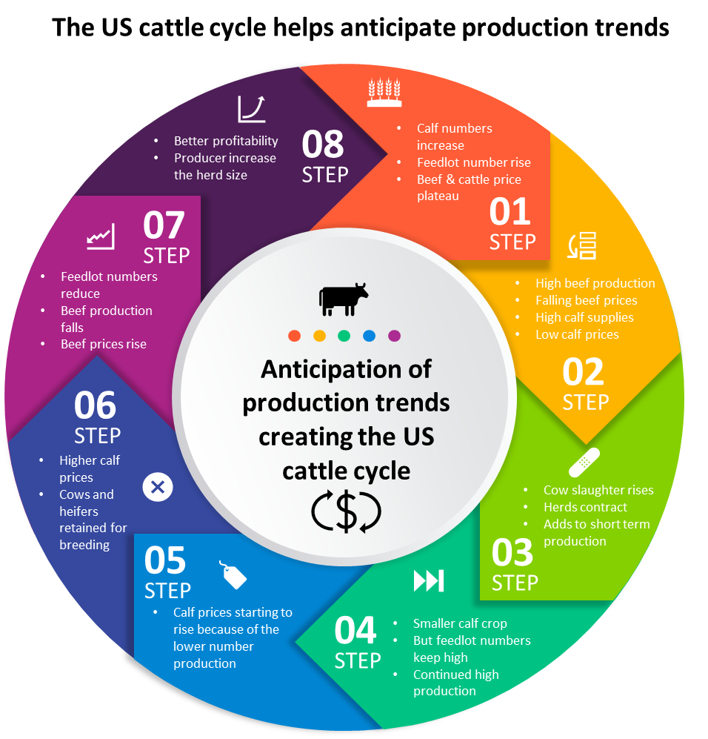
Figure 1. The different stages in beef producer decision-making processes
Source: Helmi and Griffith (2023), based on Alford and Griffith (2002)

In practice, little is known about how farmers and those to whom they sell their output go about forming their expectations about future prices, except that each farmer will do it in their own unique way. And that may change from time to time depending on the circumstances at the time. Still, the combination of expectations, the cost of change and lags in production make it possible for cycles in agricultural commodity prices to occur. This is particularly the case for livestock production because of the long lag times involved from mating to the sale of offspring. During this lag time, things inevitably change, and actual prices will not be those that were expected to occur when the animals that are being produced are expected to be sold. For the supply of animal products to increase at a future time beyond the increases that occur naturally through the effects of favourable seasonal conditions increasing reproduction performances, the number of breeders must first be increased.

An implicit assumption here for the generation of a smooth cyclical pattern is that either farmers are uninformed about these ‘other things’ happening in their industry, or that they assume these other things do not matter.

So, in livestock production enterprises, decisions to increase the breeding herd or reduce it will contribute to ‘cyclical tendencies’ that will occur, but these decisions and their consequences occur amidst many other things that are happening, most notably good and bad seasons contributing to increases and decreases in the quantity and quality of output. These things altogether increase and decrease prices. Overlaying all these events are longer-term trends that may exist in an industry, such as the long-run trend downwards in the United States beef cattle herd since the peak size of 1975, the increasing ‘industrialisation’ of production in most agricultural industries, and the increasing access to a range of information about these industries. As a final straw, purely random events upset the best-laid plans for production: events like disease outbreaks, extreme droughts and floods and temperatures, loss of access to markets, political disturbances, and so on.

The question is: What is the relative importance of the ‘cyclical tendencies’ versus all those other things which are changing?

Literature Review

All economic time series are mixtures of long run trends, cyclical behaviour of various types, lengths and amplitudes, and shorter-term irregular variations (Tomek and Kaiser, 2014). The irregular components are random variations from external shocks in this market or in related markets, that is, events which cause demand and supply shifts.

A simple definition is that ‘a cycle is a pattern that repeats itself regularly over a period of years’. The notion that there exists cyclical behaviour in some agricultural industries, particularly in livestock industries, became evident more than a century and a half ago after efforts were made to monitor and record market transactions through local authorities, and then later and more formally through government market reporting agencies. However just as markets progressed from small, local locations of exchange to global value chains, the interest of researchers expanded to include a multitude of other influences on this cyclical behaviour.

There are patterns of supply and prices within a year as the animal breeding decisions of producers are aligned with expected seasonal feed supplies. Meat is costly to store. Scope for storing and carrying product into different times of the year are limited by supplies of feed and to the extent seasonal patterns of prices are changed by supply being diverted to different times of the year the storage and carrying costs accrue to the live animal not their meat products. Prices of animals change from year to year as the conditions of domestic and global supply and demand shift. All these decisions are influenced by the prevailing and expected seasonal conditions and longer-term climate forecasts.

The cattle and the pig industries are the two livestock industries in which cyclical behaviour has been investigated in detail. The factors causing the cattle cycle are as shown in Figure 1, where due to the length of the reproductive and growing out phase for cattle, results in a roughly 8 to 12-year cycle. The work of Rosen et al. (1994) has been mentioned above. Many other influential economists have examined this phenomenon (for example, Breimyer, 1955; Maki, 1962; Mundlak and Huang, 1996; Chavas, 2000).

The four cattle cycles between the late 1950s and the early 2000s are shown in Figure 2. The lengths and amplitudes of the cycles vary, but there is no question that the cycles exist.

Figure 2. Duration of United States cattle cycles, 1958-2004
Source: USDA (2005); McCoy and Sarhan (1988)
Research on cattle cycles has often had an international focus. The reason for the focus on the United States cattle cycle was that these regular fluctuations in United States beef numbers and prices have spill-over effects world-wide via variations in United States traded quantities, since the United States has a very large beef industry and traditionally has been both a major exporter of beef and a major importer of beef. Even small variations in United States output impact traded quantities and hence global prices. Considerable previous research has shown the impact of the United States cattle cycle on the beef market globally (Rosen et al., 1994; Mundlak and Huang, 1996; Mathews, et al., 1999; Aadland and Bailey, 2001).

The cattle cycle in Australia was first highlighted by Gutman (1950). The rationale for the presence of the cycle in Australia was re-examined in Reynolds (1977), who argued that it was likely to be sizeably shocked by random external factors. It was analysed using spectral analysis by Hinchy (1978). Longmire and Rutherford (1992) found that a cattle cycle still existed in Australia, and despite the restructuring of the cattle industry that had occurred, the cycle 'appears to be Iengthenlng and strengthening' (p.11).

Using data up until 2000, Alford and Griffith (2002) found that there was an Australian cattle cycle and that it and the United States cattle cycle were closely synchronised. This was shown in several ways. First, that United States cattle prices and Australian cattle prices moved closely together in a positive way, with a correlation coefficient between the two prices (not corrected for exchange rate movements) of (r=0.67). Second, that the cattle inventory in the United States had an inverted relationship with the Australian beef prices. A higher number of slaughtered cattle in the United States resulted in a lower beef price in Australia, and vice versa. Third, that there was an equally strong inverse relationship (r=-0.6) between the ratio of United States cow slaughterings to total cow inventory (the indicator of cow herd expansion or contraction) and the prices received by Australian producers, in a similar way to the relationship with United States producer prices. All indicators suggested strong positive relationships between the United States and Australian cattle cycles up until the turn of the last century. Several other external influences were mentioned as impacting the cycles in both countries (human- and animal-health related disruptions, exchange rates, climate influences and the growing pattern of the industrialisation of production), but none of these influences was formally tested.

This perception of the close relationships between the two cattle industries was even discussed in official government publications: “However, as Australia only produces about 4% of the total world beef supply, its share and pricing ability in the world market has always been susceptible to the influences of production levels in other major beef producing nations. One such factor, which greatly influences the profitability of Australian beef production, is the USA cattle production cycle. Peaks in this cycle have occurred about every 10 to 12 years and are usually triggered by high levels of grain production in the USA” (ABS, 2005).

As indicated by the dates on those papers cited above, most academic interest in the United States cattle cycle was around 20-25 years ago. Government and industry market intelligence agencies (such as the United States Department of Agriculture (USDA) in the United States and the Australian Bureau of Agricultural and Resource Economics and Sciences (ABARES) and Meat and Livestock Australia (MLA) in Australia) (for example, MLA, 2019; USDA, 2022) have kept track of the cycles, but only recently has academic interest been renewed (Petry, 2015; Fliessbach and Ihle, 2020; dos Santos, et al., 2022a,b). Much of this recent interest has arisen from the growing presence and influence of the South American beef exporters in the world market.

The latest study of the Australian and United States cattle cycles was by Helmi and Griffith (2023). Their Figure 10 (reproduced below as Figure 3) showing herd inventories in the two countries points to a continuation of the long-term cyclical patterns in the United States industry shown in Figure 2. There is also visual evidence in the analysis on the existence of a cattle cycle in Australia, with at least three trough-peak-trough ‘cycles’ in the Australian herd since 2003, but all are of much shorter duration than the traditional beef cycle.

Figure 3. United States and Australian cattle inventories
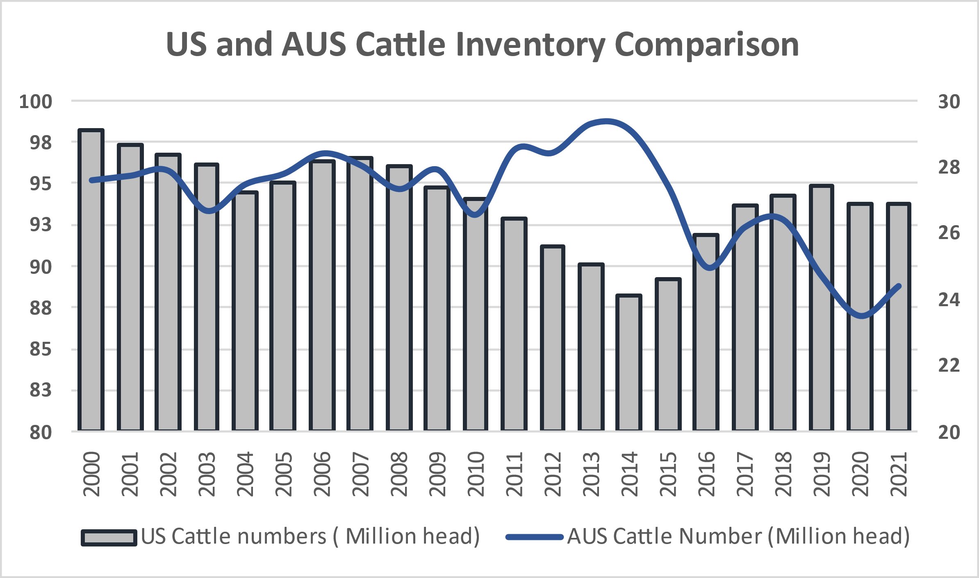
Source: Helmi and Griffith (2023)

Using graphical analysis, these authors found that in the last decade, the United States and Australian cattle cycles had become decoupled. Prices in both countries, and cattle numbers in both countries, have moved in opposite directions. Helmi and Griffith (2023) also state that “… since 2010, in three separate periods, prices and the slaughter rate moved in the same direction. The correlation coefficient is a little weaker in the second half of the data set (-0.27). This is further evidence that the United States and Australian cattle cycles are no longer closely aligned.”

This major change was put down to the growing importance of the external influences mentioned above (human- and animal-health related disruptions, exchange rates, climate influences and the growing pattern of the industrialisation of production), and a call was made for a more formal examination of the role played by these influences (see also for example, Belasco et al. (2015)).

As possible reasons for this decoupling, they note that “Recently, the Australian beef industry has undergone major changes. Australian beef suppliers to export markets are no longer just price takers, supplying low-quality beef into commodity markets. Australia has gained ground in high-marbled products and high-value markets such as Japan and South Korea, which has caused an increase in the Australian average herd size over the last decades (Siriwardana, 2015). The value added to Australia's red meat and livestock sectors has climbed 89 per cent over the last decades, mostly because of increasing demand for high-quality protein in international markets (MLA, 2020c). Australia has expanded its market reach by also supplying high-quality meat products to the US, in addition to the traditional lean beef trade. This has involved greater reliance on feedlots to meet the higher quality specifications demanded, causing the production system to change.” According to MLA (2017), there is a tendency now for Australian beef to fill gaps in supply left by the United States.
These findings are re-examined empirically below.

Analysis and Results

Data

All the data required were obtained from public sources. Definitions are provided in Table 1.

Table 1. Data definitions

Variable name used in the graphs and in the software outputs | Definitions
inallbfau | Total numbers of cattle and calves, Australia, thousands
incowau | Numbers of cows and heifers, Australia, thousands
slbfau | Slaughtering of cattle and calves, Australia, thousands
pfbfauhsr | The real price of heavy steers, Australia, cents/kg DCW
pfbfautsr | The real price of trade steers, Australia, cents/kg DCW
pfbfcwr | The real price of cows, Australia, cents/kg DCW
rainanom | Variations in annual rainfall Australia wide from long run averages
inallus | Total numbers of all cattle, US, thousands
incowus | Numbers of beef cows and heifers, US, thousands
inothus | Numbers of other cattle, US, thousands
slallus | Slaughterings of cattle and calves, US, thousands
pfbfusr | The real price of heavy steers, US, c/lb

Method

It was noted above that separating out the components of a time series of prices or quantities that are systemic, from those that are random, is no simple task. There is more to it than looking at a graph showing an apparent regular movement of prices or quantities of a farm product up and down over a past period of time (as in Figure 2), calling it a cycle, presuming it will happen in the future, and proceeding to base decisions on this expectation. This is naive empiricism, and not helpful to decision-makers. There is too much else happening, in random ways, to bet all on apparent so-called ‘cycles’.
This study examines whether it can be established that cycles in output and prices of cattle, of regular length and magnitude, with a high standard of proof, exist. In this section an attempt is made to use some time series econometrics tools to see if there is any statistical evidence of cyclical activity in the Australian cattle market, and if so, what is the nature of this activity and how can this information be used by industry. The methods used are in the class of methods called ‘time domain’, as they are simpler to implement and interpret and do not require sophisticated software packages. The more sophisticated ‘frequency domain’ methods, such as spectral analysis (Griffith, 1975,1977; Hinchy, 1978; Longmire and Rutherford, 1992) could be applied in future if required to confirm the time domain results.

Several steps are required:

- First, some of the graphs presented by Helmi and Griffith (2023) are updated to see whether the same conclusions still hold. Simple correlation coefficients are also calculated and reported in Table 2.

- Second, the relevant economic time series are checked for ‘stationarity’. Even though real prices are used, and the graphs do not suggest strong trends, it is necessary to test for stationarity before proceeding further. Most econometric estimation techniques assume that the time series being examined are stationary, that is “the mean and variance are constant over time and the covariance between two values from the series depends only on the length of time separating the two values and not on the actual time at which the variables are observed” (Hill et al., 2001, p.335). If the series are non-stationary, spurious regressions may result, where significant relationships are found when there are none.

The stationarity of a time series can be tested by using a unit root test. Here we use three different test statistics – the augmented Dickey-Fuller test, the Weighted Symmetric test, and the Phillips-Perron test. All allow the addition of constant and trend variables, and where appropriate, other exogenous variables such as dummy variables (Hall and Cummins, 2003, pp.42-48). Several ‘augmenting’ lags can be specified to control for additional serial correlation. Here, lags up to 12 are included, given the common perception based on the United States cattle cycle that a beef cycle of prices from peak to trough will often be up to 12 years in length. For the various series to be considered as stationary, the various test statistics should be significantly different from zero (p values less than 0.05). The results of applying these tests are shown in Tables 3 and 4.

- Third, AutoRegressive Integrated Moving Average (ARIMA), or Box-Jenkins (1976) models are applied to the stationary time series variables such as numbers of cattle and prices of cattle. These models use only a series’ own lagged values to forecast its future values. The lagged values can be either moving average terms, and/or autoregressive terms, which statistically best describe the patterns in the past data. These methods are preferable to the full structural econometric approach where in addition to the information on the dependent variable, all the values of all the explanatory variables that ‘cause’ future supplies, demands and prices must be either known or be reliably estimated. And as mentioned earlier, they are easier to implement and interpret than ‘time domain’ methods such as spectral analysis.

Three phases of an ARIMA process are required:
- identification of the particular characteristics of the variable of interest (is it moving average, autoregressive, or both?);
- estimation of the parameters of the model specified on the basis of what was found in the identification phase (the actual empirical relationships between past and current values);
- then forecasts into the future of the variable of interest based on the estimated model parameters.

The results of these procedures are reported in the results section below.

Results

First, the United States inventory (‘inallus’ and ‘incowus’) and slaughterings (‘slallus’) data are shown in Figure 4 for the same sample period used in the statistical analysis. The variable definitions are provided in Table 1. The graph shows clearly the same cycles evident in Figures 2 and 3.

Next, total Australian beef cattle numbers (‘inallbfau’), cow numbers (‘incowau’) and beef slaughterings (‘slbfau’) are shown in Figure 5 for the period 1970 to 2022. The substantial and long, drawn out decrease in the beef herd following the 1974/75 Japanese import quota restriction is clearly shown. This was followed by the slow and partial rebuilding through to the mid-2000s, and then a period of increased variability and decline in both numbers and output. While there are periods of rises and falls in these data series, there is little indication of any regular, longer-term cyclical activity in the Australian cattle herd, at least on a similar scale as in the United States herd as mentioned above and as shown in Figure 2.
Figure 4. United States cattle inventories and slaughterings of beef cattle, 1970 to 2022

Figure 5. Australian cattle inventories and slaughterings of beef cattle, 1970 to 2022

The real price of cattle at the farm gate (shown is the heavy steer category, ‘pfbfauhsr’) and slaughterings is graphed in Figure 6 for the same period. The bust and boom in prices from 1975 through to around 1980 is due to the trade restrictions imposed in 1974 and the diversion of surplus export beef onto the domestic market, and then the subsequent shortage of stock as herd rebuilding occurred. Likewise, the boom in prices since the mid-2000s is due to herd liquidation and shortages of stock. Both these periods of price changes inversely match the periods of quantity changes as shown in the ‘slbfau’ series. In between however is a period of reasonably constant real prices, disturbed only by the aftermath of droughts in 1982, the early 1990s, the early 2000s and 2018-2019.

The results of the correlation analyses are provided in Table 2 (copied directly from the software output file to prevent any transcription errors).

The United States beef inventory and slaughterings variables are all strongly positively correlated (all above 0.75). The strong correlation between slaughterings and inventories reflects the dominance of the feedlot sector in the US. The United States real price of cattle is moderately positively correlated with the inventory series, has no relationship with slaughterings, but is moderately negatively correlated with the slaughterings to inventory ratio ( -0.54).
Figure 6. Price of cattle and cattle slaughterings, Australia, 1970 to 2022

The Australian beef inventory variables are strongly positively correlated with each other (0.94) but there is a relatively weak relationship between inventories and slaughterings (around 0.37). This is a much weaker relationship than shown in the United States data. The weaker correlation between slaughterings and inventories reflects the significance of the pasture-based finishing sector in Australia, the wider range of environmental conditions faced by beef producers in Australia and the increasing variability of climate especially in these production systems. Australian prices of cattle are negatively correlated with both the inventory and slaughterings series (-0.68 for the latter).

Table 2. Correlation coefficients, United States and Australian beef data series, 1970-2022

INALLUS INALLBFAU INCOWUS INCOWAU SLALLUS
INALLUS 1.00000
INALLBFAU 0.25184 1.0000
INCOWUS 0.98750 0.30747 1.00000
INCOWAU 0.31861 0.94144 0.37289 1.00000
SLALLUS 0.75286 0.20603 0.77260 0.22356 1.00000
SLBFAU 0.20481 0.37363 0.27057 0.36419 0.41886
SRBFUS -0.72580 -0.20643 -0.72225 -0.28022 -0.12324
SRBFAU 0.011289 -0.23138 0.043754 -0.27546 0.27524
PFBFUSR 0.42793 0.14707 0.34842 0.22173 -0.0052279
PFBFAUTSR -0.037520 -0.32239 -0.10645 -0.29694 -0.43239

SLBFAU SRBFUS SRBFAU PFBFUSR PFBFAUTSR
SLALLUS
SLBFAU 1.00000
SRBFUS 0.033873 1.0000
SRBFAU 0.79160 0.19626 1.00000
PFBFUSR 0.082635 -0.54022 -0.051546 1.0000
PFBFAUTSR -0.67666 -0.31322 -0.50254 0.23983 1.00000

When comparing across the two industries across this whole data set, United States and Australian cattle inventories show weak positive correlations (ranging from 0.25 to 0.37), United States and Australian slaughterings show a weak positive correlation (0.42), and United States and Australian prices show weak positive correlations (0.24 for the heavy steer categories). The slaughterings to inventory ratio in the United States and Australia are only weakly positively correlated. While not conclusive statistical evidence, this is strongly suggestive that economic activity in the United States and Australian beef industries follow different paths.

This is confirmed by looking at the relationship between the slaughter to inventory ratios in the two countries (Figure 7, taken from Helmi and Griffith (2023)). While only representing the latter part of the full data set, the graph clearly shows that these ratios are moving in different directions from around 2010. This is further indication that the two industries are now uncoupled.

The main point from this simple graphical and correlation analysis is that, contrary to the analysis and advice provided some 20 years ago, the United States cattle cycle does not now determine outcomes in the Australian beef industry. However, all this speculation needs to be tested in the following more formal statistical analyses. The results for the unit root tests are provided in Tables 3 and 4, for the United States and Australian data respectively.

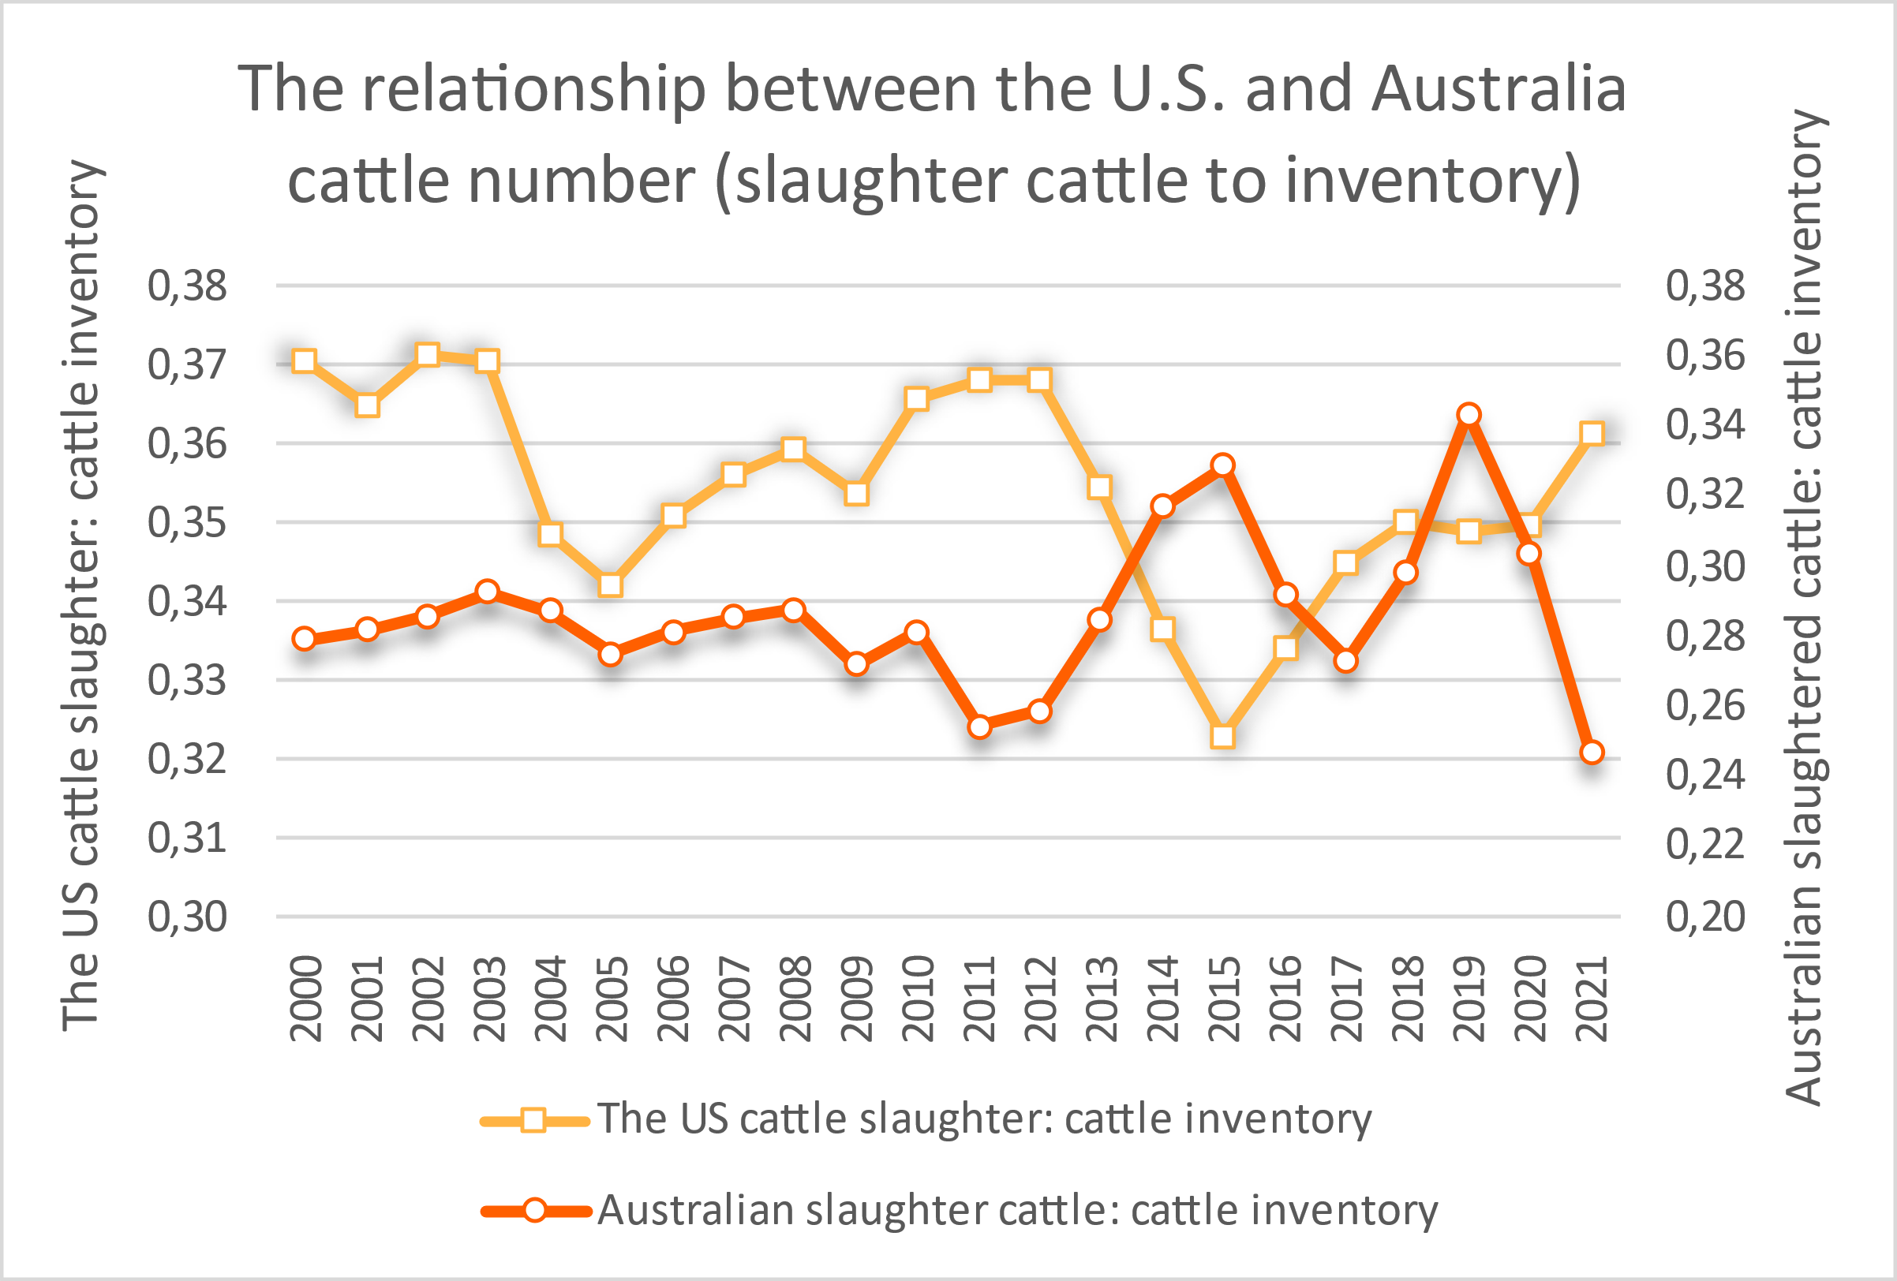
Figure 7. The relationship between the United States and Australian slaughter to inventory ratio, 2000 to 2021
Source: USDA (2022) and MLA (2022)

In Tables 3 and 4, the important results are the p-values. All the test statistics except two confirm that the hypothesis of a unit root cannot be rejected. That is, non-stationarity is indicated and using these data in statistical procedures would produce misleading results. Given these results, further transformations of all of the data series, such as first differencing, are required before any credible statistical analysis can proceed. For the Australian data series, this is the same result as found by Longmire and Rutherford (1992).

The first stage of the ARIMA modelling process is presented in Figure 8 for United States beef industry variables and in Figure 9 for Australian beef industry variables. In Figure 8, given the very high correlations between all the United States inventory variables, just one is chosen for illustrative purposes (numbers of cows and heifers, ‘incowus’), as well as slaughterings (‘slbfus’) and the real farm price (‘pfbfusr’). First differencing is performed as required from the results of the unit root tests (denoted by (1-B) in the copy of the printout). The graphs shown are the autocorrelation functions, which are the correlations of each data point of the series with its own lagged values, up to a lag of 12, and the partial autocorrelation functions, which are the same correlations net of any lower lag correlation.

Table 3. Unit root tests, United States beef data series, 1970-2022

Test Statistics
INALLUS INCOWUS INOTHUS SLALLUS PFBFUSR
Wtd.Sym. -0.20707 -1.15706 -0.50488 -2.98457 -2.14430
Dickey-F -1.50767 -2.75618 -1.18208 -4.93371 -1.86050
Phillips -9.49039 -11.76499 -9.52008 -18.01131 -7.77782

P-values
INALLUS INCOWUS INOTHUS SLALLUS PFBFUSR
Wtd.Sym. 0.99746 0.95818 0.99382 0.088632 0.54513
Dickey-F 0.82649 0.21350 0.91411 0.00027121 0.67488
Phillips 0.47133 0.32870 0.46923 0.10453 0.60148

Table 4. Unit root tests, Australian beef data series, 1974-2022

Test Statistics
INALLBFAU SLBFAU INCOWAU PFBFAUTSR
Wtd.Sym. -1.98517 -2.62829 -2.09289 -2.16684
Dickey-F -2.42003 -3.63397 -2.30955 -1.29453
Phillips -9.17228 -11.98924 -9.46598 -11.60401

P-values
INALLBFAU SLBFAU INCOWAU PFBFAUTSR
Wtd.Sym. 0.65850 0.22002 0.58289 0.52838
Dickey-F 0.36902 0.027091 0.42867 0.88927
Phillips 0.49421 0.31665 0.47306 0.33757

Changes in United States beef cow numbers (‘incowus’) are positively and significantly related to changes in beef cow numbers in the previous year (the ‘R’ outside the standard error band at lag 1), and negatively and significantly related to changes in beef cow numbers four years ago. The correlation at the lag of 5 is also close to the significance boundary. These results suggest a statistically significant regular pattern, where a current increase in cow numbers is related to a decrease in cow numbers some 4 to 5 years ago, or put another way, a full cycle in cow numbers of some 8 to 10 years. This conclusion is confirmed from the partial autocorrelation function

No such patterns are shown for United States beef slaughterings (‘slbfus’). While the negative autocorrelation at lag 4 is significant this pattern is not confirmed by the partial autocorrelation function. There is no statistical evidence of cyclical behaviour in this variable.

For farm prices (‘pfbfusr’), changes in real United States beef prices are negatively and significantly related to changes in United States beef prices five years ago. As with cow numbers, this suggests a significant regular pattern of a cycle in beef prices of some 8 to 10 years.

The patterns for the equivalent first differenced Australian beef series shown in Figure 9 are quite different to those shown in the United States data. In none of the three series analysed is there any

Figure 8. Identification tests, first differenced United States data series, 1970-2022

Autocorrelation Function of: (1-B) INCOWUS

-1.00 -0.60 -0.20 0.20 0.60 1.00
|-+---------+---------+----0----+---------+---------+-|
1 | + | + R | 0.58453
2 | + | R + | 0.099485
3 | + R | + | -0.29511
4 | R + | + | -0.49713
5 | + R | + | -0.31977
6 | + |R + | 0.020684
7 | + | R + | 0.16912
8 | + | R + | 0.10323
9 | + |R + | 0.046558
10 | + R | + | -0.098419
11 | + R | + | -0.12205
12 | + R| + | -0.035782
|-+---------+---------+----0----+---------+---------+-|
-1.00 -0.60 -0.20 0.20 0.60 1.00

Partial Autocorrelation Function of: (1-B) INCOWUS

-1.00 -0.60 -0.20 0.20 0.60 1.00
|-+---------+---------+----0----+---------+---------+-|
1 | + | + R | 0.59092
2 | R + | + | -0.36139
3 | R+ | + | -0.32134
4 | R+ | + | -0.31930
5 | + | R + | 0.15111
6 | + | R+ | 0.25477
7 | + R | + | -0.15233
8 | R+ | + | -0.30289
9 | + | R+ | 0.22170
10 | + R| + | -0.023251
11 | + |R + | 0.053584
12 | + R| + | -0.057486
|-+---------+---------+----0----+---------+---------+-|
-1.00 -0.60 -0.20 0.20 0.60 1.00

Autocorrelation Function of: (1-B) SLALLUS

-1.00 -0.60 -0.20 0.20 0.60 1.00
|-+---------+---------+----0----+---------+---------+-|
1 | + | +R | 0.32675
2 | + R | + | -0.10890
3 | R | + | -0.33408
4 | R+ | + | -0.35517
5 | + R | + | -0.20662
6 | + | R + | 0.12569
7 | + R| + | -0.054227
8 | + |R + | 0.029333
9 | + |R + | 0.041963
10 | + | R + | 0.12271
11 | + | R + | 0.10694
12 | + R + | 0.016315
|-+---------+---------+----0----+---------+---------+-|
-1.00 -0.60 -0.20 0.20 0.60 1.00

Partial Autocorrelation Function of: (1-B) SLALLUS

-1.00 -0.60 -0.20 0.20 0.60 1.00
|-+---------+---------+----0----+---------+---------+-|
1 | + | +R | 0.32858
2 | +R | + | -0.25255
3 | +R | + | -0.25015
4 | +R | + | -0.24468
5 | + R | + | -0.18151
6 | + | R + | 0.10558
7 | R + | + | -0.50008
8 | + R + | 0.017791
9 | + R | + | -0.13379
10 | + | R + | 0.13414
11 | + R + | 0.016967
12 | + R | + | -0.14678
|-+---------+---------+----0----+---------+---------+-|
-1.00 -0.60 -0.20 0.20 0.60 1.00

Autocorrelation Function of: (1-B) PFBFUSR

-1.00 -0.60 -0.20 0.20 0.60 1.00
|-+---------+---------+----0----+---------+---------+-|
1 | + R | + | -0.070068
2 | + R | + | -0.11382
3 | + | R + | 0.060573
4 | + | R + | 0.12784
5 | R+ | + | -0.30321
6 | + R | + | -0.20621
7 | + | R + | 0.15424
8 | + R + | -0.017404
9 | + R| + | -0.026771
10 | + |R + | 0.020707
11 | + | R+ | 0.27228
12 | + R | + | -0.13582
|-+---------+---------+----0----+---------+---------+-|
-1.00 -0.60 -0.20 0.20 0.60 1.00

Partial Autocorrelation Function of: (1-B) PFBFUSR

-1.00 -0.60 -0.20 0.20 0.60 1.00
|-+---------+---------+----0----+---------+---------+-|
1 | + R | + | -0.070794
2 | + R | + | -0.12089
3 | + |R + | 0.049950
4 | + | R + | 0.12697
5 | R+ | + | -0.31086
6 | +R | + | -0.24754
7 | + |R + | 0.054482
8 | + R + | -0.0068712
9 | + | R + | 0.091255
10 | + R| + | -0.038634
11 | + | +R | 0.30815
12 | + R | + | -0.14914
|-+---------+---------+----0----+---------+---------+-|
-1.00 -0.60 -0.20 0.20 0.60 1.00

Figure 9. Identification tests, first differenced Australian beef data series, 1970-2022

Autocorrelation Function of: (1-B) INCOWAU

-1.00 -0.60 -0.20 0.20 0.60 1.00
|-+---------+---------+----0----+---------+---------+-|
1 | + | R + | 0.18398
2 | + | R + | 0.16268
3 | + R | + | -0.12887
4 | + |R + | 0.039673
5 | + R | + | -0.21758
6 | + |R + | 0.045632
7 | + R | + | -0.15464
8 | + R | + | -0.076561
9 | + R | + | -0.13769
10 | + R | + | -0.074776
|-+---------+---------+----0----+---------+---------+-|
-1.00 -0.60 -0.20 0.20 0.60 1.00

Partial Autocorrelation Function of: (1-B) INCOWAU

-1.00 -0.60 -0.20 0.20 0.60 1.00
|-+---------+---------+----0----+---------+---------+-|
1 | + | R + | 0.18979
2 | + | R + | 0.14218
3 | + R | + | -0.19284
4 | + | R + | 0.087643
5 | +R | + | -0.22325
6 | + | R + | 0.079241
7 | + R | + | -0.16706
8 | + R | + | -0.18649
9 | + R| + | -0.038534
10 | + R | + | -0.15913
|-+---------+---------+----0----+---------+---------+-|
-1.00 -0.60 -0.20 0.20 0.60 1.00

Autocorrelation Function of: (1-B) SLBFAU

-1.00 -0.60 -0.20 0.20 0.60 1.00
|-+---------+---------+----0----+---------+---------+-|
1 | + | R | 0.27808
2 | + R | + | -0.16658
3 | R | + | -0.28116
4 | + | R + | 0.11630
5 | + | R + | 0.17162
6 | + R | + | -0.18937
7 | + R | + | -0.23748
8 | + R | + | -0.15369
9 | + |R + | 0.049540
10 | + R + | -0.018896
|-+---------+---------+----0----+---------+---------+-|
-1.00 -0.60 -0.20 0.20 0.60 1.00

Partial Autocorrelation Function of: (1-B) SLBFAU

-1.00 -0.60 -0.20 0.20 0.60 1.00
|-+---------+---------+----0----+---------+---------+-|
1 | + | R | 0.27875
2 | R | + | -0.26974
3 | + R | + | -0.21364
4 | + | +R | 0.30425
5 | + R | + | -0.080090
6 | R + | + | -0.45858
7 | + |R + | 0.041407
8 | + R | + | -0.17453
9 | + R | + | -0.17077
10 | + R | + | -0.10435
|-+---------+---------+----0----+---------+---------+-|
-1.00 -0.60 -0.20 0.20 0.60 1.00

Autocorrelation Function of: (1-B) PFBFAUHSR

-1.00 -0.60 -0.20 0.20 0.60 1.00
|-+---------+---------+----0----+---------+---------+-|
1 | + |R + | 0.059498
2 | R | + | -0.26170
3 | + R | + | -0.18373
4 | + R | + | -0.12738
5 | + |R + | 0.056065
6 | + | R + | 0.090458
7 | + | R + | 0.092353
8 | + R | + | -0.088574
9 | + R| + | -0.025089
10 | + R + | -0.00030059
|-+---------+---------+----0----+---------+---------+-|
-1.00 -0.60 -0.20 0.20 0.60 1.00

Partial Autocorrelation Function of: (1-B) PFBFAUHSR

-1.00 -0.60 -0.20 0.20 0.60 1.00
|-+---------+---------+----0----+---------+---------+-|
1 | + | R + | 0.064957
2 | R | + | -0.29818
3 | + R | + | -0.15299
4 | +R | + | -0.25749
5 | + R | + | -0.091380
6 | + |R + | 0.048999
7 | + | R + | 0.10821
8 | + R | + | -0.12229
9 | + R + | -0.011045
10 | + R| + | -0.041422
|-+---------+---------+----0----+---------+---------+-|
-1.00 -0.60 -0.20 0.20 0.60 1.00
Note: PFBFAUTSR commences in 1974.

significant statistical evidence of the 8-12 year cycle that was found in United States beef industry inventories and prices.

In particular, none of the correlations for the Australian cow numbers variable (‘incowau’) lie outside of the standard error bands – there are no significant correlations of current changes in cow numbers with any previous change in cow numbers. There is no regular medium-term cycle in Australian cow numbers.
There is a borderline significant negative correlation shown in the slaughterings series (‘slbfau’) at lag 3, but this is not confirmed in the partial autocorrelation function. There is also a borderline significant negative correlation shown in the farm price series (‘pfbfauhsr’) at lag 2, which is confirmed in the partial autocorrelation function. These results are both indicative of much shorter-term beef industry variability in Australia, which are more likely to be caused by changes in world market conditions on the demand side or environmental conditions on the supply side than by the decisions of uninformed, myopic beef cattle producers.

Discussion and Conclusion

To summarise and re-emphasise some of the material presented above, it was established in the literature review that there has been consistent cyclical activity in the United States cattle industry for now close on 180 years. It was also established that these regular fluctuations in United States beef numbers and prices have significant spill-over effects world-wide via variations in United States traded quantities, since the United States has a large beef industry and traditionally has been both a major exporter of beef and a major importer of beef. Considerable previous research has shown the impact of the United States cattle cycle on the beef market globally (Rosen et al., 1994; Mundlak and Huang, 1996; Mathews, et al., 1999; Aadland and Bailey, 2001). The statistical analysis reported in this study confirms that this cyclical behaviour is still a major factor in the United States cattle industry.

For almost 70 years the conventional wisdom in the Australian beef industry has been that there is similar and closely related cyclical activity in Australia that is predetermined by what occurs in the United States industry. This has been backed up by both theoretical argument and empirical evidence (Gutman, 1950; Reynolds, 1977; Hinchy, 1978; Longmire and Rutherford, 1992; Alford and Griffith, 2002).

While confirming this close relationship using graphical analysis, Alford and Griffith (2002) pointed to several other external influences as impacting the cycles in both countries (human- and animal-health related disruptions, exchange rates, climate influences and the growing pattern of the industrialisation of production). Some of these influences have been raised in the past. For example, Reynolds (1977) argued that the Australian cattle cycle was likely to be sizeably shocked by random external factors; Longmire and Rutherford (1992) found that a cattle cycle still existed in Australia, despite the restructuring of the cattle industry that had occurred. However, none of these influences have been formally tested.

The latest study of the Australian and United States cattle cycles was by Helmi and Griffith (2023). Using graphical and correlation analyses, these authors found that in the last decade, the United States and Australian cattle cycles had become uncoupled. Prices in both countries, and cattle numbers in both countries, have moved in opposite directions. This major change was put down to the growing importance of the external influences mentioned above, and a call was made for a more formal examination of the role played by these influences.

When comparing across the two industries over the period 1970 to 2022, United States and Australian cattle inventories, United States and Australian cattle slaughterings and United States and Australian cattle prices all show very weak to weak positive correlations. While not conclusive statistical evidence, this is strongly suggestive that economic activity in the United States and Australian beef industries follow different paths.

The statistical analysis reported in this study above confirms this uncoupling but goes further to say that in none of the Australian beef industry series modelled is there now strong statistical evidence of the 8-12 year cycle that was found in United States beef industry inventories and prices. In particular, none of the correlations between current and lagged values for changes in the Australian cow numbers variable, at any lag value, meets the standard of proof of being statistically significant. There is no regular cycle in cattle numbers in Australia.

The only close to significant correlations between current and lagged values are found in the beef slaughterings series (negative at lag 3) and in the cattle price series (negative at lag 2). These results are indicative of much shorter-term beef industry variability in Australia, which are more likely to be caused by changes in world market conditions on the demand side, or by changes in environmental conditions on the supply side. These factors have become increasingly and significantly more important in recent years and have effectively outweighed the cyclical tendencies embedded in expectations processes and biological lags.

So, while there may still be ‘cyclical tendencies’ evident in industry data such as a graph showing an apparent regular movement of prices of a farm product up and down over a past period of time, these tendencies are not statistically significant. Such tendencies should not be called a ‘cycle’, it should not be presumed that such patterns will happen in the future, and it should not be the information on which to base decisions about future production levels.

While no formal testing of these significant external influences has been done, a broad-brush variable representing variations in rainfall Australia wide from long run averages was obtained from the Bureau of Meteorology. Keeping in mind that at any time across Australia, regional differences in rainfall and environmental conditions are most often quite marked, the results suggest that Australia wide rainfall is moderately positively related to beef numbers (0.45), and negatively related to beef slaughterings and prices, but at lower levels of association (-0.18 to -0.26). With these levels of association Australia wide, it would seem sensible to examine the linkage between numbers, output, and prices on a more localised level, such as by State or even by major saleyard.

The results of this analysis suggests the need for more attention to be paid to risk management in the light of uncertainty. In competition policy terms the analysis would appear to reinforce the significance of factors beyond the decision-making control of cattle and sheep industry participants in relation to the factors impacting the volumes and prices of their products.

References

Aadland, D. and Bailey, D. (2001), 'Short‐run supply responses in the U.S. beef‐cattle industry', American Journal of Agricultural Economics, 83(4), 826-839. https://doi.org/10.1111/0002-9092.00212

ABS (2005), ‘Australian beef cattle industry’, in Year Book Australia, 2005, https://www.abs.gov.au/ausstats/abs@.nsf/Previousproducts/1301.0Feature%20Article232005?opendocument

ABARES (2019a), ABARES Insights, the United States and Australian agriculture - a comparison. https://www.agriculture.gov.au/sites/default/files/abares/documents/USandAustralianAgriculture_v1.2.0.pdf

ABARES (2019b), Analysis of the effects of drought and climate variability on Australian farms. https://www.agriculture.gov.au/sites/default/files/documents/EffectsOfDroughtAndClimateVariabilityOnAustralianFarms_v1.0.0.pdf

ABARES (2022), Emissions, agricultural support and food security.
https://www.agriculture.gov.au/abares/products/insights/emissions_agsupport_and_foodsecurity

Australian Competition and Consumer Commission (2017), Cattle and Beef Market Study – Final Report. Retrieved from https://www.accc.gov.au/focus-areas/market-studies/cattle-and-beef-market-study

Australian Competition and Consumer Commission (2008), Merger Guidelines, updated 2017

Australian Competition and Consumer Commission (2018), ‘Guidelines on s. 46’

Alford, A. and Griffith, G. (2002), 'The United States cattle cycle and its influence on the Australian beef industry', Review Paper No. 2, Volume 10 in Australasian Agribusiness Review, [Online]. Available: http://www.agribusiness.asn.au/Review/2002v10/Griffith/Griffith.htm

Beef Central (2023a), Change, confidence and cyclicity drove 2023 year for beef, says MLA. December 8. https://www.beefcentral.com/markets/change-confidence-and-cyclicity-drove-2023-year-for-beef-says-mla/

Beef Central (2023b), Competition review urged to include scrutiny of livestock and food prices. October 17. https://www.beefcentral.com/news/competition-review-urged-to-include-scrutiny-of-livestock-and-food-prices/

Belasco, E.J., Cheng, Y. and Schroeder, T.C. (2015), 'The impact of extreme weather on cattle feeding profits', Journal of Agricultural and Resource Economics, 40(2), 285-305. http://www.jstor.org/stable/44131862

Breimyer, H.F. (1955), 'Observations on the cattle cycle', Agricultural Economics Research, 7 (1), 1-11.

Chavas, J-P. (2000), "On information and market dynamics: the case of the United States beef market', Journal of Economic Dynamics and Control, 24(5-7), 833-853.

Deane, P., Malcolm, B., Sinnett, A., Griffith, G. and Kingwell, R. (2025), ‘Distinctions in agricultural risk’, paper being prepared for submission to Australasian Agribusiness Perspectives.
dos Santos, W.M. et al. (2022a), 'Beef cattle cycle in the State of Par a Amazon, Brazil', Journal of Agricultural Studies, 11(1). https://doi.org/10.5296/jas.v11i1.20437

dos Santos, W.M. et al. (2022b), 'Production and price cycles in beef cattle in Rondonia State, Brazilian Amazon', Journal of Economics, Management and Trade, 28(11), 7-18. https://doi.org/10.9734/jemt/2022/v28i11.30456

Erdem, F.P. and Ünalmış, I. (2016),' Revisiting super-cycles in commodity prices', Central Bank Review, 16 (4), 137-142,

Erten, B. and Ocampo, J.A. (2013), 'Super-cycles of commodity prices since the mid-nineteenth century', World Development, 44, 14-30.

Fliessbach, A. and Ihle, R. (2020), 'Cycles in cattle and hog prices in South America', Australian Journal of Agricultural and Resource Economics, 64(4), 1167-1183. https://doi.org/10.1111/1467-8489.12392

Gutman, G.P. (l960), 'The cattle cycle', Quarterly Review of Agrlcultural Economics, 3(1), 23-27.

Hall, Bronwyn H. and Cummins, Clint (2003), Time Series Processor Version 4.5 Reference Manual, TSP International, Palo Alto, United States.

Hatt, M., Heyhoe, E. and Whittle, L. (2012). Options for insuring Australian agriculture, ABARES report to client prepared for Climate Division 122.

Heilbron, S., Griffith, G. and Malcolm, B. (2025), Cattle and Sheep Cycles and Price Transmission Processes: Final Report to AMPC on Stage 1 of Project 2024-1029, Price Cycles Analysis, by S.G. Heilbron Pty Ltd, submitted to Australian Meat Processor Corporation Ltd, North Sydney, February. Available at: https://www.ampc.com.au/getmedia/dc6df438-5442-4a82-84f5-18d5dc975729/AMPC-Project-2024-1029-Final-Report-Price-Cycles-Analysis.pdf?ext=.pdf

Helmi, Muhammad and Griffith, Garry (2023), “Does the United States cattle cycle still influence the Australian beef industry?” Australasian Agribusiness Perspectives Volume 26, Paper 9, 139-156.

Hill, R.C., Griffiths, W.E. and G.G Judge (2001), Undergraduate Econometrics, 2nd Edition, John Wiley & sons, Inc., New York and Brisbane.

Hinchy, M.D. (1978). 'The relationship between beef prices in export markets and Australian saleyard prices', Quarterly Review of Agricultural Economics, .

Kimura, S., Antón, J. and LeThi, C. (2010). Farm level analysis of risk and risk management strategies and policies: cross country analysis.

Longmire, J. and Rutherford, A. (1992), Cattle and pig cycles in Australia: do they still exist? Contributed paper presented at the 31st Annual Conference of the Australian Agricultural Economics Society, University of Sydney, Sydney, 9-11 February.

Maki, W.R. (1962), 'Decomposition of the beef and pork cycles', Journal of farm Economics, 44(3), 731-743.

Mathews, K.H., et al. (1999), United States beef industry: Cattle cycles, price spreads, and packer concentration. Technical Bulleting No.1874, Market and Trade Economics Division, Economics Research Service, United States Department of Agriculture, Washington, DC.

MLA (2019), United States herd slowdown good news for cattle prices. https://www.mla.com.au/prices-markets/market-news/2019/us-herd-slowdown-good-news-for-cattle-prices/

MLA (2020b), State of industry report 2020. https://www.mla.com.au/globalassets/mla-corporate/prices--markets/documents/trends--analysis/soti-report/mla-state-of-industry-report-2020.pdf

MLA (2020c), Global snapshot - Beef. https://www.mla.com.au/globalassets/mla-corporate/prices--markets/documents/os-markets/red-meat-market-snapshots/2020/global-beef-snapshot-jan2020.pdf

MLA (2021), Global beef industry and trade report 2021. https://www.mla.com.au/globalassets/mla-corporate/prices--markets/documents/os-markets/red-meat-market-snapshots/2021/global-beef-industry-and-trade-report.pdf

MLA (2022), Global beef industry and trade report 2022. https://www.mla.com.au/globalassets/mla-corporate/prices--markets/documents/os-markets/red-meat-market-snapshots/2021/global-beef-industry-and-trade-report.pdf

Mundlak, Y. and Huang, H. (1996), 'International comparisons of cattle cycles', American Journal of Agricultural Economics, 78, 855-868.

National Farmers Federation (NFF 2023), ‘Market Price Transparency Issues Paper’ December

Petry, T. (2015), Spotlight on Economics: The Cattle Cycle Revisited, Agriculture Communication, North Dakota State University, Fargo, ND.

Rosen, S., Murphy, K.M. and Scheinkman, J.A. (1994), 'Cattle cycles', Journal of Political Economy, 102(3), 468-492. https://doi.org/10.1086/261942

Tomek, W. and Kaiser, H. (2014), Agricultural Product Prices, Fifth edition, Cornell University Press.

USDA (2022), U.S. cattle production. https://www.ers.usda.gov/topics/animal-products/cattle-beef/sector-at-a-glance/

The AREA Working Paper series reports work in progress prior to formal external review and includes draft research articles, reports to funding agencies, literature reviews, data collections and the like. Each paper is reviewed within the AREA group. Not for quotation without the consent of the authors.
This paper arose out of a broader investigation into cattle and sheep cycles in Australia funded by the Australian Meat Processor Corporation Ltd through Project 2024-1029. That funding is gratefully acknowledged. The full report is published as Heilbron et al. (2025). Comments on an earlier draft by Bill Malcolm and Emilio Morales are also gratefully acknowledged. The paper was presented at the 18th Food Systems Dynamics Forum, Garmisch, Germany, 10-14 February 2025.

