Agricultural and Resource Economics and Agribusiness (AREA) Working Papers
2026, Paper 2
-------------------------------------------------------------------------------------------------------------------------------------- An Approach to Defining the Characteristics of a Representative Farm

Chinthani Rathnayakeª, Alexandria Sinnettª, Bill Malcolmª, Margaret Ayreª,
Chitpasong Kousonsavath^{b}, Fue Yang^{b}, Lytoua Chialue^{b}, John Mullen^{ac} and Garry Griffithª

ª School of Agriculture, Food and Ecosystem Sciences, The University of Melbourne, Parkville.
^{b} Department of Rural Economics and Food Technology, Faculty of Agriculture, National University of Laos, Vientiane.
^{c} Private Consultant, Orange.
--------------------------------------------------------------------------------------------------------------------------------------
Abstract

Farm management economists use the case study approach in farm economic research. A case study could be a real farm business or a representative farm business. A representative farm business is often used as an initial step to explore research questions involving farming systems. The challenge for researchers is how to define a robust representative case-study farm business. There is limited literature outlining how researchers have defined a representative farm, as well as the challenges and limitations of this approach. In this paper the aim is to present an approach used to describe a representative case study farm household/business. This approach was used to define a lowland wet-season rice farm household in Lao PDR. The details of the steps taken to define a representative farm, the challenges faced, the benefits, and the limitations are all discussed. Central to the approach is data triangulation - using multiple data sources to improve the validity of the representative farm. Multiple sources of evidence provide strong substantiation of the case being defined. Similarly, this approach was based on defining the characteristics of a representative farm through multiple iterations. In summary, the approach involved four steps: (i) document analysis to develop an initial description of the representative farm; (ii) industry experts reviewed and refined these characteristics; (iii) farmers and industry officers further refined the characteristics; and (iv) industry experts reviewed the final draft of the characteristics of the representative farm. The benefit of this approach is the development of a typical farm business case study for the region, supported by the literature, industry experts, and farmers. Therefore, each characteristic of such a representative case study is robust and reliable. For researchers, applying this approach also offers significant benefits, as it helps them gain a detailed understanding of farming in a specific area. After applying this method to research in a country where the researchers had not previously worked, it was found to be a useful starting point for those beginning farm economic research in unfamiliar areas.

Keywords: case study research, farm system analysis, representative case study
Introduction

In farm system analysis, biophysical and socio-economic factors are combined to understand farm-level decision making and their consequences. Farm economists apply the whole-farm approach to examine farm systems—that is, they consider all parts of the system (human, technical, economic, financial risk, and beyond the farm). The case study approach has long been recognised as the method used in farm economic research (Crosthwaite et al., 1997; Elliott, 1928; Feuz & Skold, 1992; Malcolm, 2000; Malcolm et al., 2012; Sinnett et al., 2019). The case study approach is a powerful method because of its ability to investigate farm system analysis in depth (Sinnett et al., 2019).

Case studies are detailed examinations of a single case or, sometimes, multiple cases. According to Yin (2017), case study designs are considered applicable under several circumstances, where a ‘common’ circumstance would be suitable to portray an everyday situation. Case study research is used when researchers seek to answer how and why questions. Flyvbjerg (2006) argued that one of the strengths of case study research is that it generates context-dependent knowledge.

Yin (2017) used ‘context’ and ‘case’ to describe the case study design, where the context refers to the broad setting that is evaluated by conducting research. The ‘case’ should not be an abstraction, hypothesis, or argument, but reality (Yin, 2017). The case study could be an actual or a representative farm business. Similarly, Malcolm (2000) noted that in farm economic research using the whole farm approach to investigate a farm system, the case could indicate a ‘representative’ farming situation or ‘the true situation of individual farm businesses’ (p.24).

Results from analyses of case study research provide insights into economic theory regarding individual farms, rather than populations of farms (Sinnett et al., 2019). Malcolm et al. (2012) explained ‘… case studies of real and representative farm businesses, as they currently operate and as they could operate, provide information about real world phenomena that facilitates understanding them’ (p.45).
Defining the characteristics of a case study is an important step in case study research. Defining a real farm case study is straightforward, as the researchers can work directly with the farmer to define their system. However, the challenge, particularly for those new to case study research, is knowing how to develop a robust representative case study.

Using artificially constructed ‘unreal’ (synonymously used with representative, typical, virtual, synthetic, artificial, etc) farms using the case study approach is not new in farm economic research – their strengths and limitations have been discussed by Malcolm (2000). However, the approach used to develop such representative farms has not been discussed in detail in the literature.

In this paper, the aim is to showcase an approach used to develop a representative farm, building on the work by Malcolm (2000), Malcolm et al. (2012) and Sinnett et al. (2019) on using the case study approach in farm economic research. The structure of this paper is in four parts – a background section (which explains why and when a representative case study could be used), a method section (which discusses the approach used to define a robust representative farm), a results section (which showcases how the approach discussed is applied in a research project), and finally a concluding discussion section (which discusses the benefits and limitations of representative case studies).

Background: Why Choose to Use a Representative Case Study?

The concept of ‘representativeness’ has long been used in economics since the introduction by Elliott (1928) and subsequent contributions from Schultz (1939), Carter (1963), Feuz and Skold (1992), Botha and Meiring (2001), Malcolm (2000), Malcolm (2004), Malcolm et al. (2012), Sinnett et al. (2019) and many others.
Marshall (1890) and Taussig (1911) individually used the idea of a ‘representative firm’ conceptually rather than as a practical application in the early 1900s to explain and apply economic principles theoretically. Elliott (1928) later published ‘The "Representative Firm" Idea Applied to Research and Extension in Agricultural Economics’ to introduce the concept of a ‘typical farm’. He defined the typical farm as ‘… a farm which is representative of what a group of farmers is doing who are doing essentially the same thing.’ (p.486). That is, as Elliott (1928) explains, ‘they could be found in every well-established farming community’. Malcolm (2004) noted that a representative farm does not mean the idea of arithmetic average. In other words, a representative farm is able to reflect the characteristics of a homogenous group of farms as a single entity and facilitate analyses on it rather than studying each farm individually, which is time-consuming and resource-demanding.

Since Elliott (1928) introduced the representative farm approach, many agricultural economists have modified the concept to suit the needs of their studies, making it a useful tool in a wide range of contexts and applications. More recently, the approach has been adopted in multiple agricultural contexts, such as wheat livestock farming systems in Chile and crop and crop-livestock integrated production systems in Pakistan (Köbrich et al., 2003), mixed crop, crop livestock integration and poultry livestock integration systems in the United States (Dimas, 2023; Zimmel & Wilcox, 2011), crop livestock integrated farming system in Ethiopia (Eshetae et al., 2024), dairy production systems in Uganda (Ndambi et al., 2008) and South Africa (Ndambi & Hemme, 2009), and aquaculture and fisheries industries in European countries (Lasner, 2020; Lasner et al., 2017), and Brazil (Munoz & Barroso, 2018). Thus, applications have covered a range of crop, animal and fisheries production industries across developed and developing country settings.

A representative case study farm is also a useful tool in farming systems and farm economic research as a first look at understanding a farming system. Malcolm (2000) noted that ‘Representative farm models are usually the first run of such analyses.…. Using artificial farm businesses constructed for analytical purposes can be a powerful, highly useful approach, as long as these artificial businesses are typical in the ways most important to the analysis of the types of operations that exist in the distribution of businesses in the population of interest.’ (p.24).

The use of the representative farm approach has evolved gradually to wider applications, such as a platform to provide information on decision-making, providing solutions and recommendations that apply to farms with similar characteristics, known as recommendation domains (Carter, 1963; Köbrich et al., 2003; Lasner et al., 2017), increase applicability, assess policy impact, build reliable models, address socio-economic and physical diversity, to perform an economic analysis (Munoz & Barroso, 2018; Plaxico & Tweeten, 1963; Stephen et al., 2012), devise analytical frameworks for assessing farm-level impacts (Feuz & Skold, 1992) as well as financial and economic welfare measures (Botha & Meiring, 2001; Lasner et al., 2017; Munoz & Barroso, 2018) while also addressing gaps in traditional survey data (Lasner, 2020). Chibanda et al. (2020) classified these applications of the representative farm approach into four main categories as ‘understanding the status quo of production systems, benchmarking, practice change analysis and policy analysis’ (p. 3).

In addition to the common applications, at present, the approach is being widely used to evaluate farm competitiveness and the effects of changing conditions on those farms nationally and internationally by several institutions such as the International Farm Comparison Network (IFCN), headed by the IFCN Dairy Research Centre in Kiel, Germany, Texas A&M University (TAMU) in College Station, TX, USA, with its Representative Farms database, the Agri benchmark network headed by the Thünen Institute in Braunschweig, Germany, and the Brazilian national agency for supply (CONAB) (Walther, 2014).

Method: How to Define a Representative Case Study? What Does the Literature Say, and How have We Adapted this Approach?

A representative farm is not chosen randomly (Thompson, 1958), nor are there predetermined criteria for it (Miller, 1967), as its selection depends on the study's purpose.

Various approaches to defining representative farms are described in the literature, including abductive pre-definition, inductive definition, and an abductive-inductive plausibility check (Lasner, 2020). Other methods include the agri benchmark panel process, which involves data collection, validation, and explanation (Walther, 2014), and the agri benchmark Standard Operating Procedure, which includes identifying regions and production systems, data collection, processing, cross-checking, and updating (Chibanda et al., 2020; Zimmel & Wilcox, 2011).

Walther (2014) described the agri benchmark typical farm approach as using ‘the expert knowledge of farm decision makers and farm advisors to establish, validate, and explain typical farms – farm-level datasets that have a case study character’ (p.32).

According to Lasner et al. (2017), ‘The typical farm approach is a means of engineering empirically grounded ‘virtual’ farm data sets via a triangulation of qualitative methods (focus groups, expert interviews, farm observations)’ (p.3134).

Following the work of (Chibanda et al., 2020; Lasner et al., 2017; Walther, 2014; Zimmel & Wilcox, 2011), the authors have outlined the approach as a series of steps guided by information collected from multiple sources: document analysis (using existing knowledge and information to develop an initial draft of the characteristics of a representative farm); then refining and updating this draft with input from relevant stakeholders; and the final step is to validate the characteristics with key stakeholders to finally define the representative farm. The steps in this approach are captured in Figure 1.

Figure 1. Process to define a representative case study farm

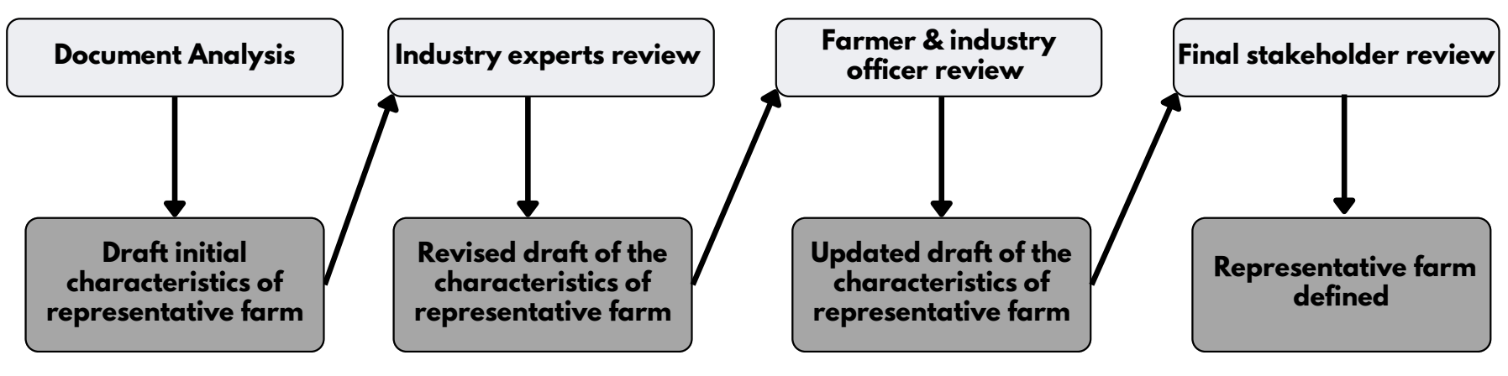

The key to this approach for defining a robust, defendable, representative farm is data triangulation. Donkoh and Mensah (2023) quote Turner and Turner (2009) and explain ‘triangulation in social science research as the process of studying a social phenomenon by combining data (p.8). That is, multiple sources of evidence strengthen the case being defined through triangulation (Carter, 2014; Jick, 1979). This process involves synthesising various evidence sources to enhance credibility, check the validity of data, and provide several perspectives on the topic of interest that might otherwise be overlooked, thereby developing a more reliable characteristic. Key sources of information include literature, statistics, interviews, and focus group discussions with local farm advisors, consultants, and farmers. Donkoh and Mensah (2023) proceed to say, ‘data triangulation is not just to gather comprehensive data about the phenomenon being studied, it is a means of validating and verifying data as well as recognising inconsistencies in the data sets’ (p.8).

Results: How was this Approach Used in an Actual Research Project? ACIAR Project ‘Assessing the Economic and Social Impacts of Shifting to Natural and Sustainable Rice Production Systems in Lao PDR’

The ACIAR project SSS/2023/137 seeks to answer the research question ‘What are the economic implications of the transition to natural and sustainable farm systems for rice farming households in Lao PDR?’. To answer this question, a representative case study farm was defined using the approach described in the previous section.

Smallholder rice farms dominate agricultural production in Lao PDR, though there is diversity in production activities, farming practices, and the connections among natural, social, and economic elements within farming systems. These systems are influenced by geography, resource constraints, and many other variables. A representative farm household that reflects various aspects of a farm system will therefore be a valuable tool not only for the economic analysis in this project but also for future work focused on lowland wet-season rice-producing farming systems in Lao PDR.

The case is a representative wet-season rice-producing farm household operating in the lowland region of Lao PDR, while the context is the rice production dynamics consisting of the farm system, resources, technologies, inputs, outputs, decisions, markets, risks and uncertainties, etc, in which the representative rice farm household operates.

Describing the characteristics of a farm household system in developing country agricultural contexts is not a simple task. It requires a proper understanding of the farming system, which includes individual farm systems with similar resource bases, enterprise patterns, household livelihoods, and constraints, within the context of natural, social, and economic elements and their interactions. A farming system is a unit involving the farm and the household operating complementarily. McConnell and Dillon (1997) described a ‘farm household system’ as a ‘goal setting-open stochastic dynamic system with a major aim of production from agricultural resources…. The whole farm system consists of all the sub-systems or components that together make up a farm, whereas the household is a social system that dominates the farm system, ‘provides purpose and management to the farm component, and as major system beneficiary it receives and allocates system outputs to itself and other beneficiaries’ (p.9). According to Dillon and Hardaker (1993), ‘Farm-household systems usually consist of three interlinked and interactive sub-systems. These are the household as the decision-making unit, the farm with its crop and livestock activities as production elements of the farming system, and an off-farm component involving one or more of work, market or social relationships.’ (p.4).

The specific process for defining a representative lowland wet-season rice production farm in Laos is summarised in Figure 2.

The process started with document analysis – specifically a literature review and compilation of secondary data sources, such as published documents, agricultural census and statistical reports from the census and databases of the Lao PDR government and international organisations on lowland wet-season rice farming systems, which formed the basis of the entire process. In particular, the work by Cramb (2020), Sacklokham et al. (2020), Mullen et al. (2019), Laing et al. (2015), Manivong (2014) and Linquist and Sengxua (2001) were enlightening.

Figure 2. The detailed process used to define the characteristics of a representative lowland wet-season rice farm

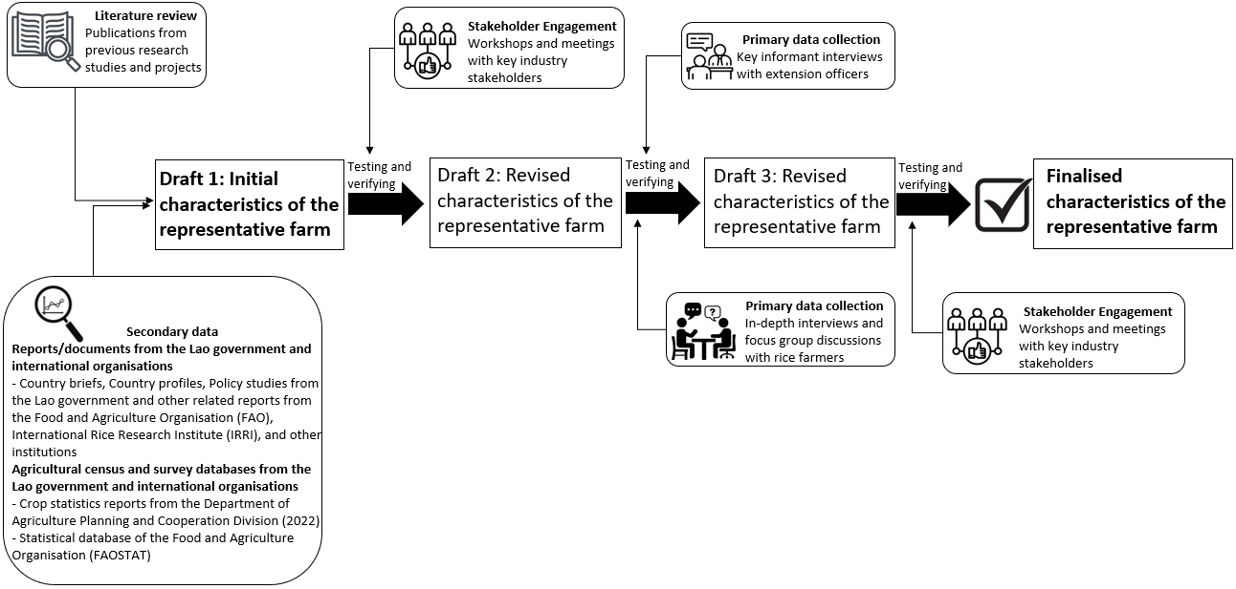

Although some of the data collection stages of the literature date back more than two decades, raising questions about data currency, this literature contributed to defining the initial characteristics of the representative lowland wet-season rice farm (Draft 1 in Figure 2).

This initial draft was tested, reviewed and refined with input from stakeholders, including Lao PDR rice industry experts, particularly during the project's inception workshop. Stakeholders included senior government officials, research scientists, academics, and international researchers. This process resulted in the revised draft, known as Draft 2 in Figure 2, reflecting stakeholders' insights about the characteristics of the representative farm that can be observed at present.

This revised draft was then updated with findings from primary data collection. Interviews and focus group discussions (Ayer et al., 2026) were conducted with extension officers and rice farmers involved in wet-season rice production in Savannakhet, the location where the lowland wet-season farming system is being defined. The data collected focused on farming practices, technologies, resource and input use, outputs, markets, and management decisions within the farm household. Extension officers from provincial and district-level government institutions, serving as key informants, provided detailed insights into wet-season rice production in Savannakhet province. They have extensive experience working directly with farmers and are responsible for gathering and analysing farm-level data to inform planning and policy decisions. Farmers, as the other primary data source, shared their individual experiences and knowledge of lowland wet-season rice farming. The researchers used these findings to create Draft 3 of the representative farm.

To ensure that the researchers had accurately captured the information from the previous steps, this updated draft (Draft 3) was tested with stakeholders during a stakeholder workshop. Participants in this workshop included industry officers from the region where the primary data were collected, senior government officials, research scientists, academics, and international researchers with more than 10 years of experience in this area. This was the final step in validating the representative farm's characteristics.

The result of this process was that a robust, defendable, rice farm representative of lowland rice production in Savannakhet was defined (see Figure 3).

Following the process described in the method section enabled the researchers to adopt a systematic approach to defining a representative case study farm. Since the researchers had not worked in Lao PDR before, starting with the secondary data sources provided a good introduction to rice production and the rice industry in the country. Subsequently, through engagement with stakeholders across various forums, the researchers' knowledge and understanding of the production system deepened. These individuals were excellent sources of information and advice. The outcome was a defined representative farm system that all stakeholders agreed on, which can be used to assess the economic impacts of changes to this system.

Concluding Discussion

The main aim of this paper was to present an approach for describing a representative case-study farm system and thereby build on the work of Malcolm (2000) and Sinnett et al. (2019). As farm economists, they have been pioneering the use of the approach to conduct case studies on real farms, addressing research questions related to farm systems analysis. This paper extends their work by demonstrating how to develop and describe a representative case-study farm. This approach was used and demonstrated in this paper for the ACIAR Project SSS/2023/137 to define a representative farm household engaged in lowland wet-season rice production in Lao PDR. The representative farm served

Figure 3. Characteristics of the representative farm

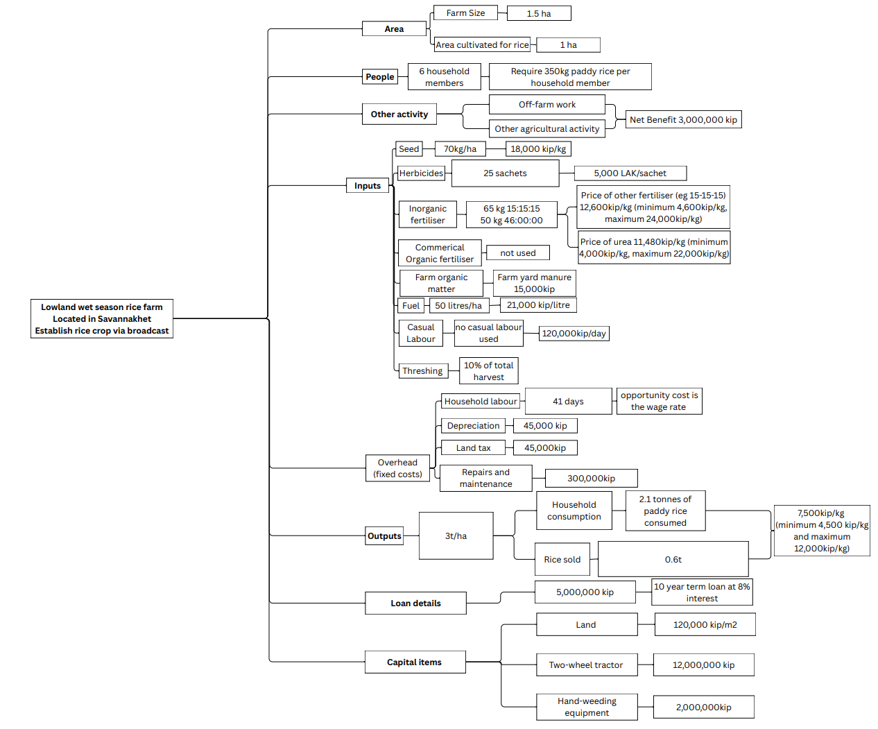

as a starting point for understanding the farm system and the current practices of smallholder rice-farming households. It also provided the basis for conducting an economic analysis of the welfare effects of changes in government policies related to agricultural production inputs for a Lao PDR rice farm business and household (see Sinnett et al., 2026). Thus, it needed to be robust and defendable.

The representative farm being discussed in this paper was constructed by defining its characteristics using multiple sources of data - secondary data obtained from the literature, agricultural and household census and survey reports, databases from the Lao PDR government and international organisations, as well as primary data collected through field visits, in-depth interviews, focus group discussions with farmers, key informant interviews, stakeholder meetings, and workshops. The initial description of the characteristics of the representative farm is based on a comprehensive literature review of previous research on rice farming systems in the country, which were then triangulated across different spatial, temporal, and other dimensions using primary data sources through document analysis, interviews, workshops and discussions. Data from multiple methods and sources enabled refining, updating, and enhancing the credibility, validity, and robustness of the data describing the representative farm.

The resulting representative farm is rich in detail, given the magnitude of information, variability, and complexity it carries, as the exercise is to construct a representative farm similar to or closer to the details of a real farm. This approach of describing a representative farm offers several benefits to researchers and has several strengths. Specifically, the approach is a useful starting point for researchers who are foreign to a research location and provides a first look for those beginning farm economic research, trying to study and understand existing farming systems in unfamiliar areas. Data obtained from multiple sources and methods help researchers study diverse dimensions of a farming system through the lens of a virtual (unreal) farm system with rich information, and conduct preliminary analyses to address a research question. Malcolm (2004) explained ‘… such analyses are most commonly carried out at a higher level of abstraction than is done for particular farm businesses, and real farm families are not part of them’ (p.51). That is why farm economists often use a representative farm to conduct a first look or to demonstrate a method. Like real case studies, developing a representative case study can be resource-intensive, requiring greater expertise and a higher time commitment.

This work, which presents an approach for defining a representative farm by triangulating multiple data sources and methods for analytical purposes, can be a powerful and highly useful approach, provided it is done systematically. The depth and reliability of information about the representative farm and its features, achieved through triangulation, are a key strength of this approach; therefore, the resulting representative farm system is grounded in evidence. Researchers can also gather a broad spectrum of information within the representative farm household, broadening the understanding of a farming system that a single farm might not be able to offer on its own.

Furthermore, it was useful in filling gaps in data from a single source and confirming findings from a primary source. For example, when data from previous literature was outdated, secondary sources like the agricultural census and even primary data proved helpful in providing current information.

A challenge faced when describing the technical features of the representative farm was the lack of current data. For instance, the rice yield estimate for the farm was based on yield response functions to nitrogen fertiliser from literature that is over twenty years old. Therefore, a limitation may be that some technical aspects might be based on expert opinion rather than current scientific data, which is why data triangulation is important to ensure that researcher bias is minimised.

Another challenge in maintaining the farm's representativeness is that selecting data carefully is essential to accurately reflect the real situation. If this is not done, then the outcomes from a representative farm built on incorrect data become highly biased and unsuitable. That is why such an iterative process is required – emphasising the need for multiple sources of evidence to back each characteristic.

A limitation of this approach was highlighted by Malcolm (2004), that ‘farm models can only ever be partial representations of reality. Farm businesses are complex operations with many dimensions (p.47). Referring to a real farm, Carter (1963) quoted Holmes (1932), ‘even a small farm is a complex economic organism, and every individual farm departs widely in one or more important characteristics from the so-called norm’ (p.1450). It needs to be noted that when defining the representative farm, there will always be a gap between the ‘synthetic case farm’ (Feuz & Skold, 1992) (p.44) created through research, and a real farm. Capturing all dimensions of a dynamic environment like a farm can be tackled using real case farms, which Malcolm (2000) explains ‘… analysis of the effects of research findings and policy changes on the situation of the representative, but unreal, farms would be enhanced by some parallel, real, whole farm case studies because representative or average farms do not actually exist' (pp.24-25).

To broaden the investigation of the research problem, a real-world case study could be used alongside a representative case study. A real farm case study would capture all aspects of a dynamic environment, which a representative farm alone cannot fully provide. Using actual farm case studies alongside representative farm analyses would provide richer detail, as each farm operation has its own history and will face different circumstances ahead, and no generalised synthetic farm will capture this. The extra insights into the options and potential of actual farm environments, as well as the ambitions of the farmers, will influence their future outcomes (Malcolm, 2004).

To conclude, the strengths and benefits of using a systematic approach to understand and describe a representative farm system result in a robust case for farm economists to conduct their research. It is particularly useful in unfamiliar settings. In unfamiliar settings, starting with a representative farm (defined using the process described above) is an excellent first step to give researchers a deeper appreciation of farming systems before adding real farm case studies to their research.

References

Ayre, Margaret, Height, Kaitlyn, Kousonsavath, Chitpasong, Fue Yang, Chialue, Lytoua, Mullen, John, Griffith, Garry, Rathnayake, Chinthani and Sinnett, Alexandria (2026), ‘Exploring the social implications of changing to low-input and organic rice production in Lao PDR’, Agricultural and Resource Economics and Agribusiness (AREA) Working Papers, 2026, Paper 1 (in press).

Botha, P. & Meiring, J. (2001). 'Production risk advice at whole farm level: Representative versus mean farms'. Agrekon, 40(2), 280-290.

Carter, H.O. (1963). 'Representative farms: guides for decision making?' Journal of Farm Economics, 45(5), 1448-1455.

Carter, N. (2014). 'The use of triangulation in qualitative research'. Oncology Nursing Forum, 41(5), 545-547.

Chibanda, C., Agethen, K., Deblitz, C., Zimmer, Y., Almadani, M.I., Garming, H., Rohlmann, C., Schütte, J., Thobe, P. & Verhaagh, M. (2020). 'The typical farm approach and its application by the Agri Benchmark network'. Agriculture, 10(12), 646.

Cramb, R. (2020). White gold: The commercialisation of rice farming in the lower Mekong Basin. Springer Nature.

Crosthwaite, J., MacLeod, N.D. & Malcolm, B. (1997). 'Case studies: Theory and practice in agricultural economics.' A paper presented to the 41st Conference of the Australian Agricultural and Resource
Economics Society, Gold Coast, 23-25.

Dillon, J.L. & Hardaker, J.B. (1993). Farm management research for small farmer development. Issue 41 of Agricultural Services Bulletin, FAO, Rome.

Dimas, A. (2023). Variability in Rice Returns Using a Representative Farm Approach. Unpublished masters thesis, Louisiana State University and Agricultural & Mechanical College, Baton Rouge.

Donkoh, S. & Mensah, J. (2023). 'Application of triangulation in qualitative research'. Journal of Applied Biotechnology and Bioengineering, 10(1), 6-9.

Elliott, F.F. (1928). 'The "representative firm" idea applied to research and extension in agricultural economics'. Journal of Farm Economics, 10(4), 483-498.

Eshetae, M.A., Abera, W., Tamene, L., Mulatu, K. & Tesfaye, A. (2024). 'Understanding farm typology for targeting agricultural development in mixed crop-livestock farming systems of Ethiopia.' Farming System, 2(3), 100088.

Feuz, D.M. & Skold, M.D. (1992). 'Typical farm theory in agricultural research'. Journal of sustainable agriculture, 2(2), 43-58.

Flyvbjerg, B. (2006). 'Five misunderstandings about case-study research.' Qualitative inquiry, 12(2), 219-245.

Jick, T.D. (1979). 'Mixing qualitative and quantitative methods: Triangulation in action.' Administrative science quarterly, 24(4), 602-611.

Köbrich, C., Rehman, T. & Khan, M. (2003). 'Typification of farming systems for constructing representative farm models: two illustrations of the application of multi-variate analyses in Chile and Pakistan'. Agricultural Systems, 76(1), 141-157.

Laing, A., Roth, C., Phengvichith, V., Inthavong, T., Sipaseuth, T., Souliyavongsa, X., Thiravong, K., Vorlasan, S. & Schiller, J. (2015). Direct Seeded Rice in Lao PDR Summary of Learnings From the ACCA and ACCA-SRA Projects. Brisbane: CSIRO Agriculture Flagship

Lasner, T. (2020). '“Being Typical”–The Representative Farms Method in Aquaculture and Fisheries.' Mediterranean Fisheries and Aquaculture Research, 3(2), 92-100.

Lasner, T., Brinker, A., Nielsen, R. & Rad, F. (2017). 'Establishing a benchmarking for fish farming–Profitability, productivity and energy efficiency of German, Danish and Turkish rainbow trout grow‐out systems.' Aquaculture Research, 48(6), 3134-3148.

Linquist, B. & Sengxua, P. (2001). Nutrient management in rainfed lowland rice in the Lao PDR. Los Baños (Philippines): International Rice Research Institute. 88 pp.

Malcolm, B. (2000). 'Farm management economic analysis: a few disciplines, a few perspectives, a few figurings, a few futures.' Annual Conference of Australian Agricultural and Resource Economics Society, Sydney.

Malcolm, B., Ho, C.K., Armstrong, D.P., Doyle, P.T., Tarrant, K.A., Heard, J., Leddin, C. & Wales, W. (2012). 'Dairy directions: a decade of whole farm analysis of dairy systems.' Australasian Agribusiness Review, 20, 39-58.

Malcolm, L. (2004). 'Farm management analysis: a core discipline, simple sums, sophisticated thinking.' Australian Farm Business Management Journal, 1(1), 45-55.

Manivong, V. (2014). Agrarian transition in lowland southern Laos: implications for rural livelihoods. Unpublished PhD dissertation, The University of Queensland]. Brisbane.

McConnell, D.J. & Dillon, J.L. (1997). Farm management for Asia: A systems approach (Vol. 13). Food & Agriculture Org.

Miller, T.A. (1967). Aggregation error in representative farm linear programming supply estimates. Iowa State University.

Mullen, J., Malcolm, B. & Farquharson, R. (2019). Impact assessment of ACIAR-supported research in lowland rice systems in Lao PDR. ACIAR Impact Assessment Series, ACIAR, Canberra.

Munoz, A. & Barroso, R. (2018). 'Economic Viability of Tilapia Farming in Northeast Brazil.' World Aquaculture Society, AQUA 2018, Meeting Abstract, Montpellier. https://www. embrapa. br/en/busca-de-publicacoes/-/publicacao/1105018/economic-viability-of-tilapia-farming-in-northeast-brazil (last access 01/30/2020),

Ndambi, O.A., Garcia, O., Balikowa, D., Kiconco, D., Hemme, T. & Latacz-Lohmann, U. (2008). 'Milk production systems in Central Uganda: a farm economic analysis.' Tropical Animal Health and Production, 40(4), 269-279.

Ndambi, O.A. & Hemme, T. (2009). 'An economic comparison of typical dairy farming systems in South Africa, Morocco, Uganda and Cameroon.' Tropical Animal Health and Production, 41(6), 979-994.

Plaxico, J.S. & Tweeten, L.G. (1963). 'Representative farms for policy and projection research.' Journal of Farm Economics, 45(5), 1458-1465.

Rathnayake, Chinthani, Sinnett, Alexandria, Kousonsavath, Chitpasong, Fue Yang, Chialue, Lytoua, Ayer, Margaret, Mullen, John, Malcolm, Bill and Griffith, Garry (2025), ‘Characteristics of a representative wet-season lowland rice farm in Lao PDR’, Agricultural and Resource Economics and Agribusiness (AREA) Working Papers, 2025, Paper 19, 4 September.

Sacklokham, S., Chialue, L. & Yang, F. (2020). 'Rainfed and irrigated rice farming on the Savannakhet plain.' In R. Cramb (Ed.), White gold: The commercialisation of rice farming in the lower Mekong Basin (pp. 151-168). Springer Nature. https://doi.org/https://doi.org/10.1007/978-981-15-0998-8

Schultz, T.W. (1939). 'Theory of the firm and farm management research.' Journal of Farm Economics, 21(3), 570-586.

Sinnett, A., Malcolm, B., Lewis, C. & Ho, C. (2019). 'Farm Economic Research and the Case Study Approach. 'Australasian Agribusiness Perspectives, 22 (13) 221-232.

Sinnett, Alexandria, Malcolm, Bill, Rathnayake, Chinthani, Mullen, John, Ayer, Margaret, Kousonsavath, Chitpasong, Fue Yang, Chialue, Lytoua, and Griffith, Garry (2026), ‘Where's the Incentive for Wet-season Lowland rice producers in Lao PDR to Adopt Alternative Rice Production Practices?’, Agricultural and Resource Economics and Agribusiness (AREA) Working Papers, 2026, Paper 4, (In press).

Stephen, L., Pavel, C., Sergio, G.Y.P. & Folkhard, I. (2012). Sustainability and Production Costs in the Global Farming Sector: Comparative Analysis and Methodologies. JRC Research Reports JRC70116, Joint Research Centre.

Taussig, F.W. (2013). Principles of economics (Vol. 2). Cosimo, Inc.

Thompson, J.F. (1958). 'Defining typical resource situations.' Southern Cooperative Series Bulletin, 56, 32-43.

Turner, P., & Turner, S. (2009). 'Triangulation in practice'. Virtual reality, 13 (3), 171-181.

Walther, S. (2014). Determinants of competitiveness of agriholdings and independent farms in Ukrainian arable production. Thünen Report 15, Braunschweig: Johann Heinrich von Thünen-Institut, 230 pp.
Yin, R.K. (2017). Case study research and applications: Design and methods. Sage publications.

Zimmel, P. & Wilcox, L. (2011). 'A representative farm approach to outreach with beginning farmers and ranchers.' Choices, 26(2). Available online: http://choicesmagazine.org/choices-magazine/theme-articles/innovations-to-support-beginning-farmers-and-ranchers/a-representative-farm-approach-to-outreach-with-beginning-farmers-and-ranchers

The AREA Working Paper series reports work in progress prior to formal external review and includes draft research articles, reports to funding agencies, literature reviews, data collections and the like. Each paper is reviewed within the AREA group. Not for quotation without the consent of the authors.
The support of the Australian Centre for International Agricultural Research in funding this investigation is gratefully acknowledged.
See Rathnayake et al. (2025) for greater detail behind the values for each of these characteristics.

