Agricultural and Resource Economics and Agribusiness (AREA) Working Papers
2026, Paper 23
----------------------------------------------------------------------------------------------------------------Long-Run Relationships Between Australian and World Dairy Product Prices

Matt Selvanª, Paul Deane^{b}, Alex Sinnett^{b}, Murray Jenkinsª, Bill Malcolm^{b} and Garry Griffith^{b}

ª Dairy Australia, Southbank.
^{b} School of Agriculture, Food and Ecosystem Sciences, University of Melbourne, Parkville.
----------------------------------------------------------------------------------------------------------------
Abstract

Since deregulation of the Australian dairy industry in July 2000, the price that farmers receive has been widely understood to reflect the export returns available to processors, who reallocate raw milk between domestic and export markets according to relative returns. Whether Australian export prices follow world prices remains empirically untested. Existing studies of international dairy price transmission typically model Australia and New Zealand as a single Oceania market, obscuring the price relationships specific to Australia given New Zealand’s dominant share of regional exports. This paper addresses that gap using monthly free-on-board prices for butter, cheese, skim milk powder and whole milk powder from Australia, New Zealand, the United States and the European Union. Cointegration between export price series is tested using the Johansen procedure and price shock transmission is examined using impulse response analysis. Butter, skim milk powder and whole milk powder are found to be well integrated, with multiple regions participating in error correction following disequilibrium. Cheese is the exception, with Australia being the only market that adjusts and the other regions appearing to be weakly exogenous. These findings provide evidence of Australia’s price-taking role in global dairy markets, with implications for how international price shocks may transmit to dairy farmer returns.

Key words: price transmission, cointegration, dairy markets, vector error correction model, impulse response analysis

Introduction

The dairy industry was the most highly regulated and assisted major industry in Australia for 75 years until deregulation in 2000. Freebairn (1992), Edwards (2003) and Griffith and Watson (2016) describe the range of policy instruments that were used. State ﬂuid milk markets were tightly controlled by state marketing authorities which licensed farmers to produce milk, regulated quality, took over ownership of milk at the farm gate, set farm prices for milk, imposed production quotas or price pooling, regulated wholesale and retail margins, regulated milk transport and restricted interstate trade in milk. These policies induced a substantial oversupply of fluid milk greater than domestic market requirements which had to be processed and sold on world markets. In response, a number of dairy product stabilisation schemes were implemented, all essentially attempts to shield farmers from the lower and more variable returns that the global market alone would deliver. All of these policies were removed in 2000. Following deregulation, it was generally understood by the dairy industry that international prices had a significant influence on farm-gate prices because a substantial share of Australian milk production is destined for export markets (Freebairn, 2016).

When Australian supermarkets introduced discount private label milk in 2011, the decision sparked debate over its potential downstream impact, ultimately culminating in a Senate inquiry (Senate Economics References Committee 2011). Farmer representative groups feared falling farm incomes, dairy processors raised concerns that the effect on farm-gate milk prices would materialise, and a group of senators argued that sustained discounting would eventually force farmers out of the industry.

The available evidence did not support these views. The Australian Competition and Consumer Commission’s (ACCC) Dairy Inquiry (2018) found that most private label milk contracts allow dairy processors to pass through the cost of raw milk to supermarkets, while the processor’s margin is the primary point of negotiation. Freebairn (2016) argued that all raw milk, whether destined for fresh consumption or manufacturing, tends toward valuation based on its worth in exported dairy products such as butter, cheese, and milk powders. Thus, the retail price of private label milk is therefore not the key determinant of the farm-gate milk price. They are instead shaped by the marginal value of raw milk to processors across all of its potential uses. That value is largely shaped by the returns processors expect to earn across the range of dairy products and markets in which they operate.

However, industry concern remains, so establishing whether Australian export prices share a long-run relationship with international dairy prices is important because it represents the first link in the chain through which global market conditions may influence Australian dairy farmer returns. If international price movements are reflected in Australian export prices, and export prices in turn discipline domestic dairy prices, the returns available to dairy processors are linked to conditions in international markets. This suggests that changes in international dairy prices may ultimately be transmitted to farm-gate milk prices.

Whether Australian export prices do in fact move with international prices in this way is ultimately an empirical question. Existing research offers useful context. Swift (2004) used cointegration techniques to test whether exchange rate movements pass fully through to foreign currency import prices. In an imperfectly competitive world market, exporters could maintain constant foreign prices by absorbing a currency change into their domestic currency markup. However, Swift found complete exchange rate pass-through for milk products and cheese over the period 1985 to 1996, consistent with Australian exporters operating as price takers in competitive markets.

Fousekis et al. (2017) investigated the international skim milk powder market, finding a considerable degree of price co-movement between the European Union, Oceania, and the United States. Price linkages have been stronger between Oceania and the European Union, but the United States has been catching up with them.

Rezitis and Rokopanos (2019) examined butter and whole milk powder markets, revealing that Europe acts as the central market for butter while displacing Oceania as the central market for whole milk powder in more recent periods. However, both Fousekis et al. (2017) and Rezitis and Rokopanos (2019) model Australia and New Zealand as a single Oceania market. With New Zealand accounting for the majority of global dairy exports and Australia just four per cent (Dairy Australia, 2025), price transmission patterns specific to Australia are likely obscured by New Zealand's dominant position within this grouping.

This study addresses that gap directly. Using monthly free-on-board (f.o.b.) prices for butter, cheese, skim milk powder (SMP) and whole milk powder (WMP) from Australia (AU), New Zealand (NZ), the United States (US) and the European Union (EU), it is established whether Australian export prices are cointegrated with export prices from other major dairy trading regions. The cointegrating relationship is analogous to the economic notion of a long-run equilibrium relationship, whereby prices may diverge in the short run but are ultimately drawn back together over time.

This paper is organised as follows. Section 2 describes the data. Section 3 presents the vector error correction model, the cointegration rank tests, and the estimated long-run parameters and adjustment coefficients. Section 4 presents Granger causality tests, impulse response analysis and forecast error variance decomposition. Section 5 concludes.

Data

The data used in this analysis are monthly f.o.b. prices (USD/tonne) of butter, cheese, SMP, and WMP being exported from Australia, New Zealand, the United States and the European Union, collected by Trade Data Monitor (https://tradedatamonitor.com/). The period covered by the analysis is January 2005 to July 2025 providing $247$ observations for estimation. Selvan et al. (2026a) summarises the market and policy developments over the analysis period, while Selvan et al. (2026b) investigates the trends and patterns in the same dataset and to inform the empirical choices made in this paper.

As argued in Selvan et al. (2026b), the data are analysed at the product group level rather than the tariff code level. Prior to the analysis, prices are adjusted for inflation using the Consumer Price Index (FRED 2025) and transformed to log prices.

Price linkages may arise through direct trade between these four regions or indirectly through competition in shared export markets. In the Australian context, both channels are likely relevant given that New Zealand, the United States and the European Union dominate imports of dairy products into Australia, and the importance of Asian markets as a common destination for dairy exports from all four regions (OECD/FAO 2025). However, the present analysis does not distinguish between these channels.

The Error Correction Model and Estimated Results

Time series are non-stationary when they lack a constant mean or variance over time (Hill et al., 2001). Non-stationary time series have the potential to introduce spurious results, finding significant effects when no such effects exist. Where a stationary linear combination of non-stationary series exists, the series are said to be cointegrated. Such relationships between price series are tested using a Vector Error Correction Model (VECM) following the Johansen (1995) procedure. The VECM with $p$ lags, takes the form:

$$Δx_{t}=Π_{0}+Πx_{t-p}+\sum_{i=1}^{p-1}{\left(Π_{i}Δx_{t-i}\right)}+BD_{t}+CS_{t}+v_{t}$$

where $x_{t}$​ is a $n×1$ vector of endogenous variables (log prices for $n$ dairy trading regions); $Δx_{t}$ represents first differences of $x_{t}$; $Π$ is the long-run impact matrix; $Π_{i}$ captures short-run dynamics; $D_{t}$ is a set of centred seasonal dummy variables; $S_{t}$ is a dummy variable representing the structural change in 2015 identified in Selvan et al (2026); $v_{t}$ is a vector of white noise error terms; and $p$ is the number of lags.

The long-run impact matrix is of particular interest as its rank determines the number of cointegrating relationships among the variables. If $0 < rank\left(Π\right)< n$, then cointegration exists and there are $r$ cointegrating relationships, where $r=rank\left(Π\right)$. The long-run impact matrix can be decomposed as $Π=αβ'$, where $β$ is a $n×r$ matrix of cointegrating vectors representing long-run equilibrium relationships, and $α$ is a $n×r$ matrix of adjustment coefficients indicating the speed at which each variable responds to deviations from equilibrium.

Before estimating the model, the price series are tested to see whether they are integrated of order one, $I(1)$; that is, they are non-stationary in levels, but stationary after taking first differences. As noted above, stationarity is necessary for the application of the Johansen procedure, as well as various other statistical techniques, where non-stationarity can lead to misleading results. In Table 1, Augmented Dickey-Fuller statistics for each price series, in levels and first differences, are reported. The null hypothesis of non-stationarity is tested against the alternative of stationarity. While there is insufficient evidence to reject the null hypothesis for some price series in levels at varying degrees of significance, the null hypothesis is rejected for all price series at the 1 per cent level after differencing.

Table 1. Augmented Dickey-Fuller Tests for Non-stationarity

 |  | Price series in:
Product | Region | Levels | First differences
Butter | AU | $$-{3.91}^{**}$$ | $${-5.20}^{***}$$
 | EU | $$-{3.77}^{**}$$ | $$-{6.59}^{***}$$
 | NZ | $$-{3.62}^{**}$$ | $$-{5.49}^{***}$$
 | US | $$-{3.15}^{*}$$ | $$-{6.36}^{***}$$
Cheese | AU | $$-{3.94}^{**}$$ | $$-{5.04}^{***}$$
 | EU | $$-3.08$$ | $$-{7.91}^{***}$$
 | NZ | $$-{4.68}^{***}$$ | $$-{4.68}^{***}$$
 | US | $$-{3.30}^{* }$$ | $$-{8.18}^{***}$$
SMP | AU | $$-{3.47}^{**}$$ | $$-{4.69}^{***}$$
 | EU | $$-2.63$$ | $$-{5.63}^{***}$$
 | NZ | $$-{3.17}^{* }$$ | $$-{4.48}^{***}$$
 | US | $$-3.02$$ | $$-{4.74}^{***}$$
WMP | AU | $$-{3.63}^{**}$$ | $$-{6.15}^{***}$$
 | EU | $$-{3.59}^{** }$$ | $$-{6.25}^{***}$$
 | NZ | $$-{4.31}^{***}$$ | $$-{4.53}^{***}$$
 | US | $$-2.64$$ | $$-{7.08}^{***}$$
Significance: *** 1 per cent; ** 5 per cent; * 10 per cent.

The log price series, both in levels and in first differences, are shown in Figure 1. The series tend generally to move together across all product groups, but this is most clear for SMP (see also the discussion in Selvan et al. (2026b) regarding interpretation of the graphs of these price series in raw nominal form). After first differencing, the series resemble stationary processes, fluctuating randomly around a mean close to zero with no persistent trend. WMP exhibits higher volatility than the other product groups, particularly for United States monthly log prices in the earlier part of the sample. This likely reflects the relatively limited participation of the United States in global WMP export markets prior to around 2011, after which United States WMP export volumes increased substantially (Rezitis and Rokopanos, 2019).

After confirming the price series are $I(1)$, the appropriate lag length for each product group’s VECM must be determined. The lag length that minimises the Akaike Information Criterion (AIC) is selected, with the maximum being twelve for monthly data. In Table 2, the AIC is minimised at $p=3$ lags for all product groups.

As in Chang and Griffith (1998), two model specifications are considered. Model A, which incorporates a trend drift in the error correction model, and Model B, which includes a constant in the cointegrating vector of the error correction model. To discriminate between Models A and B, the test statistic $LR_{λ}$ suggested in Johansen (1995, eq. 6.27) is used. The $LR_{λ}$ is defined as:

$LR_{λ}=T\sum_{i=r+1}^{n}{[\ln\left(1-λ^{*}\right)-\ln\left(1-λ_{i}\right)]}$,

where $λ^{*}$ and $λ_{i}$ are estimated eigenvalues of the matrix $Π$ for the restricted (Model B) and the unrestricted (Model A) models respectively; $T$ is the number of observations; $r$ is the number of cointegrating vectors in the unrestricted model; and $n$ is the number of price series. The statistic is distributed asymptotically as $χ^{2}$ with $\left(n − r\right)$ degrees of freedom.

Table 3 reports the likelihood ratio test statistics alongside the trace and max-eigenvalue statistics for both model specifications. Model B is selected for all product groups, as the LR test statistics fall below the 1 per cent critical values. Using the selected model and the trace statistic for each product group, one cointegrating relationship is identified for butter and cheese, two cointegrating relationships for SMP, and three cointegrating relationships for WMP.

If $r$ cointegrating relationships exist, $r$ linear combinations are stationary and $(n-r)$ are non-stationary (Williams and Bewley, 1993). The finding of $r=1$ for butter and cheese indicates that the four price series share one stable long-run relationship, while three sources of non-stationarity remain in each system. The number of remaining sources of non-stationarity falls to two for SMP and one for WMP. This points to tightly integrated markets for the milk powders, particularly WMP. This is consistent with milk powders being relatively homogeneous products. Table 4 presents the estimated long-run parameters for
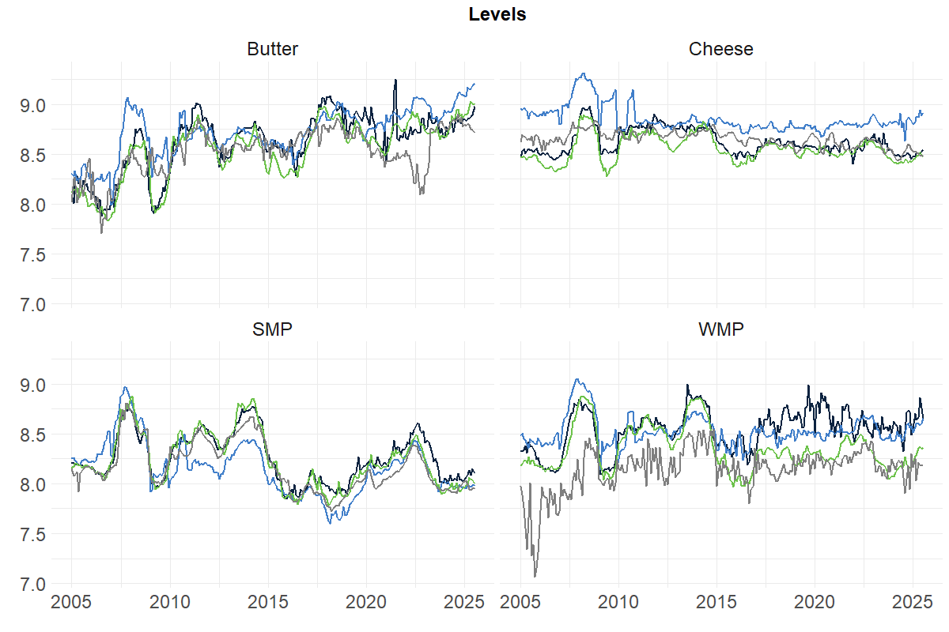each product group.
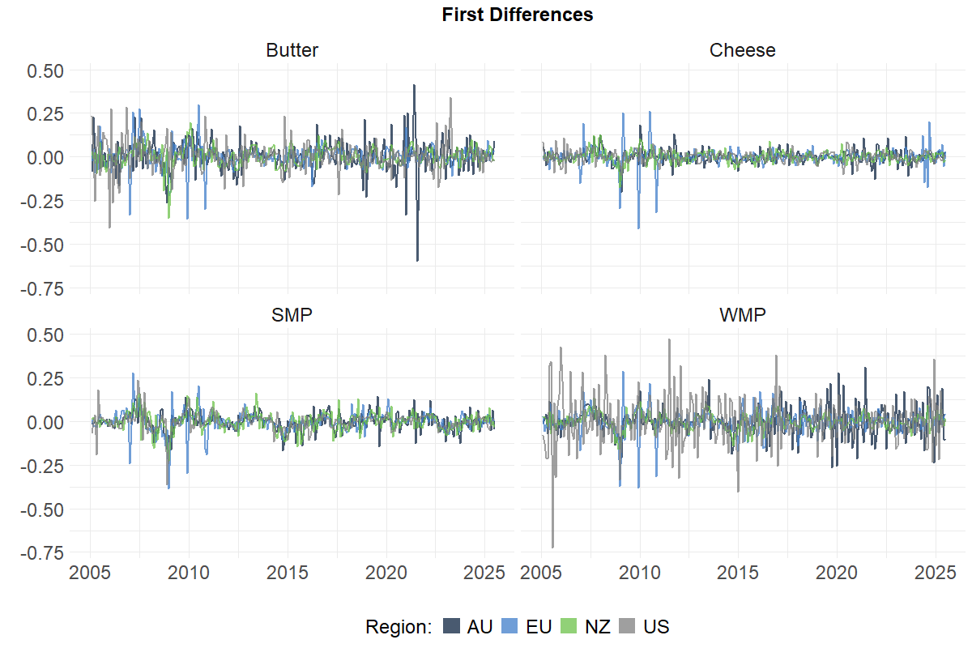

Figure 1. Monthly log prices in levels and first differences

Table 2. VAR model lag selection

 | AIC$(p)$
Lag | Butter | Cheese | SMP | WMP
1 | $$-20.98$$ | $$-25.90$$ | $$-24.00$$ | $$-20.96$$
2 | $$-21.17$$ | $$-25.92$$ | $$-24.53$$ | $$-21.26$$
3 | $$-{21.21}^{*}$$ | $$-{25.95}^{*}$$ | $$-{24.62}^{*}$$ | $$-{21.33}^{*}$$
4 | $$-21.18$$ | $$-25.88$$ | $$-24.58$$ | $$-21.12$$
5 | $$-21.11$$ | $$-25.84$$ | $$-24.53$$ | $$-21.12$$
6 | $$-21.09$$ | $$-25.76$$ | $$-24.45$$ | $$-21.11$$
7 | $$-21.03$$ | $$-25.78$$ | $$-24.44$$ | $$-21.11$$
8 | $$-20.99$$ | $$-25.58$$ | $$-24.34$$ | $$-21.10$$
9 | $$-20.89$$ | $$-25.57$$ | $$-24.28$$ | $$-20.98$$
10 | $$-20.84$$ | $$-25.57$$ | $$-24.24$$ | $$-20.97$$
11 | $$-20.83$$ | $$-25.57$$ | $$-24.23$$ | $$-20.98$$
12 | $$-20.86$$ | $$-25.58$$ | $$-24.22$$ | $$-21.06$$
* Minimum
Table 3. Summary of rank tests on matrix $Π$ of the error correction model

Butter
 | Estimated $λ$ | $$λ_{max}$$ | $$λ_{trace}$$
Model A with a linear trend in cointegration, $r=1$
$$r=0$$ | $$0.186$$ | $$50.23$$  $$(36.65)$$ | $$85.22$$  $$(70.05)$$
$$r≤1$$ | $$0.072$$ | $$18.12$$  $$(30.34)$$ | $$34.99$$  $$(48.45)$$
$$r≤2$$ | $$0.040$$ | $$9.89$$  $$(23.65)$$ | $$16.87$$  $$(30.45)$$
$$r≤3$$ | $$0.028$$ | $$6.98$$  $$(16.26)$$ | $$6.98$$  $$(16.26)$$
Model B without linear trend and constant in cointegration, $r=1$
$$r=0$$ | $$0.179$$ | $$48.08$$  $$(33.24)$$ | $$79.33$$  $$(60.16)$$
$$r≤1$$ | $$0.071$$ | $$18.07$$  $$(26.81)$$ | $$31.25$$  $$(41.07)$$
$$r≤2$$ | $$0.031$$ | $$7.65$$  $$(20.20)$$ | $$13.18$$  $$(24.60)$$
$$r≤3$$ | $$0.022$$ | $$5.53$$  $$(12.97)$$ | $$5.53$$  $$(12.97)$$
$$LR_{λ}=3.793<11.345 \left(df=3;α=1\%\right)$$
Cheese
 | Estimated $λ$ | $$λ_{max}$$ | $$λ_{trace}$$
Model A with a linear trend in cointegration, $r=1$
$$r=0$$ | $$0.122$$ | $$31.70$$  $$(36.65)$$ | $$77.76$$  $$(70.05)$$
$$r≤1$$ | $$0.091$$ | $$23.39$$  $$(30.34)$$ | $$46.06$$  $$(48.45)$$
$$r≤2$$ | $$0.049$$ | $$12.31$$  $$(23.65)$$ | $$22.68$$  $$(30.45)$$
$$r≤3$$ | $$0.042$$ | $$10.37$$  $$(16.26)$$ | $$10.37$$  $$(16.26)$$
Model B without linear trend and constant in cointegration, $r=1$
$$r=0$$ | $$0.110$$ | $$28.72$$  $$(33.24)$$ | $$69.29$$  $$(60.16)$$
$$r≤1$$ | $$0.073$$ | $$18.38$$  $$(26.81)$$ | $$40.58$$  $$(41.07)$$
$$r≤2$$ | $$0.049$$ | $$12.20$$  $$(20.20)$$ | $$22.20$$  $$(24.60)$$
$$r≤3$$ | $$0.040$$ | $$10.00$$  $$(12.97)$$ | $$10.00$$  $$(12.97)$$
$$LR_{λ}=5.554<11.345 \left(df=3;α=1\%\right)$$
SMP
 | Estimated $λ$ | $$λ_{max}$$ | $$λ_{trace}$$
Model A with a linear trend in cointegration, $r=1$
$$r=0$$ | $$0.134$$ | $$35.06$$  $$(36.65)$$ | $$80.45$$  $$(70.05)$$
$$r≤1$$ | $$0.098$$ | $$25.06$$  $$(30.34)$$ | $$45.40$$  $$(48.45)$$
$$r≤2$$ | $$0.056$$ | $$13.96$$  $$(23.65)$$ | $$20.34$$  $$(30.45)$$
$$r≤3$$ | $$0.026$$ | $$6.38$$  $$(16.26)$$ | $$6.38$$  $$(16.26)$$
Model B without linear trend and constant in cointegration, $r=2$
$$r=0$$ | $$0.128$$ | $$33.42$$  $$(33.24)$$ | $$74.71$$  $$(60.16)$$
$$r≤1$$ | $$0.093$$ | $$23.72$$  $$(26.81)$$ | $$41.29$$  $$(41.07)$$
$$r≤2$$ | $$0.047$$ | $$11.77$$  $$(20.20)$$ | $$17.57$$  $$(24.60)$$
$$r≤3$$ | $$0.024$$ | $$5.81$$  $$(12.97)$$ | $$5.81$$  $$(12.97)$$
$$LR_{λ}=4.155>11.345 \left(df=3;α=1\%\right)$$
WMP
 | Estimated $λ$ | $$λ_{max}$$ | $$λ_{trace}$$
Model A with a linear trend in cointegration, $r=3$
$$r=0$$ | $$0.155$$ | $$41.17$$  $$(36.65)$$ | $$95.40$$  $$(70.05)$$
$$r≤1$$ | $$0.088$$ | $$22.66$$  $$(30.34)$$ | $$54.22$$  $$(48.45)$$
$$r≤2$$ | $$0.078$$ | $$19.72$$  $$(23.65)$$ | $$31.56$$  $$(30.45)$$
$$r≤3$$ | $$0.047$$ | $$11.83$$  $$(16.26)$$ | $$11.83$$  $$(16.26)$$
Model B without linear trend and constant in cointegration, $r=3$
$$r=0$$ | $$0.142$$ | $$37.29$$  $$(33.24)$$ | $$85.58$$  $$(60.16)$$
$$r≤1$$ | $$0.084$$ | $$21.38$$  $$(26.81)$$ | $$48.30$$  $$(41.07)$$
$$r≤2$$ | $$0.065$$ | $$16.50$$  $$(20.20)$$ | $$26.91$$  $$(24.60)$$
$$r≤3$$ | $$0.042$$ | $$10.41$$  $$(12.97)$$ | $$10.41$$  $$(12.97)$$
$$LR_{λ}=1.442>6.635 \left(df=1;α=1\%\right)$$
Note: The figures in the parentheses are critical values for $λ_{max}$ and $λ_{trace}$ statistics at the 1 per cent significance level.
Table 4. Estimated long-run parameters, $α$s and $β$s

Butter
 | NZ | AU | EU | US | Constant
Estimated $β$s | $$1.00$$  $$(-)$$ | $$-0.80$$  $$(-)$$ | $$-0.47$$  $$(-)$$ | $$0.14$$  $$(-)$$ | $$1.23$$  $$(-)$$
Estimated $α$s | $$-{0.10}^{**}$$  $$(-2.48)$$ | $$-{0.27}^{***}$$  $$(-3.88)$$ | $${0.18}^{***}$$  $$(3.30)$$ | $${0.13}^{*}$$  $$(-1.81)$$
Cheese
 | NZ | AU | EU | US | Constant
Estimated $β$s | $$1.00$$  $$(-)$$ | $$-1.25$$  $$(-)$$ | $$-1.12$$  $$(-)$$ | $$0.29$$  $$(-)$$ | $$0.80$$  $$(-)$$
Estimated $α$s | $-0.26$  $$(-0.63)$$ | $${0.18}^{***}$$  $$(4.18)$$ | $$0.10$$  $$(1.52)$$ | $$0.01$$  $$(0.19)$$
SMP
 | NZ | AU | EU | US | Constant
Estimated $β$s
$$ect1$$ | $$1.00$$  $$(-)$$ | $$0.00$$  $$(-)$$ | $$0.04$$  $$(-)$$ | $$-1.36$$  $$(-)$$ | $$2.59$$  $$(-)$$
$$ect2$$ | $$0.00$$  $$(-)$$ | $$1.00$$  $$(-)$$ | $$0.06$$  $$(-)$$ | $$-1.42$$  $$(-)$$ | $$3.01$$  $$(-)$$
Estimated $α$s
$$ect1$$ | $$-{0.19}^{***}$$  $$(-2.85)$$ | $${0.14}^{**}$$  $$(2.27)$$ | $${0.15}^{*}$$  $$(1.88)$$ | $$0.07$$  $$(1.16)$$
$$ect2$$ | $${0.16}^{***}$$  $$(3.04)$$ | $$-{0.10}^{*}$$  $$(-1.89)$$ | $$-0.07$$  $$(-1.12)$$ | $$0.08$$  $$(1.57)$$
WMP
 | NZ | AU | EU | US | Constant
Estimated $β$s
$$ect1$$ | $$1.00$$  $$(-)$$ | $$0$$  $$(-)$$ | $$0$$  $$(-)$$ | $$-0.62$$  $$(-)$$ | $$-3.46$$  $$(-)$$
$$ect2$$ | $$0$$  $$(-)$$ | $$1.00$$  $$(-)$$ | $$0$$  $$(-)$$ | $$0.69$$  $$(-)$$ | $$-2.95$$  $$(-)$$
$$ect3$$ | $$0$$  $$(-)$$ | $$0$$  $$(-)$$ | $$1.00$$  $$(-)$$ | $$-0.11$$  $$(-)$$ | $$-9.42$$  $$(-)$$
Estimated $α$s
$$ect1$$ | $$-{0.09}^{***}$$  $$(-2.82)$$ | $$0.09$$  $$(1.30)$$ | $$0.04$$  $$(0.79)$$ | $${0.30}^{***}$$  $$(2.69)$$
$$ect2$$ | $${0.05}^{*}$$  $$(1.96)$$ | $$-{0.19}^{***}$$  $$(-3.66)$$ | $$-0.02$$  $$(0.59)$$ | $$0.04$$  $$(0.48)$$
$$ect3$$ | $$-0.01$$  $$(-0.01)$$ | $$-0.03$$  $$(0.62)$$ | $$-{0.13}^{***}$$  $$(-3.76)$$ | $${-0.17}^{**}$$  $$(-2.54)$$
Notes: T-ratios for $β$ coefficients are not calculated. Figures in parentheses are t-values.
Significance: *** 1 per cent; ** 5 per cent; * 10 per cent.

Butter. All four markets have statistically significant adjustment coefficients, although the United States coefficient is only marginally significant, indicating each market contributes to correcting deviations from the long-run equilibrium. Australia’s adjustment coefficient is the largest in absolute magnitude $(-0.27)$, suggesting that Australian prices adjust most rapidly to deviations from the long run equilibrium.

Cheese. Only Australian price has a statistically significant adjustment coefficient, indicating that it is the primary error-correcting market in the cheese system. When prices deviate from the long run equilibrium, adjustment occurs through Australian prices, while New Zealand, the European Union and the United States appear to be weakly exogenous to the cointegrating relationship.

SMP. New Zealand and Australia have statistically significant adjustment coefficients for both error-correction terms, while the European Union is marginally significant to the first error-correction term only. The United States adjustment coefficients are not statistically significant. These results indicate that adjustment towards the long-run equilibrium primarily occurs through New Zealand and Australia prices, with the European Union playing a small role and the United States appearing as weakly exogenous to the cointegrating relationships.

WMP. All four markets exhibit statistically significant adjustment coefficients for at least one of the three error correction terms, supporting the view of a tightly integrated WMP market in which each region contributes to restoring the long-run equilibrium.

A consistent finding across all four product groups is that Australia participates in error correction and does so significantly in every system. What sets cheese apart is that Australia is the only region to adjust, unlike butter, SMP and WMP, where at least one other region shares in restoring equilibrium. This would suggest that cheese is the least integrated of the four product groups.

One possible explanation is that the mix of products underlying the aggregate cheese product group series does not necessarily match from one region to the next. This means that each region’s group may not represent quite the same basket of products, which could weaken the appearance of integration even if the underlying markets are, in reality, closely linked.

An alternative explanation is that the cheese product group spans a wide range of heterogeneous products – cheddar, fresh, mould, processed, semi-hard – compared to SMP or WMP, which are largely undifferentiated products. Future work could disaggregate the cheese group into more detailed product categories.

Impulse Response Analysis

To analyse the dynamic transmission of price shocks across regions, impulse response functions (IRFs) and forecast error variance decompositions (FEVDs) are estimated. IRFs trace the response of all prices to a one standard deviation shock in a single region over a 36-month horizon and are especially useful when there are two or more cointegrating relations that may be difficult to interpret on economic grounds alone (Chang and Griffith, 1998), as is the case with SMP and WMP. The FEVDs show how much of the variation in each region’s price can be attributed to shocks originating elsewhere over the same horizon. Together, they give an indication of which regions behave as price-makers and which as price-takers in global dairy markets.

Both methods are dependent on the order of the variables based on a priori grounds. There is a reasonable case for placing New Zealand first, as the world's largest dairy exporter and home of the Global Dairy Trade (GDT) platform, which has become an increasingly credible global price reference for dairy commodities. Australia follows given its similar economy and policy stance and geographic proximity to New Zealand. The European Union and the United States are placed last, reflecting the greater insulation of their markets from global price signals as a result of policy interventions. The United States is ordered after the European Union given its weaker price leadership role in international dairy markets, as suggested by Fousekis et al. (2017) and Rezitis and Rokopanos (2019), as well as the fact that they were insignificant exporters at the start of the sample period.

As an additional check on the assumed ordering, Granger causality tests are conducted for each pair of regions, with results reported in Table 5. These results are also of interest in their own right as evidence of the direction of causality across regions. See also Griffith et al. (2026) for Granger causality tests of the same prices before log transformation. The results are broadly in favour of the assumed ordering. New Zealand prices most consistently Granger-cause movements in other regions, with Australia proving particularly responsive across all four product groups. SMP is the most globally connected, with all regions Granger-causing one another, followed by butter, while cheese is the least integrated. WMP presents the clearest case for New Zealand price leadership, with causation running predominantly from New Zealand outward.

Figure 2 presents the IRFs for butter, cheese, SMP and WMP. In each figure, columns identify the region in which the shock originates, and rows identify the responding region, with 95 per cent bootstrap confidence intervals constructed from 2,000 replications represented by the shaded areas. The results confirm that shocks to New Zealand prices have the largest and most persistent effect on the system across all commodities, with Australian prices adjusting most strongly.

This is reinforced by the FEVD results in Figure 3. The forecast error variance of New Zealand prices is largely explained by New Zealand's own shocks, consistent with its role as a price-maker, while New Zealand shocks account for a substantial and growing share of forecast error variance in other regions over the 36-month horizon. Australian prices show relatively low self-explanation and limited sway in other regions, indicating a price-taker role. European Union and United States prices exhibit higher self-explanation than does Australian prices, but do not explain much variation elsewhere either.

As noted above, this likely reflects the insulation of the European Union and United States markets from global price signals through policy interventions during the sample period (see Selvan et al., 2026a; Vitaliano, 2016). Although some of these policies were removed, others persisted or were replaced by new measures. As a result, European Union and United States prices were being actively managed rather than freely responding to global price signals.

Table 5. Granger causality tests

Butter
 | AU Causes | NZ Causes | EU Causes | US Causes
AU | — | 16.848*** | 8.696*** | 2.285*
NZ | 5.674*** | — | 3.287** | 1.523
EU | 2.812** | 4.817*** | — | 1.974
US | 2.727** | 4.016*** | 0.9204 | —
Cheese
 | AU Causes | NZ Causes | EU Causes | US Causes
AU | — | 16.032*** | 0.611 | 1.177
NZ | 1.062 | — | 0.490 | 0.528
EU | 0.014 | 1.012 | — | 0.533
US | 2.385* | 2.402* | 3.197** | —
SMP
 | AU Causes | NZ Causes | EU Causes | US Causes
AU | — | 18.677*** | 15.828*** | 15.841***
NZ | 14.144*** | — | 4.040*** | 12.521***
EU | 3.237** | 3.376** | — | 13.341***
US | 6.116*** | 7.398*** | 4.516*** | —
WMP
 | AU Causes | NZ Causes | EU Causes | US Causes
AU | — | 19.309*** | 1.705 | 0.538
NZ | 0.704 | — | 1.758 | 0.828
EU | 2.283* | 7.245*** | — | 0.346
US | 2.460* | 4.520*** | 1.558 | —
Significance: *** 1 percent; ** 5 percent; * 10 percent.

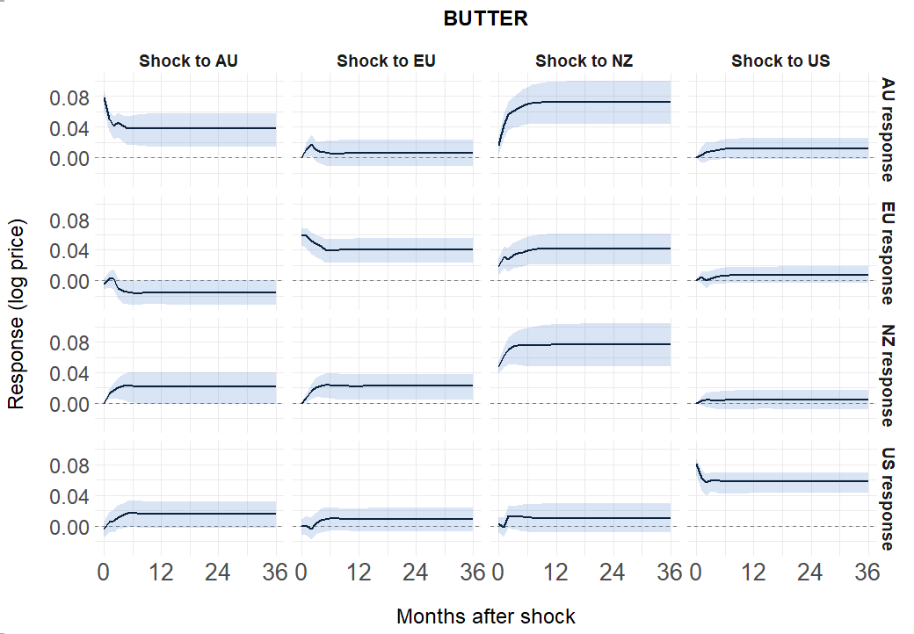
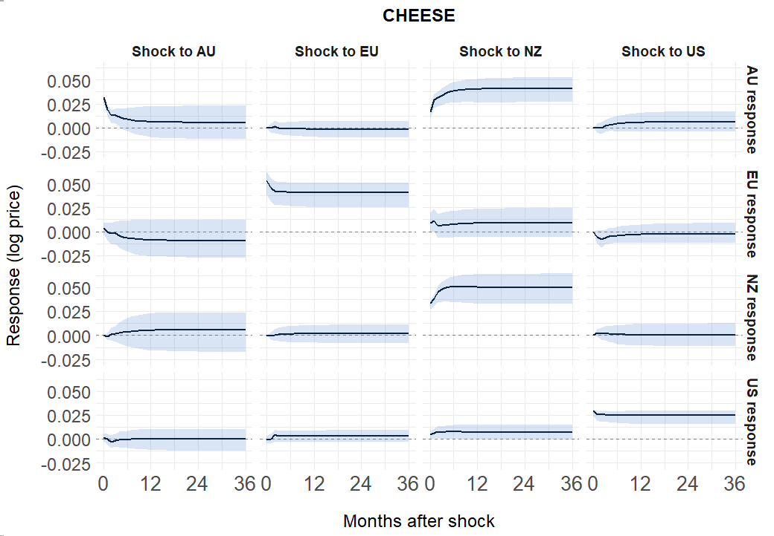

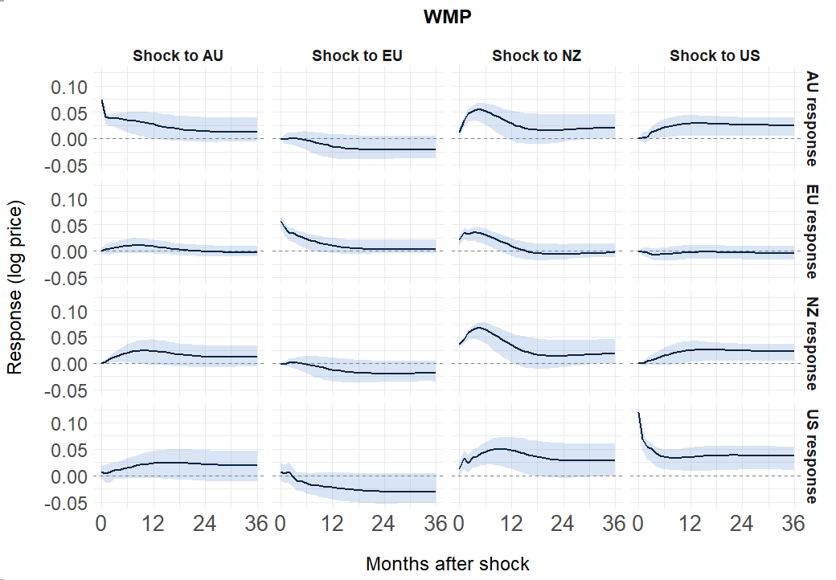
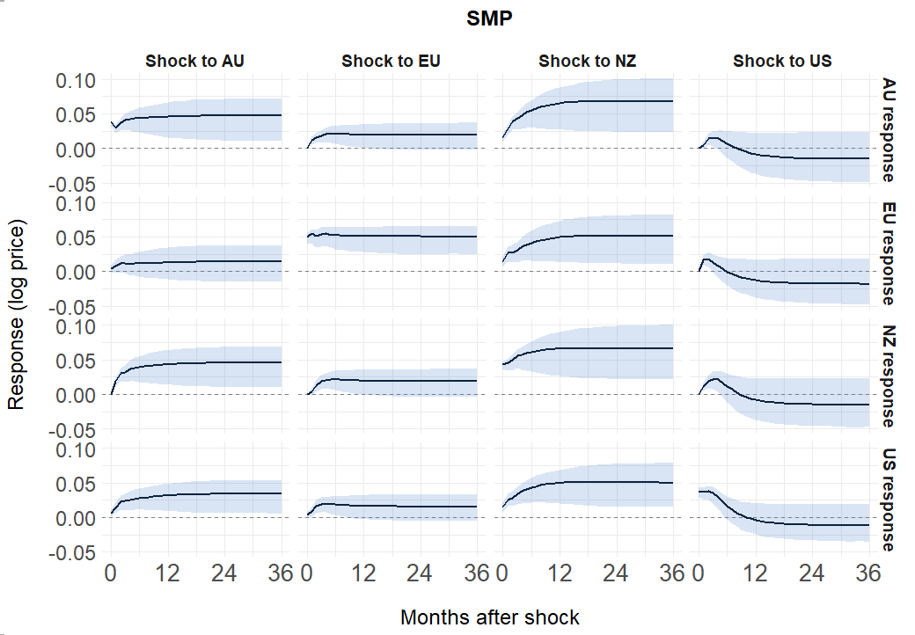
Figure 2. Impulse response functions by region and product group

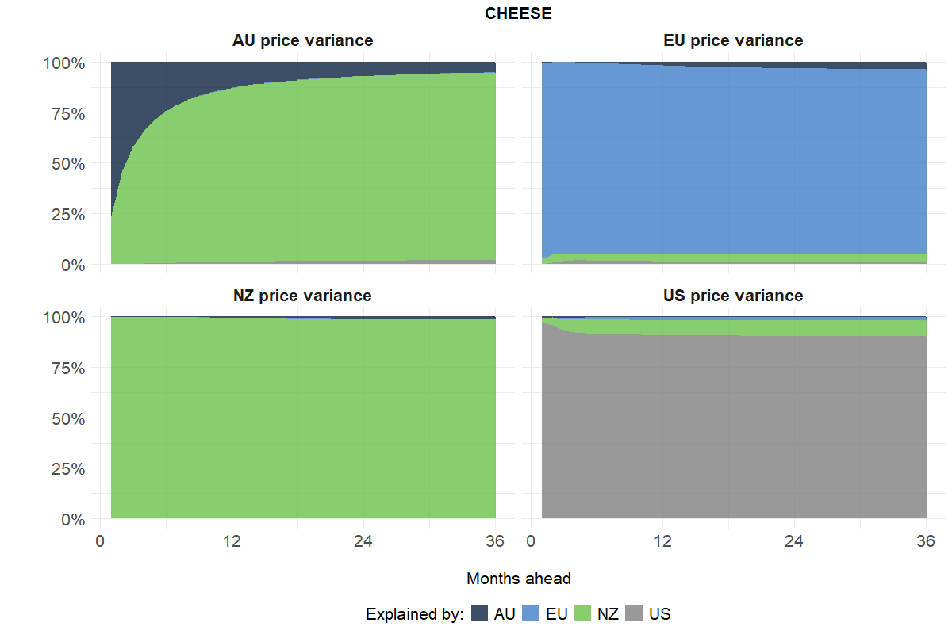
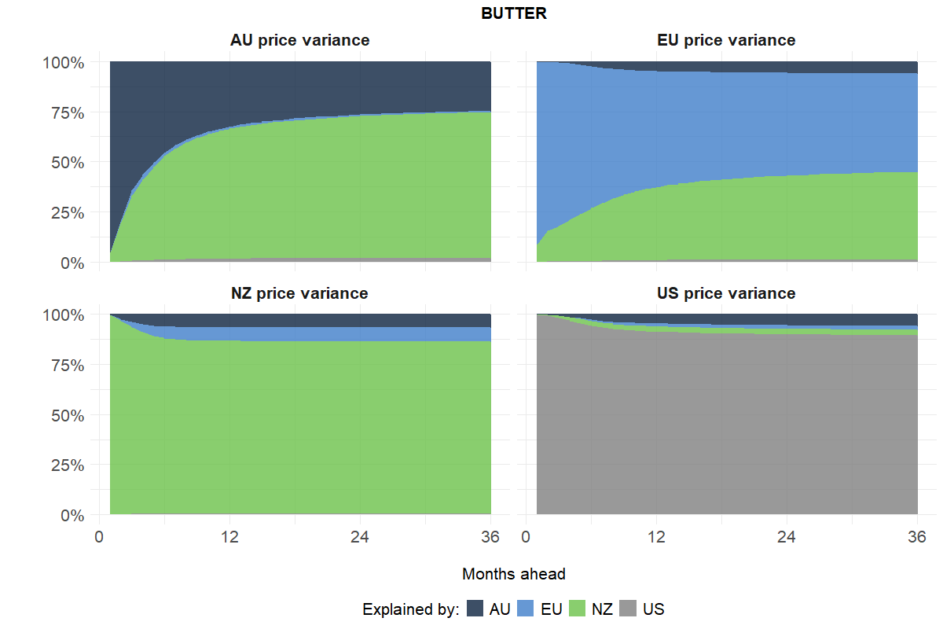

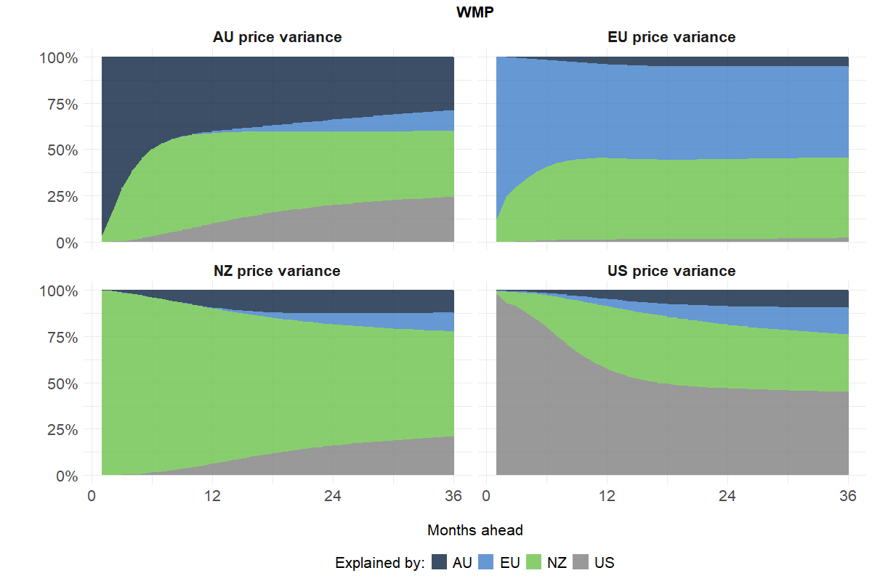
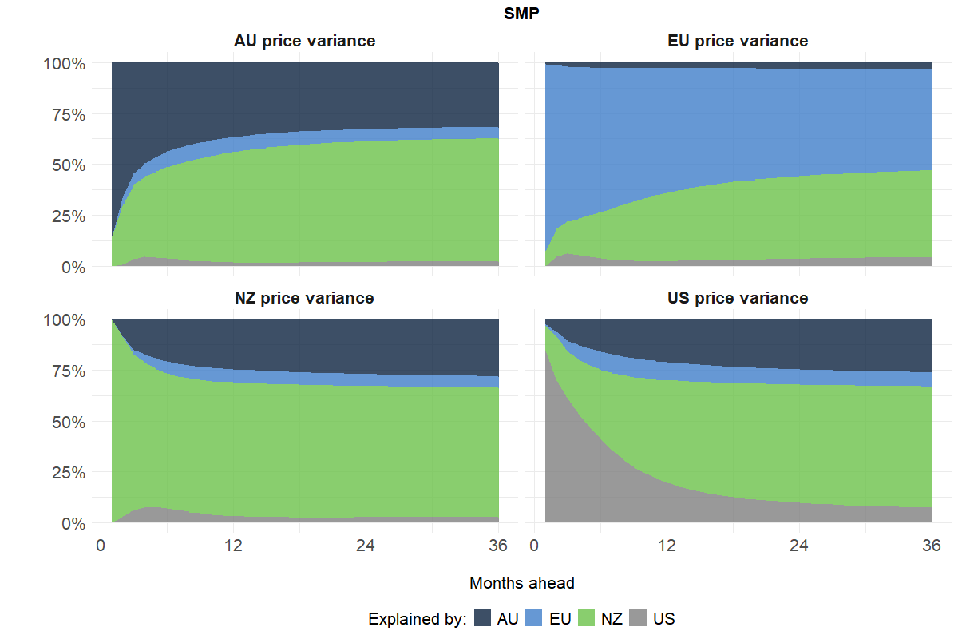
Figure 3. Forecast error variance decomposition by region and product group

Conclusion

It has long been understood that Australia's dairy industry has been exposed to international market forces since deregulation, with the returns available from export markets shaped by global dairy supply and demand conditions. However, the relationship between Australian and international dairy commodity prices has not previously been formally tested. The results of this study provide empirical evidence that Australian export prices for butter, cheese, skim milk powder and whole milk powder are cointegrated with international prices.

The results also clarify where those global price signals originate. Across the four product groups examined, New Zealand emerges as the dominant price leader, with Australian prices responding most strongly and consistently to New Zealand shocks. This is consistent with New Zealand's position as the world's largest dairy exporter, and Australia’s closeness to New Zealand. Australia, despite being a significant exporter in its own right, plays a largely price-taking role. European Union and United States prices are more insulated in the short run, likely due to policy interventions, but remain tied to global price trends over the long run.

Taken together, the findings paint a clear picture of an internationally integrated Australian dairy export sector, one in which global price signals originating predominantly from New Zealand flow through to Australian export prices with a speed and persistence that leaves little room for sustained divergence.

More broadly, the results support the view that export price parity provides a useful framework for understanding price formation in the Australian dairy industry (Freebairn, 2016). As Australian export prices move with international dairy prices, changes in global market conditions alter the relative attractiveness of export and domestic sales. When international prices rise, exporting becomes more profitable and dairy processors have an incentive to direct additional product to export markets. Conversely, as domestic prices rise above the returns available from exporting, dairy processors have an incentive to increase supply to the domestic market, placing downward pressure on prices.

Just as Australian export prices cannot persistently diverge from international prices, domestic prices cannot persistently diverge from export prices. Any sustained difference would induce processors to reallocate product between domestic and export markets until parity is restored.

This has implications for industry strategies aimed at increasing domestic demand. Even where generic marketing campaigns are successful in encouraging consumers to purchase Australian dairy products in preference to imported alternatives, the scope for sustained price increases – and, by extension, farmgate returns – is limited if export price parity continues to bind.

This study therefore provides a foundation for future research examining how these international price signals propagate domestically, both vertically along the supply chain from farm-gate through wholesale to retail, and spatially across Australian dairy producing regions.

The extent to which international price shocks are transmitted through dairy processors to farm-gate milk prices, and whether dairy farmers ultimately capture or are insulated from those movements, has direct implications for producer welfare. In this respect, the findings sharpen an unresolved question raised by Leung and Furfaro (2020), who find that dairy processor stock prices are largely insensitive to movements in global dairy commodity prices.

If Australian export prices move closely with international markets, as the results here suggest, the question of whether processors absorb that volatility within their operations or pass it through to farmers becomes all the more pressing.

References

Australian Competition and Consumer Commission (2018). Dairy inquiry: final report. ACCC, Canberra.

Chang, H.-S. and Griffith, G. (1998). ‘Examining long-run relationships between Australian beef prices’. Australian Journal of Agricultural and Resource Economics, 42 (4), 369–387.

Dairy Australia (2025). The Australian dairy industry: in focus 2025. Dairy Australia, Southbank.

Edwards, G. (2003). ‘The story of deregulation in the dairy industry’. Australian Journal of Agricultural and Resource Economics, 47 (1), 75–98.

Fousekis, P., Emmanouilides, C. and Grigoriadis, V. (2017). ‘Price linkages in the international skim milk powder market: empirical evidence from nonparametric and time-varying copulas’. Australian Journal of Agricultural and Resource Economics, 61 (1), 135–153.

Federal Reserve Bank of St. Louis (2025). ‘Consumer price index for all urban consumers: all items in U.S. city average’. Federal Reserve Economic Data (FRED). Available at https://fred.stlouisfed.org/series/CPIAUCSL.

Freebairn, J. W. (1992). ‘Dairy industry policy’. Review of Marketing and Agricultural Economics, 60 (1), 23–41.

Freebairn, J.W. (2016). ‘Higher supermarket prices for milk won't necessarily help farmers’. The Conversation, 6 June. Available at https://theconversation.com/higher-supermarket-prices-for-milk-wont-necessarily-help-farmers-60184.

Griffith, G. and Watson, A. (2016). ‘Agricultural markets and marketing policies’. Australian Journal of Agricultural and Resource Economics. Available at: DOI: 10.1111/1467-8489.12161

Griffith, Garry, Selvan, Matt, Deane, Paul, Jenkins, Murray, Sinnett, Alex and Malcolm, Bill (2026). ‘Causal Relationships in World Dairy Product Prices’, Agricultural and Resource Economics and Agribusiness (AREA) Working Papers 2026, Paper 22.

Hill, R.C., Griffiths, W.E. and G.G Judge (2001), Undergraduate Econometrics, 2nd Edition, John Wiley & sons, Inc., New York and Brisbane.

Leung, H. and Furfaro, F. (2020). ‘Comovement of dairy product futures and firm value: returns and volatility’. Australian Journal of Agricultural and Resource Economics, 64, 632–654.

Lloyd, A.G. (1950). ‘The marketing of dairy produce in Australia’. Review of Marketing and Agricultural Economics, 18 (1), 6–92.

OECD/FAO (2025), OECD-FAO Agricultural Outlook 2025-2034, OECD Publishing, Paris/FAO, Rome, https://doi.org/10.1787/601276cd-en.

Johansen, S. (1995). Likelihood-based inference in cointegrated vector autoregressive models. Oxford University Press, Oxford.

Rezitis, A.N. and Rokopanos, A. (2019). ‘Impact of trade liberalisation on dairy market price co-movements between the EU, Oceania, and the United States’. Australian Journal of Agricultural and Resource Economics, 63, 472–498.

Selvan, Matt, Deane, Paul, Jenkins, Murray, Sinnett, Alex, Malcolm, Bill and Griffith, Garry (2026). ‘Market and Policy Changes in World Dairy Product Markets’, Agricultural and Resource Economics and Agribusiness (AREA) Working Papers 2026, Paper 20.

Selvan, Matt, Deane, Paul, Jenkins, Murray, Sinnett, Alex, Malcolm, Bill and Griffith, Garry (2026). ‘Trends, Patterns and Relationships in World Dairy Product Prices’, Agricultural and Resource Economics and Agribusiness (AREA) Working Papers 2026, Paper 21.

Senate Economics References Committee (2011). The impacts of supermarket price decisions on the dairy industry: final report. Commonwealth of Australia, Canberra.

Swift, R. (2004). ‘The pass-through of exchange rate changes to the prices of Australian exports of dairy and livestock products’. Australian Journal of Agricultural and Resource Economics, 48 (1), 159–185.

Vitaliano, P. (2016). ‘Global dairy trade: where are we, how did we get here and where are we going?’ International Food and Agribusiness Management Review, 19 (B), 27–36.

Williams, C.H. and Bewley, R.A. (1993). ‘Price arbitrage between Queensland cattle auctions’. Australian Journal of Agricultural Economics, 37 (1), 33–55.

The AREA Working Paper series reports work in progress prior to formal external review and includes draft research articles, reports to funding agencies, literature reviews, data collections and the like. Each paper is reviewed within the AREA group. Not for quotation without the consent of the authors.
The authors gratefully acknowledge the assistance and support of Dairy Australia in funding this project.
This was the case even under regulated markets. Lloyd (1950) makes explicit that even in the early twentieth century, producers ‘would not be willing to sell on the local market during the export season, unless it was equally profitable.’
Specifically, non-quota markets into which Australian dairy products are sold.
Phillips-Perron tests are also conducted to confirm that all price series are $I(1)$. Results are consistent with those from the Augmented Dickey-Fuller tests.
Alternative information criteria were also considered. The SC and HQ criteria suggest one or two lags for each product group, while the FPE is consistent with the AIC, selecting three lags for all product groups.

