Agricultural and Resource Economics and Agribusiness (AREA) Working Papers
2026, Paper 14

---------------------------------------------------------------------------------------------------------------------------------

Fixing Chain Failures in Grain Value Chains: Who Benefits, Who Pays, What Shares? A Discussion Paper

Bill Malcolm and Garry Griffith

School of Agriculture, Food and Ecosystem Sciences, University of Melbourne, Parkville.

------------------------------------------------------------------------------------------------------------------------------------------

Executive Summary

The Australian Grains Industry Discussion Group (AGIDCG) sought advice about the transition and integration of the existing industry good functions of Trade and Market Access and Wheat Quality Services into a new national Industry Good Company. Advice was sought about who benefits in the grains value chain from solving problems of market failure. Information about who benefits and by how much in the grains value chain informs discussions about who pays, and how much, to solve the market failures of Trade and Market Access and Wheat Quality Services.

Performance of an agricultural value chain is partially measured by the chain economic surplus (total chain profitability) that it creates, captures and distributes among chain members. All participants along value chains create value for consumers. Most do this by operating individually in markets, in domestic and international economies. Collective action also creates value.

Contrary to private goods and services, public goods and services are non-rival in consumption and non-excludable in use. This means consumption of the good or service by one person does not diminish the availability of it to another, and the nature of the good or service means that people are unable to be excluded from obtaining and using it. The result is that too little of a public good or service with these characteristics is supplied in markets: private suppliers cannot profit from doing so. Participants in a value chain in which some goods and services are not made available because private suppliers individually lack the incentive to supply them, can act collectively to supply the good or service, for use by members of the collective.

In the case of a public good type of market failure, the rule is where there is a clear beneficiary of government intervention to fix a market failure, the beneficiaries should be required to pay for the benefits they subsequently receive, or at least a share of the benefits they receive. This ‘beneficiary pays’ principle is primarily an equity criterion (not an efficiency criterion), i.e. what’s a fair thing.

The beneficiaries of Industry Good services in the grains industry are domestic consumers, overseas consumers, producers, and providers of services such as handling and trading. Economic theory and practical evidence (Li et al., 2017, 2019) support the conclusion that consumers and farmers receive the bulk of the benefits from fixing a chain failure by supplying these Industry Goods. Combined, producers and domestic and overseas consumers of grains are likely to receive about 85 per cent of the total benefit (in Australia and overseas) created in the value chain by Industry Good services. Of this, overseas consumers likely receive around 15 per cent of benefits, leaving producers and domestic consumers combined receiving around 70 per cent of the total benefits. Participants in the value chain between producers and consumers – handling and trade – likely receive about 15 per cent of the total benefit of Industry Good services.

Similarly, a study by the Centre for International Economics (2013) found that wheat-growers and consumers received 90 per cent (Scenario 1, growers 50 per cent, consumers 40 per cent) and 85 per cent (Scenario 2, growers 70 per cent, consumers 15 per cent) of the benefits of the Australian Wheat Quality classification service.

The GRDC’s funding constituency comprises levy-paying producers (50-60 per cent of funding) and tax-paying public/consumers (40-50 per cent of funding). The GRDC’s constituency of producers and domestic consumers receive around 70 per cent of the benefit of Industry Good services. The ‘beneficiary pays’ principle would have it that the GRDC would contribute a proportionate amount of total funding required to supply the identified industry good services of Market Access and Trade and Wheat Quality Services. States with greater domestic grain use and less exports would see similar total benefits, but likely shared slightly differently, with a little more of benefits going to consumers and a little less to producers (Li et al., 2022).

Three-quarters of Australia’s population resides in Queensland, New South Wales and Victoria, which means that these consumers (i.e. taxpayers) will often be the main domestic consumer beneficiaries of grain industry ‘industry good’ activity.

One cautionary note to the above conclusion is whether there is any market power in the value chain, as the modelling analysis that apportions shares of benefits to participants in a value chain is based on the premise that firms along the value chain are competing to provide the services they offer to the market. If there was market power exercised, and firms were able to capture a share of the benefits above what competitive behavior would suggest, these firms should be bound to contribute to the creation of that benefit commensurate with their share of benefits. Unfortunately, there is little recent research evidence on this issue.

Introduction

This discussion paper is about fixing market failures in the Australian grains industry value chain. The market failures in question are those which have the characteristics of a public good but which occur not in the economy at large, but within the industry value chain. These market failures are called ‘Chain Failures’ or ‘Industry Failures’, and the solutions to these failures are the development and provision of ‘Chain Goods’ or ‘Industry Goods’.

The brief for this assignment from the Australian Grains Industry Discussion Group (AGIDG) was as follows:

The project involves the transition and integration of several existing industry good functions into a new national Industry Good Company (IGC). Currently, the agreed functions for transfer are Trade and Market Access, and Wheat Quality Services.

‘Industry Good’ refers to ‘Opportunities to implement activities that demonstrate existing or potential benefit to the grains industry, but which have not been fully harnessed by the industry’. The term does not refer to existing industry activities which already have an effective commercial solution.

There has been considerable discussion and analysis by the AGIDG about the quantum, options, sources and relative funding contributions by different parties for the IGC. These matters remain unresolved questions on the critical path to form the IGC.

Key issues that the discussion paper will need to address include:

Apportionment across the value chain. The percentage of funding that should be provided by growers, versus the percentage of funding by other value chain firms. Here the issue is the extent to which growers and other parts of the value chain accrue the benefit of industry good functions. There is a general sense that growers would likely capture more benefits, but the quantum of the relative benefits is uncertain. The situation is further complicated by different Industry Good functions potentially having different impacts across value chains at different times.

Cash or in-kind. Whether the apportionment of contributions is on the basis of cash or ‘in-kind’ contributions.

The quantum of funds. The AGIDG’s past work indicates that revenues of $3.75-$5m will be required.

Long term funding. In seeking advice about the distribution of benefits, the AGIDG are not seeking precision, but rather indicative figures to help the debate and decision-making.

The key economic information addressing the issues identified in the brief is summarized in the following sections, with more detail included in the appendices.

Value Chains

An industry value chain encompasses all economic activity from the supply of inputs into production to the consumption of end products, with each step along the way aiming to add value and enhance the willingness to pay of next users and the final consumers (Porter, 1985). The performance of an agricultural value chain is measured in part by the chain economic surplus (total chain profitability) that it creates, captures and distributes among chain members. Other aspects of the performance of food industry value chains are outlined and described in Aramyan et al. (2007).

Chain surplus is the difference between aggregate willingness to pay by customers and the cost to the value chain of meeting their customers’ requirements. All participants along value chains create value for consumers. Most do this by operating individually and collectively, in markets, in domestic and international economies, but many participants also operate collectively to supply particular functions.

An example of an export grain value chain is shown in Appendix 1.

Private Goods, Public Goods, Market Failure

Economic theory holds that private goods and services are well supplied in competitive markets. This happens because private goods are rival in consumption and excludable in use; that is, if one person obtains and uses a private good, no-one else can do so, and the supplier of the private good can benefit from doing so by excluding use of it unless payment is made. These characteristics mean that private suppliers are rewarded and have ample incentive to supply private goods and services.

Conversely, public goods and services are non-rival in consumption and non-excludable in use. This means consumption of the good or service by one person does not diminish the availability of it to another, and the nature of the good or service means that people are unable to be excluded from obtaining and using it. The result is too little of a public good or service with these characteristics is supplied in markets because private suppliers do not have sufficient incentive to do so, i.e. cannot profit from doing so. These are the types of goods and services typically supplied by governments – national defence is an often-used example.

Between the purely private category of goods and services that markets provide, and the purely public type of good or service that markets do not provide, or in the quantities people would prefer, there are a wide range of goods and services with characteristics that are part-private and part-public. These are called impure public goods. Examples are shown in Appendix 2.

One case is common property resources such as an (unregulated) ocean fishery, which is rival in consumption but non-excludable.

Another case is where the good or service is non-rival in consumption, but people can be excluded from gaining access to it and using it; these are called ‘Club Goods’. Participants in a value chain in which some goods and services are not made available because the goods and services have some public good characteristics and private suppliers individually lack the incentive to supply them can act collectively as a club to supply the good or service, for use by members of the club (Fleming et al., 2018).

Chain good/industry good

Chain Good, or Industry Good, are the terms used to describe a solution to a public good type of market failure that occurs within a value chain, i.e. a form of Club Good. Some of the services required for a value chain to operate efficiently, in both operational and pricing efficiency terms, have the Club Good characteristics of being non-rival in consumption but excludable in use. Market services with public good characteristics, but whose effects are restricted to within a value chain, include the facilitating functions of a value chain, such as providing some types of information, or establishing standard classifications and grades and certifications, or actions taken on behalf of all participants in the value chain to maintain access to overseas markets.

These concepts are discussed in more detail in Appendix 3.

Who Pays to Fix Market Failure?

In the case of an economy-wide public good failure of a market, the rule is that where there is a clear beneficiary of government intervention to fix a market failure, the beneficiaries should be required to pay for the benefits they subsequently receive, or at least a share of the benefits they receive. This ‘beneficiary pays’ principle is primarily an equity criterion and not an efficiency criterion, i.e. what’s a fair thing. The proviso is that beneficiaries should pay, to the extent this can be made possible. In the case of public goods or chain goods, if the benefits of fixing a market failure for society exceed the costs, then national social welfare is increased. If the increase in national social welfare is large enough, the economic argument is that market failure should be fixed regardless, even if beneficiaries cannot be made to pay enough or at all, for the benefits so provided.

The ‘beneficiary pays’ principle applies similarly in the case of collective action by participants in a value chain to correct for a chain/industry market failure: the beneficiaries should pay for the provision of the chain/industry good solution.

Note that the concept of ‘beneficiary pays’ sometimes has the implicit and sometimes mistaken assumptions that: (i) there are no public (beyond-chain participants) benefits from fixing the chain failure; and (ii) participants in the chain are investing the right amount to correct the chain failure. That is, the amount that achieves maximum economic efficiency (marginal benefit equals marginal cost). This may not necessarily be the case.

Distributing the Benefits of Fixing a Chain Failure Among Participants in a Value Chain

There is a useful concept in economics called the ‘incidence’ of an added cost or a benefit through a value chain’. The incidence of a cost or burden explains why an added cost is not ‘paid where it is laid’ in a value chain, or an added benefit is not ‘retained where it is received’ in a value chain.

Competition among participants in the value chain redistributes over time much of an initial change in costs or benefits within a value chain to either end of the value chain, to the consumers and to the producers. The way changes in costs or benefits in a value chain are shared between producers and consumers depends on the extent to which and how soon consumers can change their demand for a good or service in response to a change in its cost and how much and how soon producers can change the quantity they supply in response to the change in the costs they pay or the prices they receive. This responsiveness is measured by the ‘price elasticity of demand’ and the ‘price elasticity of supply’, respectively. While the relative responsiveness of participants in a value chain does not much affect the size of the total benefits accruing to the value chain, it strongly affects the way the benefits are shared.

Well established in theory and practice (Alston et al., 1995; Davis et al., 1987) is the following: the side of the market, the producer or consumer, that is, the participants in the value chain who are able to respond the least to a change in cost, price, quantity in the market to the change they face in the market in which they operate, will bear the greater share of an added cost and receive the greater share of an added benefit that occurs through the chain.

For example, consider a supplier such as a farmer who cannot change the quantity they supply easily or quickly, and who sells to a buyer who has many alternative choices (i.e. can change their buying behavior easily, quickly), such as the case of a buyer on an export market where many suppliers put very similar product on the market. A rise in costs to the farmer will be mostly borne by the farmer because they cannot pass it on to their buyers, because if they did raise the price even a little they would lose their buyers to other suppliers. The opposite, when a benefit is created along this value chain, competition to sell will only require a small reduction in price to consumers for them to consume more, while competition to induce increased farm supply will mean more of the benefit (a greater increase in price to farmers than the reduction in price to consumers) has to be passed back to the suppliers. The supply side - in this case the farmer – receives the largest share of the benefit created along the value chain. Fixing a market failure creates benefits in the market chain and the relatively less responsive farmers will get the greater share of this gain.

Measuring the Gains from Changes such as Fixing a Chain Failure in a Value Chain: Economic Surplus Methods

The gains from making a change to how a value chain operates, such as reducing costs or avoiding a cost (this is a benefit), or by adding a benefit by fixing a chain failure, can be estimated using the concepts of ‘Economic Surplus’ (Alston et al., 1995) (as described in Appendix 4).

Economic surplus methods estimate the total extra economic surplus (net social benefit) as well as how it is shared among the participants along the value chain. This information is useful in deciding how the benefits of collective action by participants in a value chain might be shared.

Some empirical evidence about how total benefits are shared between participants in a value chain is available from the application of a method of analysis called Equilibrium Displacement Modelling (EDM). Results from the EDM method of measuring additional economic surplus from investing in agricultural R,D&E can be used to estimate how gains in efficiency from any source would be shared by participants through the value chain. That is, the benefits from correcting a market failure will be distributed through the grain value chain in a similar way to the benefits of any cost-reducing or benefit-increasing change in the grain value chain.

The EDM technique has been used to estimate the benefits from investments in R,D&E in many Australian agricultural industries such as the beef industry (Zhao et al., 2000), sheep meat and wool industries (Mounter et al., 2008; Jackson et al., 2012), dairy industry (Liu et al., 2013) and more recently the grains industry (Li et al., 2017, 2019, 2022). An EDM for the WA grains industry was constructed and tested by Liu et al. (2017, 2019) as a precursor to the development of an Australia-wide model. This preliminary model provided a stylised representation of the wheat and barley industry and contained three industry sectors—farm production, storage and port. Two scenarios were analysed: (i) new technologies or practices that reduce the costs of production and (ii) improvements in a characteristic of wheat that increase the willingness to pay of (mostly overseas) consumers.

The benefits and distribution of benefits from RD&E along the value chain depend on the economic assumptions and market characteristics of the value chain. The payoffs are particularly sensitive to (Borrell et al. 2014) the type and nature of the change caused by successful RD&E, where the change occurs along the supply chain, the elasticities of supply and demand and the elasticities of substitution between inputs and substitution between final products, and the relative sizes of gross value of production at each point along the value chain .

Some Evidence About How Benefits are Shared Among Participants in Agricultural Value Chains in Australia

Estimates of shares of benefits going to participants in the West Australian grains value chain have been made (Li et al., 2017, 2019). In that model, for a 1 per cent improvement in profit/reduction in cost in the highly export-oriented WA wheat and barley industry, domestic consumers receive 13 per cent of the benefits, overseas consumers receive 17 per cent, farmers receive 59 per cent and grain handlers receive 12 per cent. Overall, consumers and farmers receive the bulk of the benefits from fixing a chain failure in the grains industry and increasing profits/reducing costs. These shares will change for other regions as export shares change (Li et al., 2022).

To put these estimates in context, the distribution of benefits from cost savings or increased benefits along agricultural value chains as estimated for the beef, lamb and dairy industries range from producers obtaining around 30-50 per cent of the benefits, consumers getting around 30-50 per cent of the benefits, and those in the value chain getting the rest, approximately 10-20 per cent (for details, see the studies cited in the reference list).

Detail of the WA case

For the WA grains industry, a reduction in farm cost of production of 1 per cent for wheat and barley growers was estimated to deliver a gain in economic surplus of $15.49m (2017$) per year. This was shared amongst participants as follows: domestic consumers $1.98m (13 per cent), overseas consumers $2.58m (17 per cent), producers $9.11m (59 per cent of total gain), and handlers and traders $1.74m (12 per cent). In total, producers and domestic consumers received 72 per cent of the extra economic surplus resulting from a change that reduced costs of production for all grain-growers by 1 per cent.

In another scenario, where demand was increased by 1 per cent, such as from quality-enhancing research that increased the willingness to pay by all consumers of WA grain, the total extra surplus was estimated to be $22.32m per year. Domestic consumers gained 9 per cent of the total benefits and overseas consumers received 15 per cent. Producers received 63 per cent of the extra benefits. In total, producers and domestic consumers received 72 per cent of the extra benefits. Participants in the domestic value chain between producers and consumers received 13 per cent of the gains.

Another study of the distribution of benefits on the wheat value chain – the CIE study (2013)

Wheat Quality Australia (WQA) commissioned the Centre for International Economics (CIE) in 2013 to estimate the benefit created by Australia’s Wheat Classification System.

At the time of this analysis Wheat Quality Australia (WQA) classified new wheat varieties, according to market needs, as:
- Australian Hard (AH);
- Australian Prime Hard (APH);
- Australian Premium White (APW);
- Australian Standard White (ASW);
- Noodle and Durum; and
- Feed.

The critical wheat quality attributes to customers and end users were grain hardness; grain protein content; and protein quality or dough strength. Export customers were critical to Australian wheat producers as around 75 per cent of non-feed production was exported.

The case without a classification system was for 2008-2009 to 2011-2012 and all non-feed wheat was assumed to receive the lowest-priced non-feed wheat price – one extreme case with little change in farm response assumed. The classification system was estimated to be worth around $9/t in WA and $13/t to the Eastern States. This benefit was shared between four market participants: breeders; growers; handling and marketing; and final customers.

The value of the classification system itself is separate from the value deriving from the quality characteristics which form the basis of different classifications. The wheat breeding and classification scheme had a critical role in maintaining the linkage between the quality characteristics described above and the quality expectations of end-users.

The benefits to wheat producers came in the form of an increased demand for Australian wheat (compared to the ‘without’ case). The benefits came from:
- lower marketing costs;
- better capacity of growers to respond to price signals about varieties to sow; and
- higher levels of demand (relative to the ‘without’ case).

The result of providing wheat classification services was greater value in the industry, and greater investment in the industry, than the situation in which there was not a classification system. This analysis concluded that ‘customers of Australian wheat and Australian producers are the main beneficiaries in the first instance’ (p.6).

In sum, providing the classification system provided greater certainty to users and avoided costs that would otherwise be incurred to ensure that Australian wheat met buyer specifications. The distribution of benefits was summarised (Table 1) for two scenarios. In Scenario 1 the assumption was that there was a moderate amount of substitution of Australian wheat by users from other countries. In Scenario 2, it was assumed that there was a large amount of substitution. In this analysis, wheat-growers and consumers received 90 per cent (Scenario 1, growers 50 per cent, consumers 40 per cent) and 85 per cent (Scenario 2, growers 70 per cent, consumers 15 per cent) of the benefits of the Australian Wheat Quality classification service.

Table 1. Distribution of benefits from CIE study

Supply chain element Scenario 1 Scenario 2

% %

Breeders 5 10

Growers 50 70

Storage and handling providers,

traders and exporters 5 5

Customers 40 15

Source: CIE (2013)

Overseas Examples of Grains Industry Good Organizations and their Funding

French Intercéréales

Intercéréales (in France) manages three programs: (i) Research and Development; (ii) Promotion in Internal Markets; and(iii) Export Promotion.

Intercéréales’ funding comes from what the French interestingly call ‘Voluntary Compulsory Contributions’. The current contributions were defined in an agreement established in October 2015 and apply to the 2016-2017, 2017-2018 and 2018-2019 financial years. The basis of funding is as follows:
€ 0.63 per tonne of cereals from cereal producers,
€ 0.03 per tonne of cereals from bulk handlers, and
€ 0.20 per tonne of breadmaking flour produced (collected from flour milling companies).

Funds from contributors are used as follows:
- 3.5 per cent of the levies collected from producers, bulk handlers and millers is allocated to the general actions carried out by Intercéréales and to its administration;
- 72.5 per cent of the levies collected from producers and 39 per cent of the funds from bulk handlers is used to finance R&D for cereal producers and value chain operators;
- 48.5 per cent of the levies paid by bulk handlers is allocated to general activity (industry good) for the cereals sector;
- 96.5 per cent of the levies paid by millers is for promotion-communication and scientific, nutritional and sociological studies to encourage bread consumption in France; and
- 24 per cent of the levies paid by producers' grain harvest and 9 per cent of the bulk handlers’ levies are for other promotion, communication, and economic studies.

France's Export Cereales (FEC). France exports about a third of its wheat production. Intercéréales (funded by growers' levies) funds Export Céréales. Export Céréales delivers three program services, maintaining five trade offices and is also responsible for promotion of French cereals within the European Union. Export Céréales operates to inform producers, collectors (cooperatives and traders) and their organisations about current and future consumer demand for French cereal exports (in both quantity and quality), and about threats to and opportunities for French cereal exports.

Export Céréales provides information about how French cereals are perceived in different markets, the strengths and weaknesses of the French products, and changes that may be needed to maintain current customers and move into new markets. To carry out its role, Export Céréales:
(i) Maintains close relationships with importers in different countries (situated in North Africa, Middle-East and Asia) in order to gain a better understanding of the needs of end users and local consumers in these countries. Export Céréales maintains four overseas offices.
(ii) Promotes the use of French cereals through seminars, colloquiums and international trade shows.
(iii) Receives foreign delegations, showing them French cereal industries, laboratories, warehouses and so, to highlight the technological assets of the French industry.
(iv) Trains millers, bakers, malt producers and brewers to work with French cereals.

US Wheat Associates

The US Wheat Associates (USW) does not receive direct funding from grain traders. The USW claims: ‘USW does not receive direct funding from any commercial source.’ (See https://www.uswheat.org/policy/public-private-partnership).

The USW receives its funding from state wheat commission members and cost-share funding from the USDA’s Foreign Agricultural Service (FAS) through the Market Access Program (MAP), the Foreign Market Development (FMD) program and other programs. Wheat producers contribute a portion of their wheat sales (either by volume or by production value) to their state wheat commission (this is called a checkoff). State wheat commissions in 17 states contribute a portion of their checkoff dollars to USW.

On average, US wheat farmers contribute $0.032 per bushel to USW. This is the equivalent of $AUD 1.56 per tonne. If the same applied to Australian wheat production, then the annual contribution from Australian wheat producers would be $AUD40 million (based on the average volume of wheat production over the last five years).

The USDA/FAS matches checkoff dollars with export market development funding through the MAP and FMD programs. While the specific contribution varies each year, the USDA/FAS has matched about $2 for every $1 in farmer funding.

USW also applies every year for USDA funds to support its export market development mission.

US Grains Council

The US Grains Council has over $US16 million in assets. It receives funding (similar to Grain Trade Australia) through membership dues and from meeting fees paid by members and attendees. Its membership includes the major grain traders (e.g. Bunge, Cargill). The US Grains Council’s mission is to develop markets for US grains and enable trade that benefits the US grains sector. It administers its members’ funds, but principally funds from the US Foreign Agricultural Service (FAS) (i.e. taxpayer funds).

Canadian International Grains Institute and Cereals Canada

An article at https://www.manitobacooperator.ca/news-opinion/news/cigi-cereals-canada-funding-membership/ in May 2018 explains how the Canadian International Grains Institute (CIGI) is funded, asserting ‘Farmers and the grain companies will equally cover about 58 per cent of CIGI’s $7.6 million 2018-19 budget.’

Another grains industry good group in Canada, Cereals Canada receives funding from traders and agribusiness: It has an operating budget of around $1.3 million. Thirty-nine per cent of its budget comes from farmers. A further thirty-nine per cent comes from six grain company members — Cargill Canada, G3 Canada, Parrish & Heimbecker, Richardson International, Viterra and Louis Dreyfus Canada and two processors, Canada Bread and Warburtons. Another 22 per cent of Cereals Canada’s funding comes from nine seed and/or life science companies — BASF, Bayer, Canterra Seed, Dow AgroSciences, DuPont, FP Genetics, Monsanto, SeCan and Syngenta.

In total, in Canada grain trading companies commit $2.8 million to these two industry good groups (CIGI and Cereals Canada).
Cash or in-Kind?

Individual participants representing private firms from all levels of the value chain are involved in committees and providing specialist information of value to the operation of the grain classification and quality systems. Thus, both producer and handlers and traders in the value chain contribute in-kind resources to the ‘chain failure fixing/industry good’ activities of the current wheat classification and export access activities. The time of these participants in doing so, and the information they provide, is valuable from an industry-wide viewpoint. Such participation also serves the self-interest of the firms so represented.

An issue is: how much can the contribution of representatives of private firms in the value chain, who invest time and supply expertise to help solve a chain failure – an in-kind contribution - be counted as contributing to an industry good outcome that is equivalent to a cash investment?

In-kind contributions and cash contributions are of a different nature, with different implications for the way such contributions are used by the recipient in pursuing Industry Good outcomes. Cash can be put to a myriad of purposes which in-kind investment cannot: pay bills, fund research to help answer questions, finance access to information from a range of sources, etc. It is also able to be easily measured. A recipient agency has no command over the nature and quality of in-kind contributions in pursuing the aims of the agency, but the agency would have full control over how cash is used to pursue aims. In-kind investments are prone to ambiguity: How is it measured? How is it valued? Was the time and information provided by the in-kind provider beneficial to industry only; and what was it’s worth to industry and in what way?

The, perhaps simplistic, economic view would be that relevant expertise required to help fix chain failures is generally available and can be obtained commercially; hence a properly set up and run entity that is properly resourced with cash could deliver the services required. From the viewpoint of such an entity delivering the Industry Good, for reasons of accountability, transparency, flexibility and ‘value for money’, cash would seem to be king. The alternative view is that currently the handling and trade segment of the grain value chain provide considerable amounts of highly useful time and highly specialized expertise to the delivery of the services whose absence would otherwise represent a chain failure. The argument follows that this same in-kind expertise would be required in a changed set of arrangements if the same industry good benefits are to be delivered.

Discussion: Implications for Funding to Fix Some Chain Failures in the Australian Grains Industry

From the information reviewed above, it can be deduced that there will be benefits from collective action by participants in the grains value chain to fix genuine chain failures such as exist in supplying services to do with classification/grades, market access and some sources of information.

In principle, and on the available evidence, it may also be concluded that the largest share of such benefits will likely go to producers and domestic consumers. This is true even allowing for the different reliance on export and domestic markets of the various states: Western Australia exports 95 per cent of production, South Australia 70 per cent, and Victoria, New South Wales and Queensland export varying proportions depending on the seasonal conditions, but typically would export around half of production.

The economic reasoning set out hitherto is abstract. The shares of additional benefits by participants in agricultural value chains is what would happen between two ‘equilibriums’ a few years apart, where the effects on prices and costs are able to be worked through the various markets in the value chain and the participants in the value chain have adjusted their behavior accordingly based on the incentives they receive and the flexibility they have to respond. In practice of course, much happens along the way as the economy moves from the first situation to the changed situation as represented in these models of the part of the economy in question. For example, a loss of access to an export market will have immediate effects on participants along the whole value chain. Traders may be immediately caught holding stocks, farmers might experience delayed or lower receipts for their product. A sudden increase in demand for a product characteristic might deliver windfall gains to some operators through the value chain, and windfall losses to others. Recent experience in Australia-China trade relations confirm these suppositions.

The value of the gains from industry good services supplied though an agricultural value chain can come from services adding benefits, or from services that enable a cost to be avoided. A cost avoided as the result of a service supplied is a benefit; and a benefit not supplied is a cost. Assessing the nature and size and beneficiaries of services supplied that are of an industry good nature, for the purposes of applying the beneficiary pays rule for funding the provision of industry good services, is based on a medium-term view, all the while recognizing that in any short term there will be winners and losers from changes affecting the operation of the value chain. Attributing benefits of an industry good to participants in an agricultural value chain (the incidence concept) can only sensibly be based on notions of ‘on average’ and ‘over a run of years’.

The different markets and the different responsiveness of consumers on these markets will change how the benefits are shared between producers and domestic and overseas consumers, but the share of total benefits going to producers and domestic and overseas consumers will be similar regardless of the degree exported or used domestically. This share of total benefit will likely be around 85 per cent, or around 70 per cent to producers and domestic consumers. The share going to those in the value chain other than producers and domestic and overseas consumers will likely be around 15 per cent. In this case, the GRDC represents both producers and consumers; producers as levy-payers and consumers as the tax-paying public putting in 40-50 per cent of total GRDC funding.

An interesting question is ‘To what extent will the benefits of fixing a chain failure to do with classification and quality, or a chain failure to do with access to export markets, differ in the size and distribution of their benefits?’ This is difficult to estimate. Preventing both these chain failures affects all participants in grain value chains. Both these Industry Goods are significant to the grains industry. The classification and quality dimensions of the grains industry are a fundamental, ever-present, essential element of the efficient functioning of the industry. Maintaining and obtaining access to markets too is fundamental to the industry, albeit perhaps more intermittent in occurrence, but with great significance when adverse events do occur.

It may not be possible to come up with a subjective weighting of the separate relative significance of having in place measures that avoid the costs each of these two chain failures would otherwise impose on the grains industry. The benefits of gaining, retaining and losing market access are probabilistic and time bound. The loss of access to a market for a time means product is either placed onto other similar markets or retained in storage. Extra costs to growers, handlers, traders will be incurred, possibly with benefits to consumers somewhere.

The competition assumption

The modelling analyses reported above that apportion shares of benefits to participants in a value chain is based on the premise that firms along the value are competing to provide the services they provide. Competing in this context means having other businesses supplying similar services competitively such that greater than ‘normal profits’ are not able to be sustained over a medium-term time horizon. No firm can exert market power such that they can persistently capture a share of the value created along the value chain that does more than reward their resources at market rates, and thus enable them to earn above normal profits over a medium term. If this is so, the majority of the benefits along the chain are competed away from the services sector to end up either in the hands of consumers or producers.

Identifying the exercise of market power is possible. First the conditions of entry to the market need looking at: are there a reasonable number of firms supplying services? Is a firm (s) in the sector making above normal profits? Is the market contestable, i.e. are there significant barriers to entry or is entry low cost and easy? Is there scope for regional ‘natural monopolies’ or quasi-monopolies? If any of these conditions exist, are they of an enduring nature, or a short-term phenomenon? Cases where some of these conditions may apply - or appear possible - can sometimes be found, for a time at least.

There are two important cases where the competitive equilibrium model may not be accurate. One is the non-competitive market case, such as where large service providers have sufficient market power not to pass on cost savings to other chain participants.

Key players in the value chain in some jurisdictions, such as a large operator like Viterra in South Australia, might, prima facie, appear to have some potential to exercise some market power. If that was the case in reality, then a larger portion of the benefits would remain within that part of the value chain than is suggested by modelling exercises based on competition. If this was the case, as beneficiaries, any firms able to capture a share of the benefits above what competitive behavior would suggest should be bound to contribute to the creation of that benefit commensurate with their share of benefits. Another case of a dominant operator is the case of the CBH in Western Australia. However, as a grower-owned co-operative, benefits obtained by the grain handler are redistributed back to growers in the form of lower cost services and so on. Thus the estimated shares of total benefits attributed to growers in Western Australia would be greater than the analysis indicates.

Work that was done a decade ago on competition in Australian food markets (Griffith, 2000) found that only the grains industry had some evidence of some non-competitive potential, a result confirmed in subsequent work by O'Donnell et al. (2007). Unfortunately, this work has not been updated. Equilibrium Displacement Models, such as the grains industry modes by Li et al (2017, 2019, 2022), can be reconfigured to capture any such effects if they are found to be present. When the competitive behaviour criterion is relaxed, the share of benefits to participants along the value chain such as the grain handlers and traders increases, and the shares to farmers and consumers decrease.

Another exception to the competitive model approach is if there are positive or negative externalities in the grain value chains that the industry goods being researched and delivered would capture or minimize. Providing information may be such a case. In such cases, measurement and attribution is difficult and whole-of-chain approximate methods are probably the only practical solution.

To sum up: if market power or externality effects are not pronounced, the practical position of share of funding according to approximate share of benefits is likely near enough.

Equity considerations

The EDM estimates discussed above assume benefits to grains producers are valued the same as benefits to consumers and other value chain participants, and further that all producers, all consumers and all value chain participants place the same value on the benefits they receive (or the costs that they pay). These are the principles on which economic surplus values are estimated and aggregated.

Improvements in market access or market share that arise from industry investment in relevant industry good activity would often be mostly captured by growers.

Domestic consumers benefit mostly indirectly through access to grain-based foods (e.g. breads, cakes, pastries, pastas, breakfast foods and snacks, pulse foods) and other products derived in part via use of grains (e.g. beer, cooking oils, meats based on grain-feeding of animals). Three-quarters of Australia’s population resides in Queensland, New South Wales and Victoria, so these consumers (i.e. taxpayers) will often be the main consumer beneficiaries of grain industry ‘industry good’ activity.

Over the last five years almost 55 per cent of Australia’s production of wheat, barley, oats and canola have come from Western Australia and South Australia. So, the domestic consumers who benefit from grain production in Western Australia and South Australia reside in other states. Producers in Western Australia and South Australia, relative to consumers, are the major beneficiaries in those states. There are spatial and numeric differences in grain producers and consumers in Australia. Industry good activity in domestic and export markets will have a different suite of beneficiaries.

Grain traders (represented by GTA) and value chain service providers (represented by CBH, Viterra and GrainCorp who are also key members of the GTA), receive less benefits from industry good activities relative to Australian grain consumers and producers. The implication is that they should be minor contributors to those activities. As lesser beneficiaries and lesser financial contributors than producers and consumers, they should have a lesser say in the nature, structure and operation of the industry good company.

If only some, albeit the largest providers of value chain services between farmer and consumers, are asked to contribute there is a degree of the unfairness, when others in the sector will free-ride on their industry good contributions. This may or may not matter. An option to prevent free-riding would be to impose a small export tax. This could be supported by Queensland, New South Wales and Victoria that in some years do not export much grain, yet it might be opposed by Western Australia and South Australia who do the bulk of exporting and therefore would be the principal payers.

As GRDC is seen as representing both producers and taxpayers/domestic consumers, and these two groupings are the major beneficiaries of fixing a chain failure, the main funder of a body responsible for correcting chain failures would be the GRDC. There is a principle of welfare economics that if the benefits of fixing a market failure exceed the costs by a large enough amount, relative to fixing other market failures in the economy, then the failure should be fixed because net social welfare is increased, regardless of whether the beneficiaries are able to be made to pay their share. Increasing net social welfare is an efficiency issue, beneficiary pays is an equity issue.

The importance of the grains industry to domestic consumers in Australia raises the possibility that along with the GRDC’s current 40-50 per cent funding from taxpayers, another principal contributor to funding could be other representatives of the domestic consumers/public who are beneficiaries of fixing a chain failure. For example, this could be achieved by a State Government-Commonwealth funding agreement based on relative populations. If intergovernmental agreement is not feasible, a fall-back position could be that some state governments (e.g. Western Australia, South Australia and New South Wales) are convinced by the strategic and political importance of their grains industries that they could be prevailed on to provide funding support for industry good activity; or support projects that deliver benefits mostly to the producers and consumers in their state.

Appendices

Appendix A1. Export grain value chain

Appendix A2. Markets and market failures

Appendix A3. Chain failure/club goods/industry goods

Chain failure

Chain Failure is a value chain variant on economy-wide market failure. The primary focus in value chains is on the interdependent processes that generate value for customers. Chain failure occurs when a value chain fails to maximise chain surplus because insufficient of a good or service is supplied and used within the chain. This occurs when the good or service has attributes similar to public goods, such as being, at least in part, non-excludable in use or non-rival in consumption by participants in the chain. When this happens the good or service is called a chain good, analogous to, and a sub-set of, a public good in the wider economy. The degree to which chain economic surplus is not maximized is a measure of the degree of chain failure (Griffith et al., 2015).

In the case of chain failure (insufficient supply of a good or service in the chain because it has public good characteristics), members of the community using the value chain can overcome the problems of non-rivalry in consumption and non-excludability in use by acting collectively within the chain to supply the missing chain good and share the benefits created.

The over-riding idea is that if collective action to supply goods and services (i) by the public or (ii) by participants in a value chain or (iii) by a combination of the two, will provide the correct quantity and quality the goods and services that are currently under-supplied, and the benefits of doing so are expected to exceed the costs, then collective intervention is warranted because there will be a net gain in social welfare.

Areas typically prone to failure in a value chain include: strategic chain RD&E; regulation of markets and transactions in the value chain; measures to enhance consumer and user knowledge about the chain; sustainability along the chain; education and training in value chain analysis; operation and management; chain governance; and managing relationships both across and along the chain (Griffith et al., 2015).

The case for taking action in a value chain to correct a chain good type of market failure – called ‘chain failure’ - rests on the answers to the following questions:

(i) Is the case chain failure caused by the chain good characteristics of non-rivalry in consumption and selective non-excludability in use, leading to insufficient supply and use of something that would improve the efficiency of, and consumer value created by, the chain?
(ii) If not public good features, are other market failures such as externalities, or asymmetric information a source of failures in this value chain?
(iii) If there is failure in the value chain, is it a chain failure that could be corrected solely by collective action of the private participants in the value chain or is public involvement needed?

Club goods

A club good is a part-private, part-public good. The concept of chain goods can be considered as analogous to a club good (non-rival in consumption, excludable in use) where the club comprises members of a value chain and uses collective action to increase chain surplus (Fleming et al., 2018).

The Productivity Commission and industry goods

The Productivity Commission report of 2010 into the wheat export industry reported that the grains industry uses the term ‘industry good’ functions to describe services provided to the industry that support trade and industry development and affect the performance of the entire industry (p.23).

Industry goods may apply only to the grains industry or have some application to the economy at large, and this has implications for applying the beneficiary pays criterion to funding questions. The PC went on:

‘a small number of industry goods exhibit ‘public good’ characteristics. These goods may have value to the industry, and even be important to its efficient operation, but will be underprovided if left to the industry to fund on a voluntary basis. In principle, the cost of providing an industry good function should be borne by those who benefit from it.’

In this report the PC set out the Industry good functions of the grains industry and who benefits from them. Crop shaping activities and industry strategic planning mostly of a private commercial nature, as also was some information about stocks, receival standards, technical market support, wheat branding, wheat classification and promotion (p.24). Information that was core long-term information was ‘Industry Good’ as it had industry and wider public good characteristics, while information about stocks by state and nationally was industry good. Trade policy advocacy was both an industry good and a wider public good. The PC noted that if the industry sees merit in the coordinated provision of a range of industry goods, it may wish to consider establishing an industry-led body (p.24). The Productivity Commission report saw classification as a ‘weights and measures’ type of case, saying:

‘The quality standards system is an ‘industry good’ function, which has a combination of private and intra-industry public good characteristics. That is although the use and benefits of the system are confined to the industry itself, those benefits cannot be captured exclusively by any individual industry participant. There is little or no commercial incentive for participants to independently provide or maintain a system of quality standards, and many of the benefits lie in there being widespread use of the system. Hence, there is every incentive for the industry to act collectively to establish and maintain a quality standards system. In principle, there is no case for government involvement in the design or implementation of such a system, given that the benefits are confined to the industry, and incentives within the industry are such that under-provision of such services is not a risk…’ (p.344)

The third major area of industry good the PC identified - after information and classification - was trade advocacy activities. The PC said:

‘Trade advocacy has a strong public good element, and gives rise to significant spillover benefits to other export industries (inter-industry spillovers) and the broader community. Taxpayer funding for trade advocacy activities is appropriate. Trade advocacy must be provided, in part, by the Australian Government as it is not possible for private industry to do so (for example, sign trade agreements with foreign governments).’ (p.365).

Other industry good functions included industry strategic planning; market signals via grade systems; technical market support; wheat branding and promotion; and policy and regulatory advocacy.

As one indicator of the relative importance attached to the provision of these various industry good activities, the PC reported the allocation of funds by the single desk AWB for the three years prior to 2005-2006 (Table 3.1). It would quite wrong to think that with this allocation of funds the AWB had the allocation to Industry Good issues completely right. For instance, allocating $1,678,000 to promoting Australian wheat would have been a complete misspend (see Watson et al., 2018).

What are the areas of chain failure/industry good in the grains industry value chain?

Using the definition of chain failure/industry good as being goods and services which will not be supplied here in the ‘right’ amount in the in the value chain because an individual supplier does not have sufficient incentive to do so, because of the non-rivalry of consumption or non-excludability in use, there are three areas of chain failure/industry good in the grains industry. These are (i) classification and quality standards services, (ii) defending market access for grains, and (ii) providing strategic information.

Table 2. AWB expenditure on industry good functions
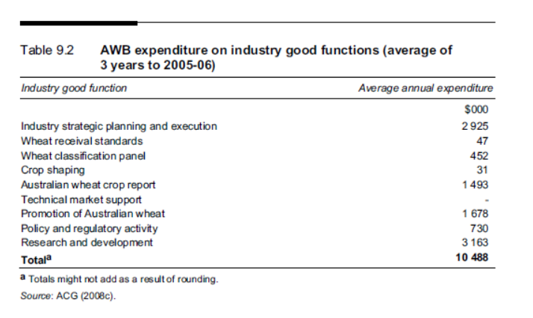

Source: from Productivity Commission (2010)

Appendix A4. Measuring the gains from changes in a value chain: economic surplus methods

The economic surplus approach evaluates the benefits from shifts in supply due to changes in productivity (such as brought about by the adoption of agricultural innovation). Changes in productivity will affect the relationship between inputs and outputs and this will in turn, change the relationship between production costs and output and thus between supply and price. Using this approach, the technological impacts spurred from research can be assessed by looking at the relationship between research investments and a commodity’s industry-level supply function (Alston et al., 1995).

A change that reduces the costs of production or an action that creates a benefit by avoiding a cost, in a market for a commodity such as wheat, is looked at in a typical year. Note that in this simple model, the impact of the reduction in costs/creation of a benefit in terms of supply shift or a demand shift is both contemporaneous and the change is fully adopted across the industry (or that part of the industry to which the technology pertains).

The market in which the change is modelled determines who is classed as a consumer and who is a producer. In this example, the market is for wheat at the farm gate and the technology is a change in the value chain farm that reduces cost of production. Producer surplus accrues to the wheat grower and any input supplier. Consumer surplus accrues to all value chain participants downstream of the farm gate including grain traders and processors and the ultimate consumers of wheat products.

Results from the EDM method of measuring additional Economic Surplus from investing in agricultural R,D&E can also be used to estimate how gains in efficiency from any source would be shared by participants through the value chain. That is, the benefits from correcting a market failure will be distributed through the grain value chain in a similar way to the benefits of any cost reducing or benefit increasing change in the grain value chain.

There is an extensive literature describing how these welfare gains from cost-reducing or benefit increasing changes can be estimated, such as Alston, Norton and Pardey (1995).

Applications of Equilibrium Displacement Modelling in Various Australian Agricultural Industries to Facilitate R,D&E Decisions

EDMs have been used extensively to determine the impacts of new policies in many agricultural settings in Australia, particularly in livestock industries. EDMs have been developed for the beef industry (Zhao, Mullen, Griffith, Griffiths, and Piggott, 2000), the sheep and wool industry (Mounter et al., 2008), pig industry (Mounter, Griffith, and Piggott, 2004), and the dairy industry (Liu, Tarrant, Ho, Malcolm and Griffith, 2012; Ludemann, Griffith, Smith, and Malcolm, 2015.).

The EDM developed by Zhao et al. (2000) was used to (i) estimate and compare the potential benefits from research-induced new technologies, generic promotion investments, and other policy changes in the different sectors and markets of the Australian beef industry, and (ii) estimate the distribution of the total economic impacts among different industry participants such as farmers, feed-lotters, processors, exporters, retailers and domestic and overseas consumers. In all scenarios analysed, most of the total benefits accrued to domestic consumers and beef cattle farmers, with domestic consumers gaining the largest share of total benefits (between 48.3 per cent to 65.6 per cent) and farmers gaining between 19.8 per cent to 33.7 per cent of total benefits (Zhao et al., 2000, p.85). Overseas consumers and domestic retailers also gained significant shares of the gains from research, with the shares of total surplus gains going to overseas consumers ranging between 5.1 per cent to 11.7 per cent, whilst domestic retailers gained between 3.6 per cent to 6.8 per cent of total benefits in all scenarios (Zhao et al., 2000, p.86).

Mounter et al. (2008) used an EDM to estimate and compare the potential benefits from new technologies, generic promotion investments, and other policy changes in the different sectors and markets of the Australian sheep and wool industries. The model considered numerous market segments to enable estimation of the distribution of total industry returns among the various regions and sectors. Using the model, Mounter et al. (2008) considered the effects of RD&E and promotion investments in two hypothetical scenarios – firstly, a reduction in the cost of producing lamb, and secondly, a hypothetical wool promotion investment on the export market. One of the main findings in scenario 1 was that domestic consumers were the main beneficiaries (have the largest surplus gain), although the proportion of total benefits collected by overseas consumers were also significant. Sheep and wool producers were found to receive less than one quarter of the total benefits. In other parts of the supply chain, the domestic sheep-meat processing and retail sectors were the only sectors to exhibit moderate gains. In one scenario, overseas consumers gained the majority of total returns from export promotion of greasy wool, with buyers of greasy or semi-processed wool obtaining gains upwards of 85 per cent of the total benefits. Domestic consumers received a smaller share of the total benefits.

Jackson, Griffith and Malcolm (2013) constructed a simplified EDM of the Australian lamb industry. The total annual benefits from a 1 per cent reduction in the cost of producing lambs was on average $18m. Of this, mean expected benefit to lamb producers was $5.9 million. The average proportion of benefits received by lamb producers was 33 per cent. This is similar to the share of benefits received by cattle farmers following a 1 per cent cost reduction on cattle farms calculated by Zhao et al. (2000). Consumers received benefits of greater magnitude than those received by producers: average benefit was $9.7 million or 56 per cent. The other participants in the industry which benefit from this shock were the suppliers of the other inputs used in production and distribution of lamb. On average, these suppliers receive benefits of $2.0 million, or 11 per cent.

An equilibrium displacement model of the Australian dairy industry was developed to estimate the net benefits from dairy research undertaken by DPI Victoria (Lui et al., 2012). A 1 per cent hypothetical shift in the supply curve in the farm and processing sectors saw consumers getting nearly 74 per cent of the benefits and farmers receiving 25 per cent, with the processors in between producers and consumers getting 1 per cent of the gains.

Results from a Preliminary EDM measuring the Economic Surplus resulting from R,D&E in the WA Grain Industry

The Australian grains industry is made up of many grain types and qualities produced across three broad agro-ecological regions, with a range of different intermediate sectors and end uses. Constructing a comprehensive EDM of the grains industry in Australia is a complex activity. Below is reported some preliminary results from the only attempt so far to construct such a model of the Australian grains industry. The analysis gives an indication of how a coast saving or benefit increasing change in the grains industry would be shared among all the participants in the grains value chain: producers, consumers and everyone in between.

As a starting point, a simplified EDM for the WA grains industry was constructed and tested by Li et al. (2017), as a precursor to the development of an Australia-wide model. This preliminary model provided a stylised representation of the wheat and barley industry and contained three industry sectors—farm production, storage and port. There were 50 equations specified in the EDM which represented the supply, demand and equilibrium conditions for each of the three industry sectors. Two scenarios were analysed: (1) new technologies or practices that reduce the costs of production and (2) improvements in a characteristic of wheat that increases the willingness to pay by the (mostly overseas) consumers.

The WA grains industry consists of several market segments along the supply chain. The majority of grain destined for export is first transported from farm to storage at upcountry receival sites. This reduces the risk and cost to producers of storing grain on-farm. From the country receival sites, the grain is transported to a port terminal for shipping. In WA, the CBH is the main handler of grain owning a network of 197 receival points. It also operates all four main port terminals in WA. Bunge operates a small port terminal at Bunbury.

The structure of the EDM of the WA grains industry is depicted in Figure A4.1. Each rectangle represents a multi-output production function. Each arrow represents the market for a product, with the arrowed end being the demand for a product, and the non-arrowed end being the supply of the product. Each oval represents the supply and demand schedule of a product where an exogenous shift may occur.

To study the returns from new technologies and methods brought about by R&D, as well as the distribution of benefits among the various sectors, vertical and horizontal industry disaggregation is required. Vertically, the industry supply chain is disaggregated into the farm, storage, port and domestic consumption sectors. Horizontally, the industry is disaggregated into the production of grains for both export and domestic use. For simplicity at this stage, the entire industry has been modelled as producing only wheat and barley.

For the WA grains industry, a benefit from a reduction in farm cost of production of 1 per cent for wheat and barley growers was estimated to deliver a gain in economic surplus of $15.49m (2017$) per year. This was shared amongst participants as follows: domestic consumers $1.98m (13 per cent), and overseas consumers $2.58m (17 per cent), producers received $9.11m (59 per cent of total gain), and handlers and trades received $1.74m (12 per cent). In total, producers and domestic consumers received 72 per cent of the extra economic surplus resulting from a change that reduced costs of production for all grain-growers by 1 per cent. The remainder of the value chain participants received 12 per cent of the total extra benefit that resulted, and overseas consumers received around 17 per cent of the extra benefit.

These surplus areas for this scenario are shown in Figure A4.2.

In another scenario, where demand was increased by 1 per cent such as from quality-enhancing research that increased the willingness to pay by all consumers of the Western Australian grain, the total extra surplus was estimated to be $22.32m per year. Domestic consumers gained 9 per cent of the total benefits and overseas consumers received 15 per cent. Producers received 63 per cent of the extra benefits. In total, producers and domestic consumers received 72 per cent of the extra benefits. Participants in the domestic value chain between producers and consumers received 13 per cent of the gains while overseas consumers received 15 per cent of the extra benefits.

Figure A4.2. Structure of the EDM of the WA grains industry

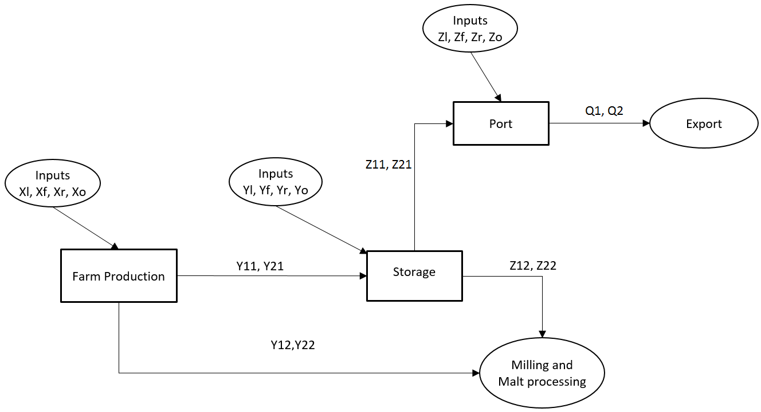

Figure A4.2. Market displacement and surplus changes in Scenario 1 ${(t}_{Xo}=-0.01)$

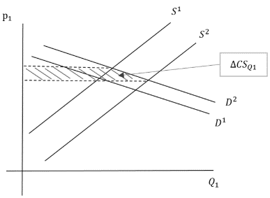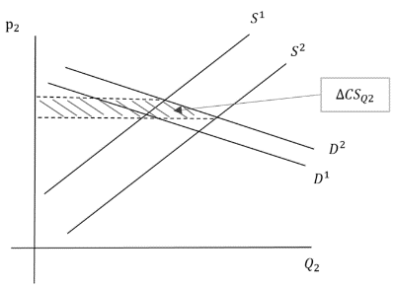

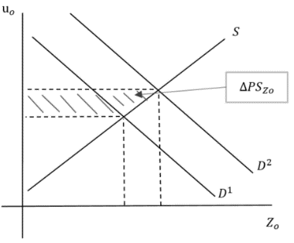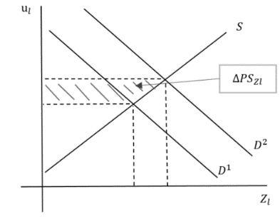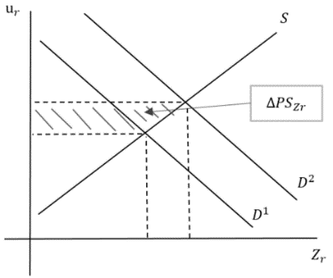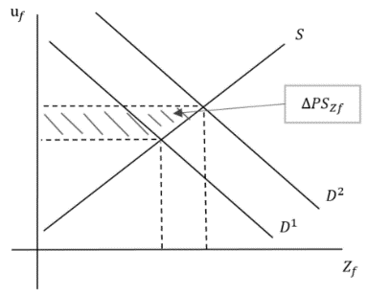

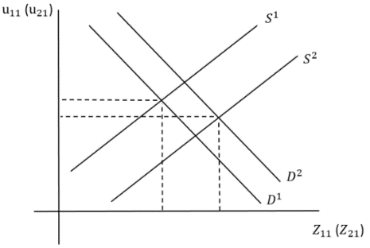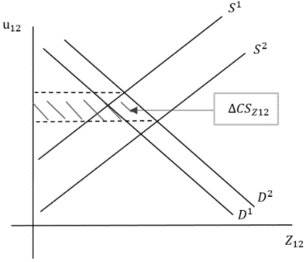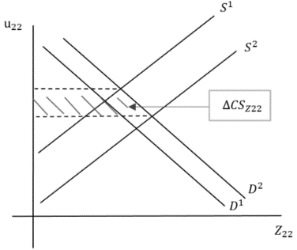

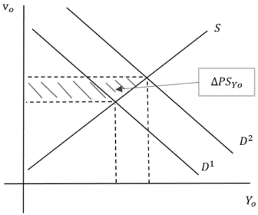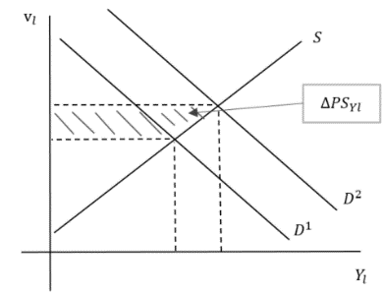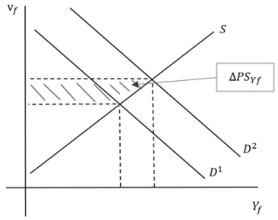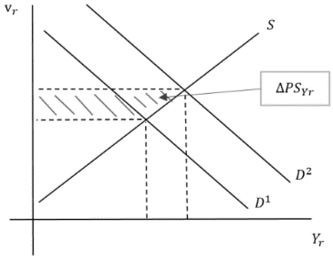

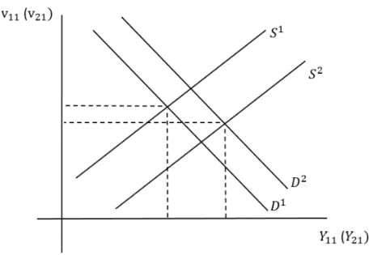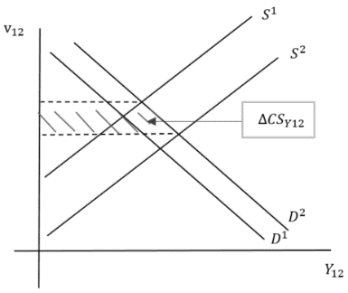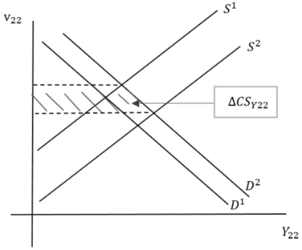

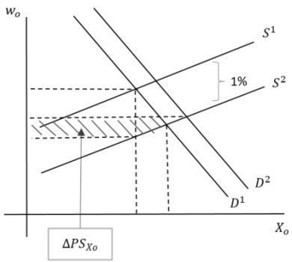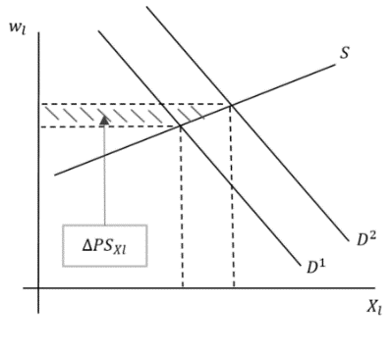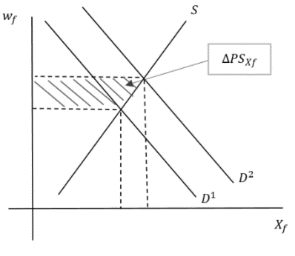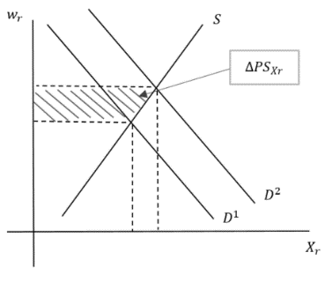

References

Aramyan, L.H. et al. (2007), ‘Performance measurement in agri‐food supply chains: a case study’, Supply Chain Management: An International Journal, 12(4), 304-315. doi:10.1108/13598540710759826

Australian Export Grains Innovation Centre (2014), The cost of Australia’s bulk grain export supply chains: An information paper, AEGIC, South Perth.

Alston, J.M., Norton, G.W. and Pardey, P.G. (1995), Science under Scarcity. CAB International. Wallingford, Oxon, UK.

Borrell, B., Jiang, T., Pearce, D. and Gould, I. (2014), ‘Payoffs from research and development along the Australian food value chain: a general equilibrium analysis’, Australian Journal of Agricultural and Resource Economics, 58(3), 409-429

Centre for International Economics (2013), Analysing the Australian Wheat Variety Classification System, Report to Wheat Quality Australia, Canberra, February.

Davis, J.S., Oram, P.A. and Ryan, J.G. (1987), Assessment of Agricultural Research Priorities: An International Perspective. Canberra and Washington, D.C: Australian Centre for International Agricultural Research and International Food Policy Research Institute.

Fleming, E., Griffith, G., Mounter, S. and Baker, D. (2018), ‘Consciously pursued joint action: Agricultural and food value chains as clubs’, International Journal on Food Systems Dynamics 9(2), 166-177. DOI:
https://doi.org/10.18461/ijfsd.v9i2.925

Griffith, G.R. (2000), ‘Competition in the food marketing chain’, Australian Journal of Agricultural and Resource Economics 44(3), 333-367.

Griffith, G., Gow, H., Umberger, W., Fleming, E., Mounter, S., Malcolm, B. and Baker, D. (2015), ‘Refocussing on the Value Chain Perspective to Analyse Food, Beverage and Fibre Markets’, Australasian Agribusiness Perspectives, Paper 104.

Jackson, T., Griffith, G. and Malcolm, B. (2012), ‘Evaluating the Impact of Research Proposals and Outcomes on Farm Businesses, Industry and the Public’, Paper presented to South Australian Grain Industry Trust Seminar, March.

Li, K., Griffith, G., Kingwell, R. and Malcolm, B. (2017), ‘Measuring the returns to investment in research and development in the Australian grains industry’, Paper presented at the 61st Australian Agricultural and Resource Economics Society Conference. Brisbane, Queensland, February.

Li, K., Kingwell, R., Malcolm, B. and Griffith, G. (2019), ‘Measuring the returns to investment in R&D in the West Australian grains industry’, Australasian Agribusiness Review, Volume 27, Paper 4, 65-106.

Li, K., Kingwell, R., Malcolm, B. and Griffith, G. (2022), ‘Evaluating the potential returns to investment in R&D in the southern Australian grains industry’, Australasian Agribusiness Review, Volume 30, Paper 2, 26-65.

Liu, E., Tarrant, K., Ho, C., Malcolm, B. and Griffith, G. (2012), ‘Size and distribution of research benefits in the Australian dairy industry’. Paper presented at the 56th Australian Agricultural and Resource Economics Society Conference. Fremantle, Western Australia, February.

Ludemann, C., Griffith, G.R., Smith, K.F. and Malcolm, B. (2015), ‘Potential Scale and distribution of benefits from adoption of a genetically modified high-energy perennial ryegrass (Lolium perenne L.) by the Australian dairy industry’, Paper presented at the 59th Australian Agricultural and Resource Economics Society Conference. Fremantle, February.

Mounter, S., Griffith, G., Piggott, R., Fleming, E. and Zhao, X. (2008), An Equilibrium Displacement Model of the Australian Sheep and Wool Industries. Economic Research Report 38, Armidale, NSW Department of Primary Industries.

O'Donnell, C.J., Griffith, G.R., Nightingale, J.J. and Piggott, R.R. (2007), ‘Testing for market power in the Australian grains and oilseeds industries’, Agribusiness: an international journal 23(3), 1-28.

Porter, M. (1985), Competitive Advantage, Creating and Sustaining Superior Performance, The Free Press, New York.

Productivity Commission (2010), Wheat Export Marketing Arrangements, Productivity Commission Inquiry Report, No.51, Canberra, Australian Government Publishing Service, July.

Watson, A., Kingwell, R., Griffith, G. and Malcolm, B. (2018), ‘Review of opportunities to promote Australian wheat in export markets’, Australasian Agribusiness Perspectives, Volume 21, Paper 10, 165-193.

Zhao, X., Mullen, J.D, Griffith, G.R., Griffiths, W.E. and R.R., Piggott (2000), An Equilibrium Displacement Model of the Australian Beef Industry. Economic Research Report 4, Armidale, NSW Agriculture.

The AREA Working Paper series reports work in progress prior to formal external review and includes draft research articles, reports to funding agencies, literature reviews, data collections and the like. Each paper is reviewed within the AREA group. Not for quotation without the consent of the authors.
The development of this Discussion Paper was funded by the Australian Grains Industry Discussion Group (AGIDG).
Kuo Li was a GRDC-funded PhD student at the University of Melbourne, supervised by Garry Griffith, Bill Malcolm and Ross Kingwell.
The information contained in this section was supplied by a highly respected grains industry colleague. See also the discussion in Watson et al. (2018)

